  We are excited to have Melissa Hennon and
  LM Clinton from the Ohio Department of Education Presenting TGRG / K-3 Literacy
  The presentation will benefit staff who deal with instructing teachers adhering to related TGRG law, staff who gather the data to code for correct EMIS reporting, district EMIS Coordinators and district leadership who look at the related data points for accountability and data related to the At-Risk data measure prior to it being published on the local report card.
  Third Grade Reading Guarantee & Improving At-Risk K-3 Readers
  - TGRG requirements and reporting (Diagnostics, Reading Improvement and Monitoring Plans, and Retention)
  - Any recent or upcoming changes
  - Understanding TGRG data displayed on Report Card Measures
  - Q & A (hopefully starting with questions submitted in advance of the session, but will also entertain any other questions throughout the presentation)
  - Questions in advance can be submitted to Melissa at:
  Melissa.hennon@education.ohio.gov
  Presenters:
  Melissa Hennon – EMIS Data Administration Manager, Data Quality and Governance
  LM Clinton – TGRG Program Administrator, Office of Approaches to Teaching and Professional Learning
  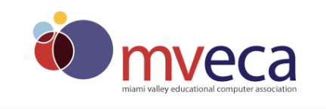
  TGRG / K-3 LITERACY
  DATE:
  APRIL 29, 2022
  A
  TIME:
  12:00 – 3:00 pm
  12
  THIS SESSION WILL BE *VIRTUAL* AND YOU WILL RECEIVE AN EMAIL THE DAY BEFORE WITH THE WEBEX LINK.
  aUDIENCE:
  emis cOORDINATORS, sUPERINTENDENTS, pRINCIPALS, cURRICULUM/aSSESSMENT, AND OTHER INTERESTED EDUCATORS
  Registration:
  www.mveca.org
  Click on View Monthly Calendar and click on April 29th to register.
  Questions: Karen Wilson
  wilson@mveca.org

