Setting up Archive FTED 001 detail spreadsheet for balancing.

1. You can delete as many columns that you want. You will be working with the following columns
   1. M- FTE Fund Pattern Code
   2. Q – Adjusted FTE
   3. R- Adjusted Sped Cat FTE
   4. AG- FTE Inclusion code

Highlighting those columns will help you find them better.

I moved FTE Inclusion code to be to the right of FTE Fund pattern code. This way all the columns you need are next to each other.

1. Once you have your calculating spreadsheet open and your FTED 001 open, click on the view at the top and choose arrange all – Vertical- That will put the spreadsheets side by side.
2. Each time you filter on your Fund Pattern Code and Inclusion Code, clear your filters prior to filtering on the next group.
3. When you have filtered on the Fund Pattern code and then the Inclusion code, click on the top of the Adjusted FTE column and look at the bottom for the total of that row.

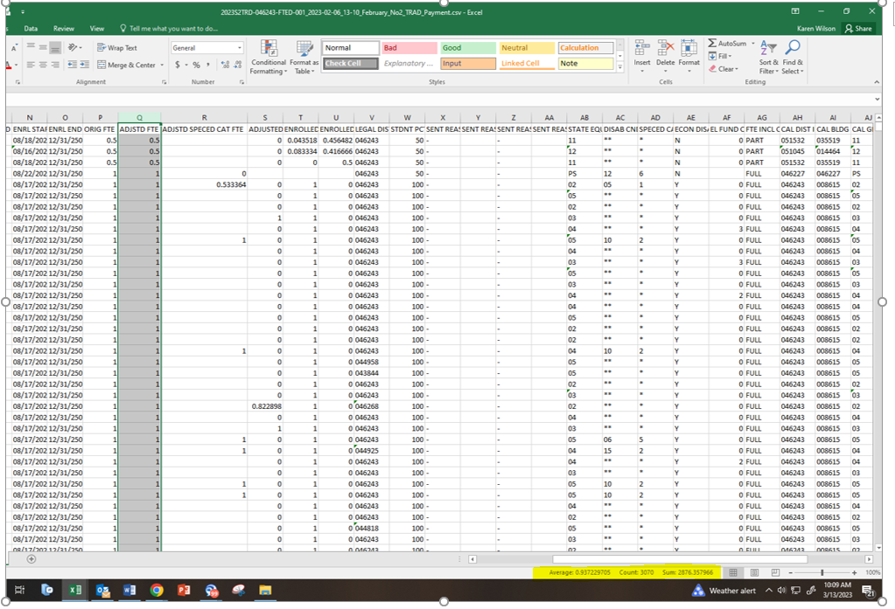

1. Enter that full amount into the spreadsheet.

Enrolled ADM are they using 3 year average of current.

=H2+I2\*0.5+J2+K2+L2+M2+N2\*0.2+O2\*0.2

Use on the 08 report.

