To begin reporting the Dyslexia (DS) and Reading Diagnostics (RD) you will need to go to the Analytics hub and pull your spreadsheets for each Record Type.

Under Assessments ­­­­

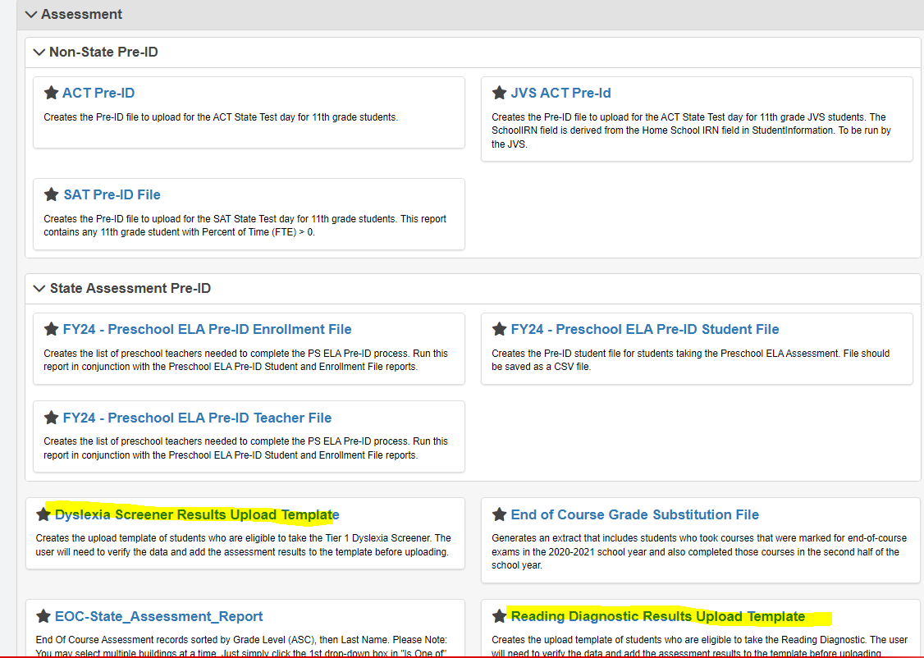

Each one will have your list of students that should be tested based on the filters you applied and two columns at the end of the spreadsheet for the Test Date and Score. They are pre-populated with the Assessment type and the other items that are needed for loading.

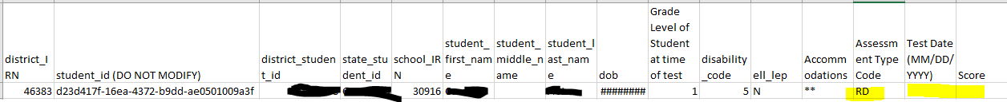

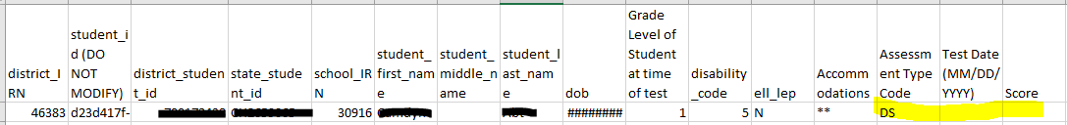

When reporting your Dyslexia and Reading Diagnostic scores, please refer to the charts at the end of this document.

The first chart lists the tests that are available for both the Reading Diagnostics (RD) and the Dyslexia (DS) testing and the Test Area Code. The Test Area Code will be needed when you load the scores into SI. They will be loaded through assessment import. You will choose the assessment that was given then upload the file. That process is still not available but should be out in the next release.

You have a column that indicates if the element is looking for a Numeric or Alpha entry.

When it refers to score, I would think that your testing coordinators would know which score out of the many that are on the files that you should be reporting.

If the test that was given indicates that an Alpha entry is needed, refer to the second chart at the bottom of this document for how to report.

Example: If you used mCLASS DIBELS 8th Edition for both





You will enter The Numeric score for the Reading Diagnostic. For the Dyslexia you will **NOT** enter At Risk or Not At Risk- You will enter ATR for At Risk and NAR for Not at Risk. This is taken from the 2nd chart at the end of this document.

Results that ODE is expecting by Test Type –Taken from EMIS manual section 2.8 Pages 17-18

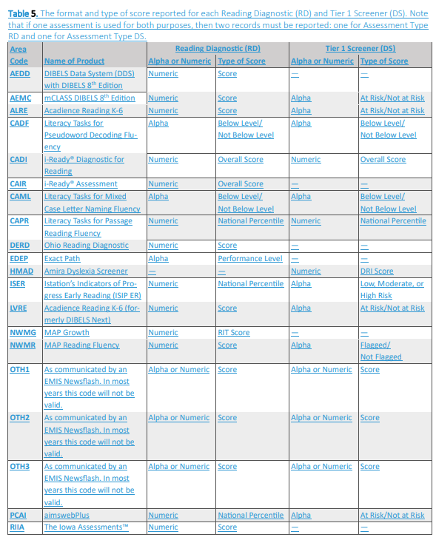 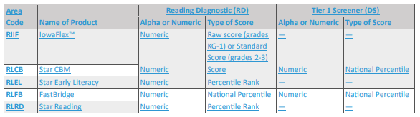

Alpha reporting abbreviations to report

