Pre-School ELA Reporting
Go to https://www.ohio-k12.help/ela-score-entry-and-reporting/
Download the ELA Score Entry and Reporting Form
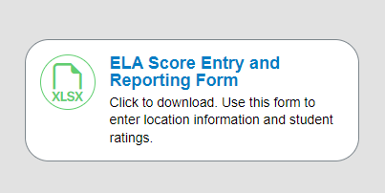
- Open the file and you will have a workbook with 3 tabs (Instructions, Priority Required 15, Comprehensive – Full 32). The district will need to decide which test they are giving – you do NOT do both.
- Open the tab for the test that the district is giving (I will use the Priority 15 for my example)
- Go to the Analytics Hub in Student Information at the district level and under Assessments > State Assessment Pre-ID > PreSchool ELA Pre-ID File
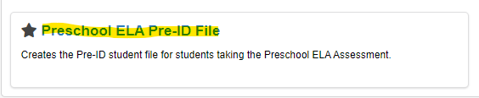
You will use the filters for the correct school year, select the school that houses your Pre-school unit, select the PS grades, and your status for your pre-school students. Export this report to an excel file and then copy the rows with the student information in it. You will not want to copy the header row. Once you have your information copied, you will paste it in the downloaded ELA score and Entry reporting form document starting on line 3.
Our recommendation is that you create a file for each teacher and send to the teacher and then you can upload their scores when they are done. This form can not be converted to a google doc and it can not be manipulated or changed in any way.
Once the document has been returned to you; you can go back to the same site and upload the document.

