Changing Calendars for Delays and Calamity Days

For Delays
You can be in the district to make the changes you just have to remember that you cannot change all buildings at the same time if their start and stop times are not the same.
- Type Calendar Bulk into the Go to Box.
  - Choose either option-both take you to the same place.
  - On the Sub Calendar Day box set up as below assuming it is a 2 hour delay
You will not change the Sub Calendar Day Type as it is still the same type of day
that is on the Master Calendar- School Day. Enter the time that the day will begin. Click the Update box

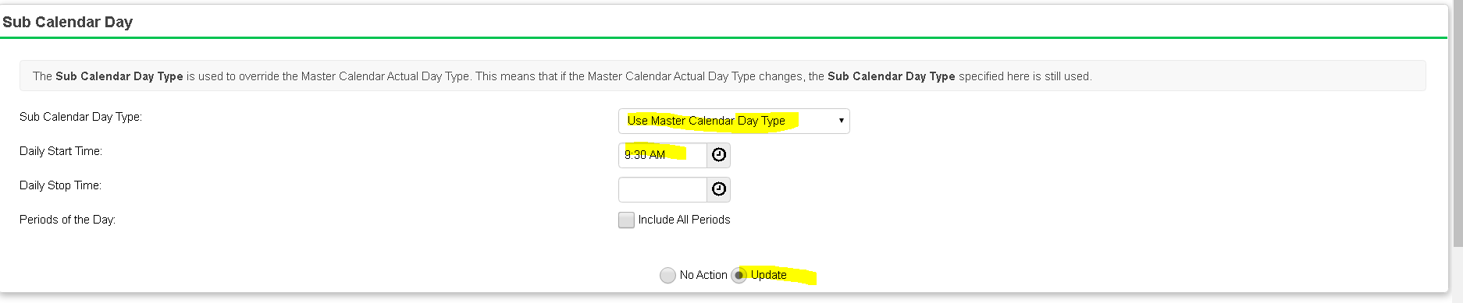

- State Reporting Exceptions
  - Click the + to add the exception
  - Choose weather related Shortened Day
  - In the hours box enter the number of hours the students attended
  - Click add/updated exceptions
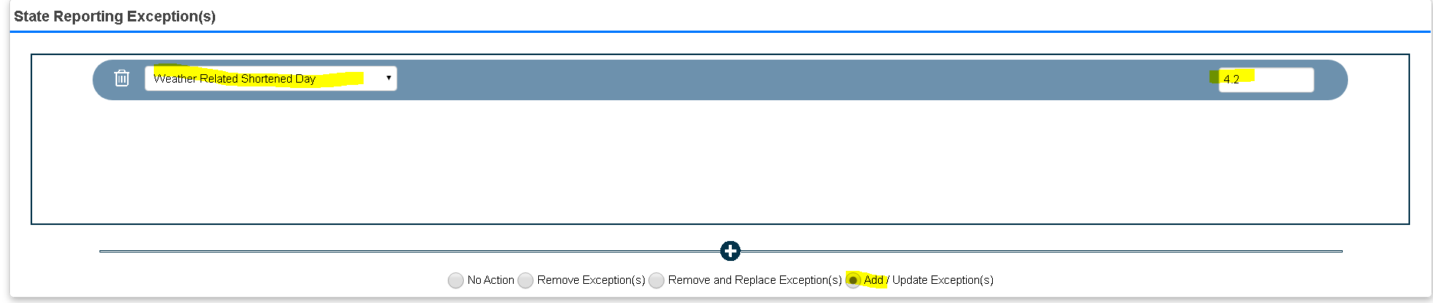
- Days Box
  - Click Add Days Click on the day that you want to add and click on Add these days
It should look like this when you are done
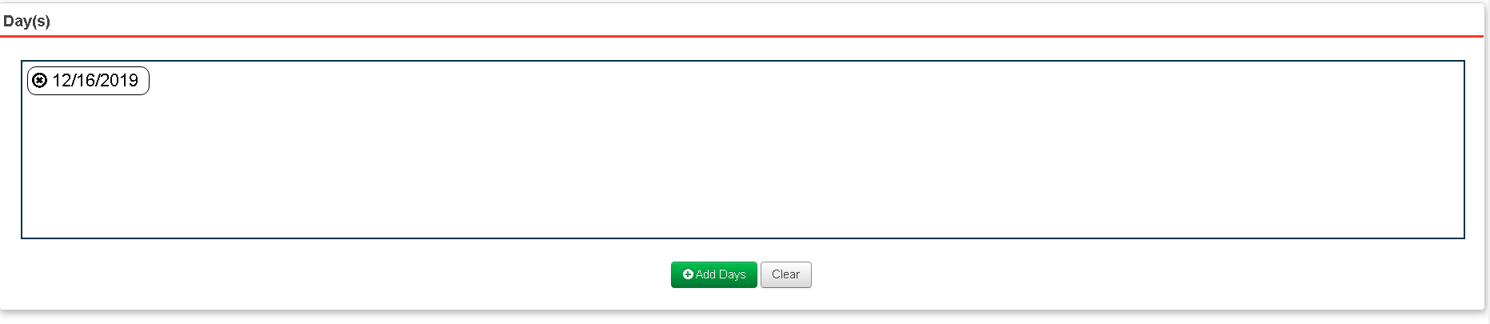
- Calendars Box
  - Click the box next to all the calendars that apply
  - Then click Save.
Remember if you have ESC calendars the delays may or may not apply.
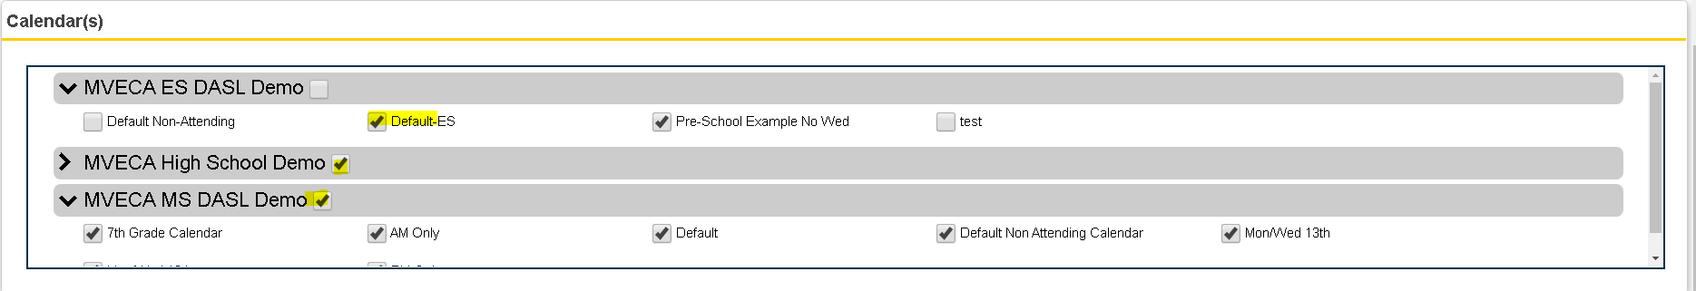
- Repeat the process for all other buildings with different times.

Calamity Days – No Student Attendance.
You can be in the district to make the since it is most likely that all your calendars will be reporting the same
- Sub Calendar Day
  - Change Sub Calendar Day Type to the correct type. I am using Snow day but it could be another reason that the students are not attending.
  - Click Update
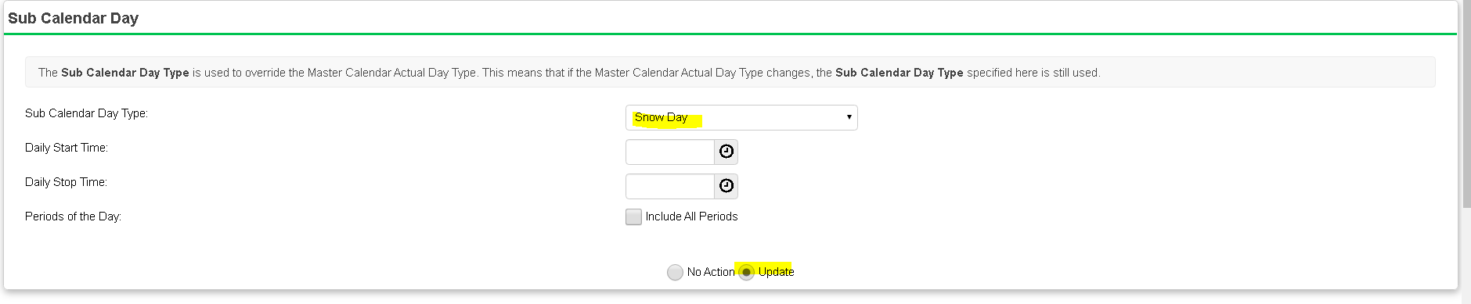
- State Reporting Exceptions
  - Click the + to add the exception
  - Choose Calamity Day
  - In the hours box enter 0.0 hours showing ODE that there are no Student hours on that day.
  - Click add/updated exceptions
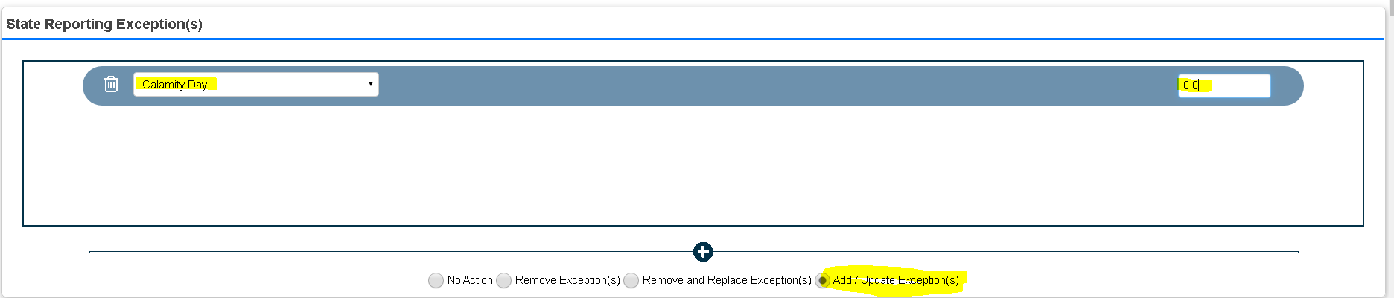
- Days Box
  - Click Add Days Click on the day that you want to add and click on Add these days
It should look like this when you are done

- Calendars Box
  - Click the box next to all the calendars that apply
  - Then click Save.

There is another step that must be taken when a district takes a calamity day where no students are attending.
- You will need to go to the Master Calendar in each building.
- Click the edit pencil on the date that is the calamity day
- Leave the planned school day, planned rotation day and planned student and staff attendance the same.
- Change the Actual School Day Type to Snow day or whatever is appropriate. The actual student and staff attendance will change to 0.
- Click Save.
If you have rotation day, you will have to tumble your A and B days so that you come up with the correct A or B day for the next school day.

