EMIS Update Monday August 14th
Course Appeals Manifest.
Remember to take a look at the files tab in the DC and check out your students.
If you have Career tech students that should be receiving credit and it is not showing a P with a credit amount then you will need to update your Clisemis\Ctrmemis in the 16/17 school year, send an L file over the DC and check to see if credit was updated. IF so submit the data to ODE. You could still have students with a P and no credit if you are using a CTE subject code for CCP or another course that is not a Career tech course. A student would also show with a P and no credit if they failed the course or withdrew without credit. You will NOT receive another report in the Files tab on this data.
Appeals must be submitted prior to 5:00 p.m. On Monday the 21st.
FY17 Related
Grad data is coming in now. ODE hopes to have the first set of reports out later this week or beginning of next week. There will be a missing assessment report out related to Grads.
CTE assessment manifest
Working on the missing list. Will be pushed out within the next couple weeks.
H Reporting
Ends August 31st for the main data, Capital Assets can be reported in the Supplemental manifest when it comes out in September.
FY18 Related
Retention Manifest. Please submit as soon as possible. It closes on August 31st. Once you have submitted and the data has been loaded into the SDC, make sure that someone in the district looks at the LRC and pulls the TGRG district data so you can verify the data submitted. If at all possible you do not want to see inconsistent retention on any of your students.
Remember to report a retained status of H for any 3rd grade student that was a summer withdraw and would have been retained if they had not withdrawn. Does not apply to students that were reported as withdrawn in the final 16/17 manifest.
Community Schools -Beginning of the year manifest. As of Monday SOES had not been loaded. They were anticipating trying to load on Wednesday. I did see a little data in there yesterday.
SCR
SCR is open, you have 30 CALENDAR days from the first day that a student starts school. At the beginning of the school year it would be 30 Calendar days from your 1st day of school.
1st TRD is scheduled to open early September.
Staff to open in early October along with several Assessment collections.

Change Call
Gifted Program Codes
The following program codes will be deleted for the 17/18 school year
205040
205047
206040
206045
206050
206052
206055
206065
206075

Additions to the Gifted program codes
205090 Innovative Services
206090 Innovative Services
205067 International Baccalaureate course
205095 Services through a trained arts instructor
Update the name for the following program code:
205055 Regular Classroom with Early Entrance to Kindergarten or First Grade

Military Collection
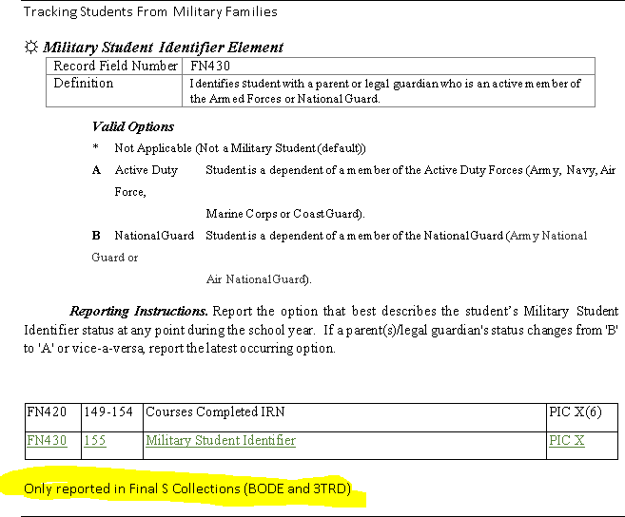

New element on the FN record.
If a student meets the point at ANY time of the school year. As far as A or B report the most current option at the end of the school year. If you have a student with a parent that is A and one that is B report A although David did not think that it would make a difference.
Reserves does not apply unless the parent is deployed. ODE will be verifying this.
Reported by the district where the student would count for testing accountability – i.e. Students placed in a special ed coop- testing accountability is with the resident district not the educating district.
Step parent – ODE is doing more checking on this.- Indicated that you would enter if the step parent was a legal guardian.

ESSA Changes on LEP and how long they count.
Students will count for 4 years. ODE has decided that they no longer need the LEP reclassification date. If data is reported it will be ignored.
You will still be updating the LEP status of a student as they move though them.
Truancy
Four options that you will be reporting
ODE will start collecting the data in January-BUT… It needs to include what occurred from the beginning of the school year
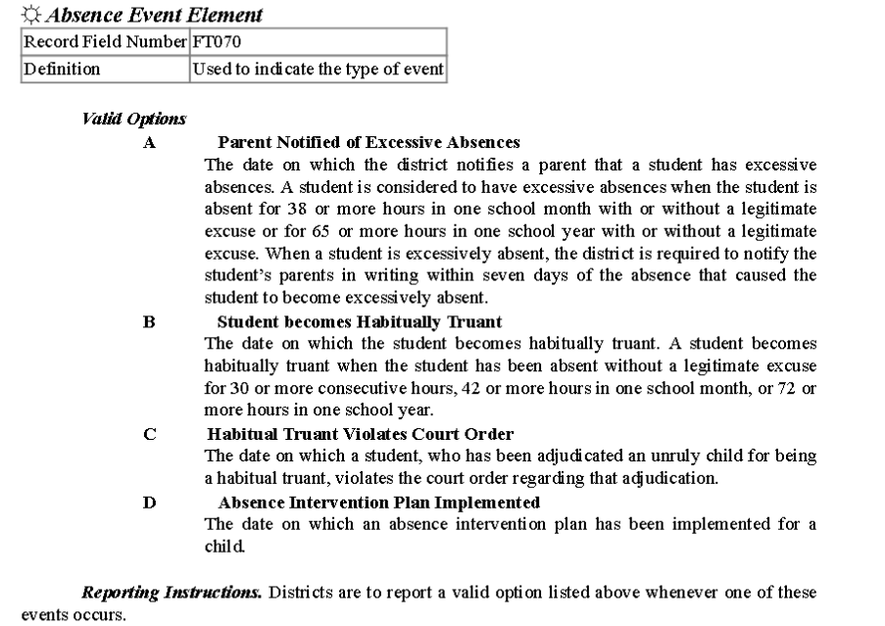
ODE Asked that we not share the document, but…. it is out on the Change call section of ODE which anyone can access. It is still in draft form so there will probably be tweaks to the element, but the basics are here.
http://education.ohio.gov/getattachment/Topics/Data/EMIS/Technical-Documentation/EMIS-Change-Committee-Conference- Calls/2 22-Student-Truancy-Record-DRAFT-for-August-Change-Calls.pdf.aspx
17.1 Release for DASL Districts
I have attached the release notes for the 17.1 update that will be installed over the weekend of August 26-27. There are some really nice updates and fixes in this release. Please read through it carefully.

