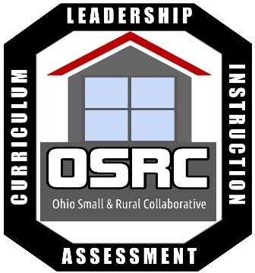

Ohio Small & Rural Collaborative

Mr. Kirk Koennecke
Executive Director

Mr. John Carder
Associate Director

Mr. Ryan Rismiller
President

Mr. Tate Skinner
Secretary

Mr. Bill Wade
Treasurer

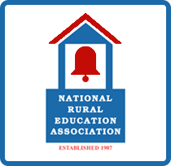
OSRC is an affiliate of NREA

OHIO SMALL & RURAL COLLABORATIVE
7790 W US Highway 36
Saint Paris, Ohio 43072
937-663-4123
1st Annual State Conference
March 2nd, 2018
Nationwide Hotel & Conference Center
Lewis Center, Ohio
Cancellation Policy: Registrants who cancel prior to 72 hours before the event will not be charged and will receive a full refund. No shows and registrants who cancel less than 72 hours prior to the event will be charged the full registration amount.

Join us for 1 day conference of valuable learning with national small & rural school leaders, powerful breakout sessions, and partner demonstrations.

Featured Speakers and Presenters:
Allen Pratt, Executive Director, National Rural Education Association
Dr. John, White, Rural Matters
Don Rodgers, Texas Rural Education Association
Learning Blade
DSD Professional Development
EnvisionEd
INFOhio
TeachingReady
Loth/Steelcase and others!

Registration Information
Registration fee includes all materials, hospitality, lunch and beverages
- Member Rate- $125
- Non- Member Rate - $175
- Member Group Rate (4 Members) - $400
  - Group members must be from the same district to receive the pro-rated group rate

INSERT REGISTRATION LINK HERE

Hotel Accommodations
Nationwide Hotel & Conference Center
100 Green Meadow Drive South
Lewis Center, Ohio
1-866-233-9393
www.nwhotelandconferencecenter.com

**Special OSRC Group Rate
$129 – Single Room
$139 – Double Room
Be sure to tell them you are with Ohio Small & Rural Collaborative!

