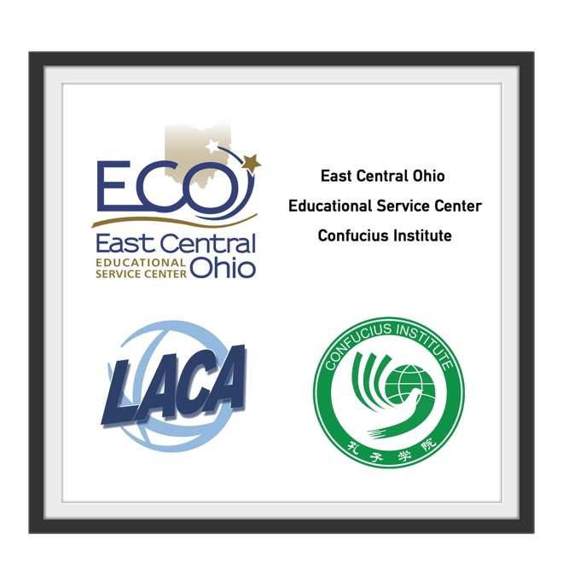
Connected Learning 2019-2020

It is with great pride that we begin plans for the 2019-2020 Video Distance Learning course offerings. Our established partnerships along with a funded and sustainable infrastructure continue to allow us to offer to your districts high quality, affordable, daily course solutions each year. In addition to being established as one of only six K-12 Confucius Institutes in the United States, our infrastructure was largely placed through a Rural Utilities Service Distance Learning Telemedicine (RUS DLT) grant. This grant and these partnerships will allow us to further strengthen our Video Distance Learning network to our member districts.

The courses listed on this brochure are delivered through Interactive Video Distance Learning (IVDL) equipment. Associated network support for video is STRONGLY suggested. If you are unsure where to secure video support, please ask us, we will point you in the correct direction if it is not through our agency. In addition to providing your students a face-to-face instructor through the use of IVDL, all courses have access to additional online material through various solutions and daily access to the recorded version of the live instruction. Our teachers are ODE licensed, and HQT in the content field.

Mandarin Chinese, American Sign Language, and Spanish courses are offered as a whole class purchase. The cost of each period (not to exceed 20 students per instructional period) is $11,000.00** per year. On a case by case basis, we will be offering Chinese and Spanish on a per-student price structure when needed. ASL does not offer this option.

Through our supported school districts, there will also be opportunity for additional singleton courses. This course availability will be added on a per-seat basis as they are released to us. The course list attached to this brochure are shared courses currently offered. The offering is expected to be the same, or have increased options during the 2019-2020 school year, and school partners are currently finalizing their schedule.

While focus remains on the sharing of courses through Interactive Video Distance Learning, we also are approved hosts for both Visiting teachers from China and also from Spain. The application window to host a new Visiting teacher from China will close to priority members (ECOESC) on January 14, 2019. The window for requests for new Visiting teachers from Spain has opened and the deadline is March 30, 2019, but we expect to have a very competitive window of opportunity during this application cycle. Please contact Michele Carlisle today if interested in receiving a Visiting teacher to your district in the coming year.

Mandarin Chinese Levels I-IV – also available as College Credit Plus - and AP CHINESE

Beginning students will learn the basics of spoken and written Mandarin Chinese. By stressing proper tones and pronunciation, this class introduces Mandarin Chinese to those who are curious about the most widely spoken language in the world. Students will engage in communicative skills such as introducing themselves, meeting, greeting, and describing others, ordering at a restaurant and asking for directions, all performed in a culturally appropriate and linguistically accurate manner. Speaking and listening skills are the main focus of Chinese; however, students will also be introduced to the character-based writing system in Level I, progressive conversation, listening, speaking and writing will build through each level. College Credit Plus is offered through Lorain County Community College currently. ECOESC is seeking additional College Chinese partners at this time. Additionally, students in all levels will be offered the option of taking the STAMP (STAndards-based Measures of Proficiency). STAMP is also on the ODE approved vendor list for those assessments that qualify as a measure for the Seal of Biliteracy for Language learners. We now also offer AP Chinese to students ready for the AP Chinese coursework. To request AP Chinese, individual student rates apply.

American Sign Language Levels I-IV -also available as College Credit Plus course

American Sign Language (ASL) is the natural language used by deaf individuals and the Deaf community. Students will focus on mastering the basics of fingerspelling, numbers, colors, facial grammar and sentence structure; students will also learn conversational/cultural behaviors necessary to hold a beginning-level conversation in ASL, with deaf/hard-of-hearing native users of the language. Language instruction progresses in each subsequent level of instruction. College Credit Plus Option will be offered for ASL from Rhodes State College. At this time, tuition rates are still being negotiated. While ASL is not a TAG course, many state Universities recognize ASL as a foreign language credit on High School transcripts labeled as such.

Spanish -also available as College Credit Plus course - AP SPANISH

Using interactive video distance learning, Spanish levels I-IV will be offered on a per-period basis for school year 2018-2019. Our ongoing partnership with ODE and the Spanish Foreign Ministry allows us to become a host to a Visiting teacher from the Spanish Foreign Ministry program. Currently the ECOESC is host to 6 Spanish Visiting teachers, and currently one of those teachers is available in the afternoons each day. Similar in nature to the Chinese Guest Teacher program, we are an approved applicant of for the hosting of a visiting teacher. This teacher is then placed in your building, providing a unique opportunity to provide HQT Spanish language, from a native speaker. AP Spanish is now offered, but during a limited time frame, dependent upon the face-to-face schedule of the instructor.

English Language Learner (ELL) Classroom Coaching – customizable options

Students enrolled in this course will receive instruction based around the RIGOR program. The RIGOR program is specifically designed to assist students learning English as their second language in grades 7-12. Throughout the course, students will learn vocabulary, reading, and writing strategies through Science and Social Studies. There will be assessments based on language goals. This class is designed specifically for students with beginning or newcomer language proficiency levels. (costs for this are dependent upon needs of district.)

Shared Singleton Courses
Districts served by our video conferencing consortium are in the position to offer courses via IVDL from year to year. Additionally, they also look for courses that might be offered from other partner High Schools as well. Finally, there are some Institutes of Higher Education that have a great selection of courses available via distance learning directly to your own campus. If you would like for us to add and share a course you can or would be willing to offer a course, contact Michele Carlisle today!

For more information, contact:
Michele Carlisle
Coordinator, Distance Learning, ECOESC
Distance Education Support, LACA
Director, Confucius Institute at East Central Ohio Educational Service Center
330-308-9939 x 8220
michele.carlisle@ecoesc.org
mcarlisle@laca.org

