
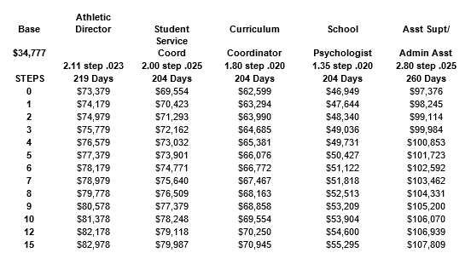
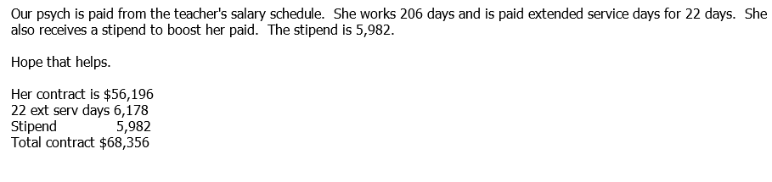
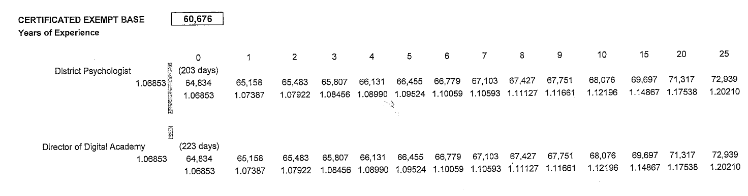
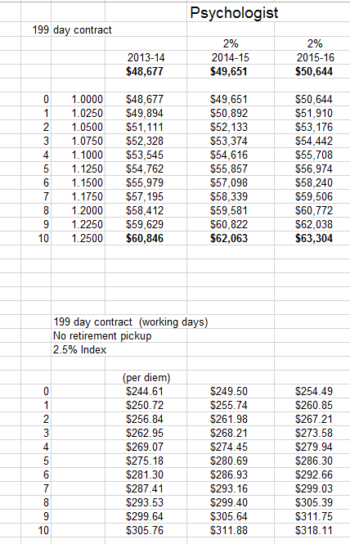



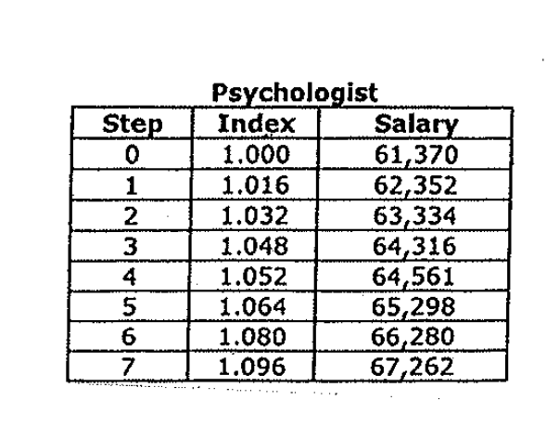

we are in the middle of a similar situation. Originally they had a salary schedule for 200 days beginning at 35,000, which I have pasted below.
They are currently in discussions to revise, to start at about 52,000.

 | 35000
0 | 35000
1 | 36750
2 | 37100
3 | 37450
4 | 37800
5 | 38150
6 | 38500
7 | 40250
8 | 40600
9 | 40950
10 | 41300
11 | 41650
12 | 43750
13 | 44100
14 | 44450
15 | 44800
16 | 45150
17 | 47250
18 | 47600
19 | 47950
20 | 48300
23 | 49350
26 | 50400
29 | 51450
32 | 52500
35 | 53550



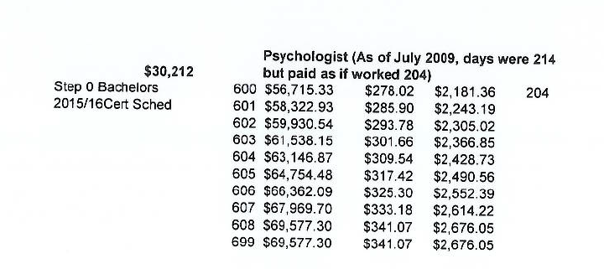
Our school psychologist is on our teacher’s salary schedule and also receives 18 extended service days at his daily rate.
