**Logan-Hocking Local School District** is seeking applicants for a **Treasurer’s Assistant – Budgetary Accounting, Federal Programs and Payroll Specialist Backup.**  This is a 255 day (7.5 hours/day) exempt salaried position with applicable fringe benefits.

Logan-Hocking Local School District is located in the picturesque, rural Hocking Hills area in Southeastern Ohio. The administrative office is conveniently located on State Route 33, fifty minutes from downtown Columbus and twenty-five minutes from Athens. The District is comprised of five elementary buildings (PreK – 4), one middle school (5-8), and one high school (9-12) with an average ADM of 4000 students. Logan-Hocking is the only school district in Hocking County and the largest employer in the region.

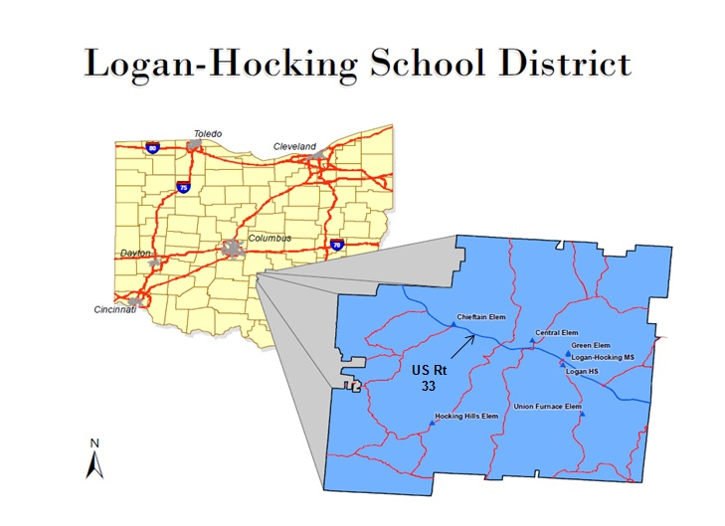

The mission statement of the Office of the Treasurer is “Promoting an ethical workplace where individuals treat each other with respect, take pride in their work, care about one another, promote accountability, and place the public interest over individual and organizational self-interest.”

**APPLICATION DEADLINE:  Monday, February 27, 2017 at 12:00 Noon**

**PREFERRED MINIMUM QUALIFICATIONS:**

Associate degree preferably with training and experience in accounting or finance;

Knowledge and experience with state software;

Proficient in Microsoft Excel, Word, and other software (able to provide written evidence of computer literacy ie: certificates or course work);

Accounting and Payroll skills including knowledge of benefits, healthcare, and tax administration;

Self-motivated and self-directed;

Detail-oriented with organizational and analytical skills;

Ability to collaborate with others and handle confidential matters;

Strong interpersonal, verbal, and written communication skills;

Strong technology skills

**MAJOR RESPONSIBILITIES:**

Special Revenue Funds maintenance and oversight;

School District Budgets development and monitoring;

Appropriations/Estimated Resources management;

Serve as Technology lead for Treasurer’s office;

Payroll specialist backup;

Be proficient in office protocol;

In the short term, serve as Accounts Payable Specialist

**TERMS OF EMPLOYMENT:**

Salary: Competitive salary with excellent fringe benefits

Anticipated employment date: March 20, 2017

**APPLICATION PROCEDURE:**

Interested candidates wishing to apply should submit:

* a completed application (from: [loganhocking.k12.oh.us/employment.php](http://www.loganhocking.k12.oh.us/employment.php))
* cover letter
* resume - with 3 professional references

to: Paul F. Shaw CPA CGMA RSBFO, Treasurer

Logan-Hocking Local School District

2019 E. Front St.

Logan OH 43138

Or by email to: [pshaw@lhsd.k12.oh.us](mailto:pshaw@lhsd.k12.oh.us) (Subject: Treasurer’s Assistant Position)

Logan-Hocking Local School District is an equal opportunity employer and does not discriminate on the basis of race, national origin, sex, disability, or age in its employment practices.

District Website: www.loganhocking.k12.oh.us