**FY17 Community School FTE detail to SFPR reconciliation**

There is not a required way to use the FTE detail report. This is one suggestion on how to reconcile it to your SFPR. Please use as best meets your need. CTE reconciliation is still a work in progress and when it comes out will be a separate set of instructions.

**Phase One:**

This document is not a finished product. It is a work in progress. When updates occur to the FTE Detail these directions will change. This method can work in any size district in Ohio.

Open your foundation funding report on the ODE website. Choose the period you want to reconcile such as Oct #1. Choose your district and click on Community School Detail Payment Report. Open your reconciliation workbook. It should open to the SFPR tab, if not, click on the SFPR tab. You may want to hide columns D through G, and column I to make entering the base data easier. In cell B4 enter your IRN number. Make sure your District name shows up in cell C4!! Go to cell H4 and put the Month you are reconciling. Enter the FTE’s from the ODE Foundation “Detail” report for cells H7 and H8, H10 to H15, H17 to H21, and H23 to H27.

**Phase Two:**

Open your FTE Detail Report. It should have one tab, and in that tab columns A to AK. **Stop**. Was the last column AK. If the last column is not AK the reconciliation may not work. It means that the detail report has changed and the reconciliation may need to be modified.

Place your cursor in cell B3, click on Sort and Filter and choose filter. Click on the “VIEW” menu at the top of the spreadsheet. Click on Freeze panes and choose “Freeze Top Row”. Now scroll to the very last row of this worksheet. Let’s say there are 4,140 rows. Go to cell column Q row 4,142 and put in the following formula =subtotal(9,Q2:Q4140). You can now filter any criteria you want and the number of Adj FTE’s for that criteria will subtotal. You are now going to copy the FTE detail report into the “FTE Detail” tab in the reconciliation workbook. Once you do that save the original FTE Detail report. I would recommend saving it in an FTE detail report folder and name it the date that you created it.

The reconciliation workbook should have populated with the FTE details. Variances between the FTE detail and the SFPR should be showing up in column I. You may be wondering why there are three columns between D and F and some have numbers and some don’t. If you hover your mouse over D5 there is a comment in that cell that will read “Community School”. Each cell from D5 to F5 has a description of the type of student being captured in that column.

Let’s look at the FTE detail report to see what column combinations created the FTEs. Currently there are 37 columns from A to AK. Of those 37 I am using some combination of eleven of them to populate the reconciliation spreadsheet. Those eleven are:

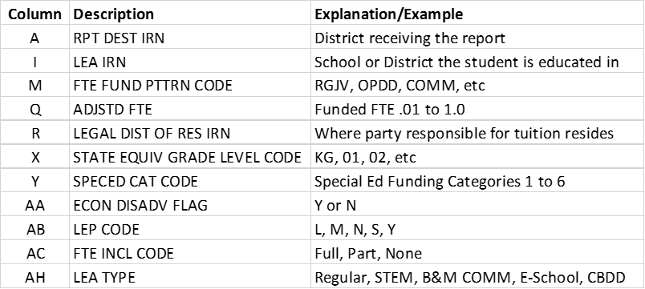

Each cell being calculated at the minimum looks at the IRN in cell B4 of the SFPR tab to find a match in column A, I, or R of the FTE Detail tab. It then matches the Fund pattern code in row 5 of the SFPR to column M in the FTE Detail. If there is a match it includes the FTE amount in Column Q of the FTE Detail.

Some cell calculations will only include FTE INCL CODE FULL or PART in column AC of the FTE detail, some will include both. If a cell calculation is only looking at FULL or PART only, it will reference column AC in the calculation.

Your special education (SFPR b1 – b6), Limited English Proficient “LEP” SFPR d1 – d3), and economically disadvantaged (SFPR e1 and e2), funding lines look at columns Y (SPECED CAT CODE), AA(ECON DISADV FLAG), and AB (LEP CODE), in the FTE Detail tab respectively.

**CTE Reconciliation**

The CTE detail can be found in the data collector. For FY17 the manifest code is 2017L1S2R. I recommend saving this spreadsheet separately from the reconciliation. You will find 20 columns, A to T, of data when you open this spreadsheet. The number of rows will vary by District. You will have a separate line for each career ed class a student takes. Go to cell N2. It will have a =” followed by 1 through 5 and “. We will get rid of the =” and the “ in two steps. Highlight column N. Click on “Find and Select”, then click on replace all. Make sure you have column N only highlighted. If you don’t select an area it will replace every =” on the spreadsheet and you do not want that to happen. Type =” in the Find what and leave the Replace with blank just like below.

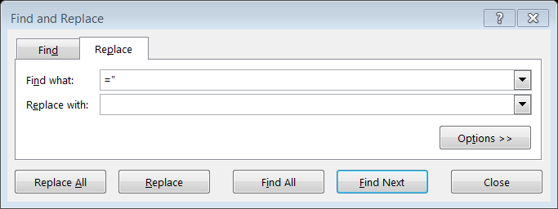

Click on Replace All. Once they have been replaced do the same step but just use “

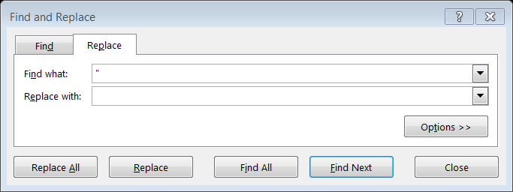

Next go to cell B2 and click on Sort and Filter, then click filter. Freeze the top row by clicking on view, then click freeze panes, lastly click on freeze top row. Click on the filter drop down box in column D, local classroom code, and click sort “A to Z”. You now have all the classes grouped together. I would then put a subtotal for most of the columns. Assuming the class data goes down to row 250 and you want a subtotal for column E the formula would be =subtotal(9,e3:e250). Now you can do different filters and the subtotal will change automatically.

You may want to add a couple of more tabs. Name one, “class”, the other “student”. Copy the entire data from the original download into both tabs. Sort the class code by column D and then subtotal column L and M by the classroom code. You can subtotal by “Sum” or “Count” depending on what you want to verify. This will give you your classroom roster that could be easily verified. Next go to your student tab and sort by SSID. This will allow you to check each students’ classes.

Now copy all the information from the original CTE download into the CTE detail tab of the reconciliation spreadsheet. Next, copy all of the class codes from “column D” in the CTE detail tab to cell A3 in the CTE analysis tab of the SFPR reconciliation. Go to Data and click on remove duplicates. You will be left with a single entry for each class.

In the CTE analysis tab copy the formula from column B, row 3 to column N, row 3 as far down as you need for the classes you have. You now have detailed information on each class that was offered. You have how many CTEs were generated, you can also see how much funding a class generated in column F as well as how many students were in the class in column G. Column I tells you when the course started and ended. Column J through L shows how many students were in the different fund pattern codes. Put your cursor in cell B3, click on view, freeze panes, and then click freeze panes. You may also want to put subtotals at the bottom of selected columns.

Enter the FTEs in C1-C5 from the SFPR detail worksheet report to cells R12 down to R16 of the CTE analysis tab. In column S the difference between the CTE detail and the SFPR will show and column T will reflect your projected CTE funding.

Congratulations, you are done ☺ the next time will be much easier!