**FY17 Traditional School District FTE detail to SFPR reconciliation**

**Includes CTE Detail reconciliation**

There is not a required way to use the FTE detail report. This is one suggestion on how to reconcile it to your SFPR. Please use as best meets your need. Community school students and scholarship students are now included in the FTE detail report. You can also now reconcile your BDD adjustment and VE services adjustment if you have them. Keep in mind this is still a work in progress. Some of your differences may be attributed to rounding. Rounding issues will be more prevalent in districts that have greater mobility with their students. Lastly there will be timing issues. Your FTE detail report may be more current than your SFPR. For best results try to run an FTE detail report two Mondays prior to the SFPR settlement you are trying to reconcile.

**Phase One:**

This document is a work in progress. When updates occur to the FTE Detail these directions will change. This method can work in any size district in Ohio.

Open your foundation funding report on the ODE website. Choose the period you want to reconcile such as Jan #2. Choose your district and click on five reports; 1) School Finance payment report Detail 2) Open Enrollment 3) Scholarship Deduction 4) Community School Deduction Summary 5) Preschool Special Education.

Open your reconciliation workbook. It should open to the SFPR tab, if not, click on the SFPR tab. You may want to hide columns D through W, and column Y to make entering the base data easier. In cell B4 enter your IRN number. Make sure your District name shows up in cell C4!! Go to cell X4 and put the Month and #1 or #2 for the period you are reconciling. Enter the FTE’s from the ODE Foundation “Detail” report for cells X8 to X11, X13 to X18, X20 to X24, X26 to X28, X30 and X31, X33 to X39, and X41. Enter the Preschool category 1 through 6 FTE’s into X45 to X50 from the Foundation Preschool report.

Go to the foundation funding report. Copy the Community School Transfer **Summary** info into the COMM tab. Copy into cell A1. Click on Data, Text to Columns, choose fixed width and then go through the steps. You may have to move the line separators around, especially if a STEM school is included. Sort the community schools by IRN number, “Smallest to Largest” sort order. The end result should look like below:



Copy the first two columns with descriptions IRN and Community School into cell B55 and C55 on the SFPR tab. Next copy the Student FTE data into column X of the SFPR tab. You do not need any of the other information. If any Community School names have an asterisk that means they are a STEM school. Place the info for those schools under STEM and delete from Community School. The row STEM begins on will depend on how many community schools you have.



Go back to the foundation funding report. Copy the Open Enrollment Data into the reconciliation workbook tab OE. Copy into cell A1 and do a text to column. Click on Data, Text to Columns, choose fixed width and then go through the steps. You may have to move the line separators around. The end result should look like below:



Sort Column “Type”, “Z-A” sort order. The CT’s will be at the bottom. Add three empty rows between the bottom JVSD and the first CT code.



Next sort by “or RECEIVED”, “Smallest to Largest” sort order. If you have **NO** positive numbers, you only have open enrolled out. *Insert three rows between the last negative number row and the first positive number row. Copy the headings in row 1 down to the top of the positive number row. Next sort column A (IRN)* ***negative*** *amounts and then sort Column A (IRN)* ***positive*** *amounts smallest to largest.* Next copy ALL of the negative IRNs in column A to column L. Click on Data and choose “Remove Duplicates”. Go through the steps, below you will see the “Before” and “After”:



A message box will pop and tell you “13 duplicate values found and removed; 8 unique values remain”.

Obviously everyone will have different numbers of duplicate values and unique values.

You will then copy the unique IRN values to column B into the first row reserved for Open Enrolled Out IRNs. Column C in the first row will have a formula that will look up the name of the District that corresponds with the IRN. You may have to copy that formula down as far as you need it.

Go through the same steps for your positive amount IRNs.

Once they are sorted you can click on DATA, then subtotal the open enroll out using the **sum function** and adding to columns (1) FTE and (2) FTE. Example below.

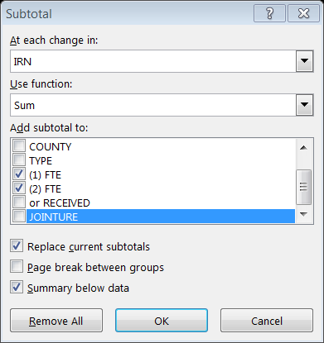

The results should look like this.



You now need to enter the STUDENT FTE (first FTE column) into column X of the SFPR tab. The easiest way to do this is by clicking on box 2 in the left hand corner next to column A and row 1. This will give you a total for each IRN and this should make it easier to copy each IRN total by holding the control key down while you copy each individual cell over to the SFPR tab. 

Next go through the same steps for “Open Enrollment In” students.

The difference between the grand total you come up with and the “STUDENT FTE IN & OUT” on the SFPR will be the total CT’s you have either coming in or going out.

The “Other Adjustments” is your special ed and vocational contract students. Many of you will not even have this. If you do, you will want to copy that data over into the “Other” tab just like you did with the community school and open enrollment data. Next sort the data by the Status code and separate the SEs from the VECs. Use the same procedures for subtotaling and bringing the data into the SFPR tab as you used for open enrollment.

On the SFPR tab of the reconciliation spreadsheet scroll down past the Special Ed-Other Out and Voed-Other Out. You will find the BDD adjustment. You will need to enter your state share index into the orange colored cell for category 1. The total should match your BDD adjustment on the “Other Adjustments” report if you have an adjustment.

In order to verify your VE Services Adjustment go to the Other tab in the reconciliation spreadsheet and enter your state share index into cell O2.

**Phase Two:**

Open your FTE Detail Report. It should have one tab, and in that tab columns A to AK. **Stop**. Was the last column AK. If the last column is not AK the reconciliation may not work. It means that the detail report has changed and the reconciliation may need to be modified.

Place your cursor in cell B3, click on Sort and Filter and choose filter. Click on the “VIEW” menu at the top of the spreadsheet. Click on Freeze panes and choose “Freeze Top Row”. Now scroll to the very last row of this worksheet. Let’s say there are 4,140 rows. Go to cell column Q row 4,142 and put in the following formula =subtotal(9,Q2:Q4140). You can now filter any criteria you want and the number of Adj FTE’s for that criteria will subtotal. You are now going to copy the FTE detail report into the “FTE Detail” tab in the reconciliation workbook. Once you do that save the original FTE Detail report. I would recommend saving it in an FTE detail report folder and name it the date that you created it.

The reconciliation workbook should have populated with the FTE details. Variances between the FTE detail and the SFPR should be showing up in column Y. You may be wondering why there are nineteen columns between D and V and some have numbers and some don’t. If you hover your mouse over D5 there is a comment in that cell that will read “Regular/Other District and Regular JVSD”. Each cell from D5 to V5 has a description of the type of student being captured in that column. In most cases the columns with the highest FTE count will be RGJV, COMM (Community School FTE), and OPDD (Open Enrollment).

Let’s look at the FTE detail report to see what column combinations created the FTEs. Currently there are 37 columns from A to AK. Of those 37, I am using some combination of eleven of them to populate the reconciliation spreadsheet. Those eleven are:



Each cell being calculated at the minimum looks at the IRN in cell B4 of the SFPR tab to find a match in column A, I, or R of the FTE Detail tab. It then matches the Fund pattern code in row 5 of the SFPR to column M in the FTE Detail. If there is a match it adds the FTE amount in Column Q of the FTE Detail.

Some cell calculations will only include FTE INCL CODE FULL or PART in column AC of the FTE detail, some will include both. If a cell calculation is only looking at FULL or PART only, it will reference column AC in the calculation. Example; cell D8 (a3-Total ADM of the SFPR) includes both FULL and PART FTEs in order to capture both regular students and those going to the JVS. Cell D10 (a5-Jointure JVS ADM) adds the AC reference, PART, to capture only those students going to the JVS. The remaining cell calculations in column D use the FTE INCL CODE FULL because those lines of the SFPR do not include the JVS FTE component. The JVS receives the special ed, LEP, or economically disadvantaged funding for those students.

Your special education (SFPR b1 – b6), Limited English Proficient “LEP” SFPR d1 – d3), and economically disadvantaged (SFPR e10 and e12), funding lines look at columns Y (SPECED CAT CODE), X (ECON DISADV FLAG), and AB (LEP CODE), in the FTE Detail tab respectively. LEP lines also look at column AH (LEA Type) and only captures “B&M Comm” because Community e-schools do not receive LEP funding.

This is a good time to remind you that in addition to not receiving LEP funding, e-schools do not receive K-3 literacy funding, targeted assistance, economically disadvantaged, or gifted intervention and coordinator funding.

The e-school student “does” generate funding for gifted identification and capacity aid because those formulas use formula ADM from line a1.

“Open enrollment out” students require a FTE INCL CODE “FULL” to be used. The “open enrollment in” students require a FTE INCL CODE “NONE”.

Pre-school funding includes fund pattern codes PSRD, PSEN, PSNR, PSOP, PSET, PBDD, PSON, PSIN, PSOT, and PSIT. These are your special ed category students that get funded and a have a FTE INCL CODE of FULL. Pre-school students coded with a PBDD are educated by the County Board of Disabilities. You will have a deduct for these students in “Other Adjustments” coded “BDD Adjustment”. I have included a reconciliation for this at the bottom of the reconciliation. Pre-school students coded with a NFRG do not have a special ed category and have a FTE INCL CODE of NONE.

When reconciling community school students remember that STEM schools are included with Community Schools on the SFPR deduction summary report. If you have a STEM school, it will have an asterisk next to the name.

When you reconcile Open Enrollment you have to be aware that the SFPR Open Enrollment report does not show the IRN for students attending a JVS, it shows the IRN of the pass through school. It will show those FTEs like this;



You will need to add the IRN numbers of the JVS to your spreadsheet in order to capture those students from the FTE Detail. Tab “IRN” includes all the IRN numbers for JVSDs for you. The jointure Y students (IRN 48397) will show up under FTE Pattern Code OJVR in both lines a2 and a4. Just like the RGJV students that are on line a4 they will not generate FTEs for special ed, disadvantaged youth or LEP. The jointure N student (IRN 50252) will show up as OPID student on line a2. They do not show up on line a4 or line a5. .2 will go to the traditional school and .8 to the JVS.

Special Ed co-op student are coded SPCO. SPCO students who are resident but are leaving the district are differentiated by having a **FULL** in the FTE INCL CODE. Those students are funded normally. The “Other Adjustments” report on the SFPR will show these students as a deduct with the funds going to the district that has the co-op program. If your district has a co-op program, you will find the students coming to your district under SPCO with a FTE INCL CODE of **NONE**. Under the SFPR “Other Adjustments” report these students will be added to your revenue. The adjustments will look like this:



The formula for a SPCO student is (ADM*6,000)+(ADM*Category weight). The above calculations look like this:



Vocational contract students are coded as CTID, CTVC, and CTOP. Students who are resident but are leaving the district are differentiated by having a **FULL** in the FTE INCL CODE. Those students are funded normally. The “Other Adjustments” report on the SFPR will show these students as a deduct with the funds going to the district that has the contract program. If your district is accepting contract career tech students, you will find the students coming to your district under CTID, CTVC, and CTOP with a FTE INCL CODE of **NONE**. Career tech students will also have a corresponding weight associated with those students and it will be calculated separately with a “CTA1” through “CTA5” code.

In the “Other Adjustments” you may also have a **BDD ADJUSTMENT,** this was mentioned earlier and is for your pre-school students attending a Board of Disabilities school.

**CTE Reconciliation**

The CTE detail can be found in the data collector. For FY17 the manifest code is 2017L1S2R. I recommend saving this spreadsheet separately from the reconciliation. You will find 20 columns, A to T, of data when you open this spreadsheet. The number of rows will vary by District. You will have a separate line for each career ed class a student takes. Go to cell N2. It will have a =” followed by 1 through 5 and “. We will get rid of the =” and the “ in two steps. Highlight column N. Click on “Find and Select”, then click on replace all. Make sure you have column N only highlighted. If you don’t select an area it will replace every =” on the spreadsheet and you do not want that to happen. Type =” in the Find what and leave the Replace with blank just like below.

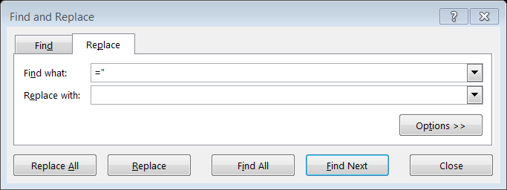

Click on Replace All. Once they have been replaced do the same step but just use “

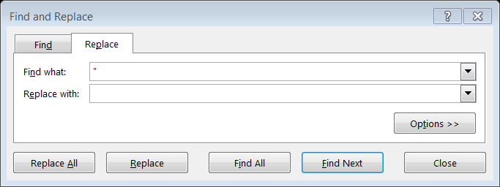

Next go to cell B2 and click on Sort and Filter, then click filter. Freeze the top row by clicking on view, then click freeze panes, lastly click on freeze top row. Click on the filter drop down box in column D, local classroom code, and click sort “A to Z”. You now have all the classes sequentially. I would then put a subtotal for most of the columns. Assuming the class data goes down to row 250 and you want a subtotal for column E the formula would be =subtotal(9,e3:e250). Now you can do different filters and the subtotal will change automatically.

You may want to add a couple of more tabs. Name one, “class”, the other “student”. Copy the entire data from the original download into both tabs. Sort the class code by column D and then subtotal column L and M by the classroom code. You can subtotal by “Sum” or “Count” depending on what you want to verify. This will give you your classroom roster that could be easily verified. Next go to your student tab and sort by SSID. This will allow you to check each students’ classes. Most traditional districts will not have many lines per student but JVSDs will have considerably more.

Now copy all the information from the original CTE download into the CTE detail tab of the reconciliation spreadsheet. Next, copy all of the class codes from “column D” in the CTE detail tab to cell A3 in the CTE analysis tab of the SFPR reconciliation. Go to Data and click on remove duplicates. You will be left with a single entry for each class. Most traditional districts won’t have more than 50 rows, if you are a JVSD or a large urban you may have over 1,000 rows.

In the CTE analysis tab copy the formula from column B, row 3 to column Y, row 3 as far down as you need for the classes you have. Go to cell AE3 and enter your state share index. You now have detailed information on each class that was offered. You have how many CTEs were generated by your resident students in column E, your “open enrolled in” CTEs in column F, and your “other in” CTEs in column G. You can also see how much funding a class generated in column I as well as how many students were in the class in column J. Column L tells you when the course started and ended. Column M through W shows how many students were in the different fund pattern codes. Put your cursor in cell B3, click on view, freeze panes, and then click freeze panes. You may also want to put subtotals at the bottom of selected columns.

As of this writing the CTE detail lists every student your district educated in a career tech class. It does not include “open enrolled out”, “other out”, or community school student CTEs. As you are aware those CTEs are included in lines C1 through C5 of the SFPR detail worksheet. These numbers are readily available to you on the open enrollment report, other adjustments report, and the community school deduction report. You will want to enter the open enrollment out CTEs in cells AE12 through AE16. The open enrollment out CTE show up as a negative adjustment on the report example shown below.



The “Other” out CTEs can be found on the Other Adjustments report. You should have already copied this data into the “other” tab on the reconciliation spreadsheet when you were doing the FTE reconciliation. If you have not subtotaled them, please do so now. Enter those CTEs in cells AF12 through AF16.

You will find the community school CTE data on the last page of the community school deduction report under school “All”. It will be the amounts in line C1 through C5. Enter these amounts in cells AG12 through AG16.

Next enter the CTEs from the SFPR worksheet you are reconciling into cells AI12 through AI16. You can now see the difference between the CTE detail report and the SFPR. Next, enter your state share index into cell AE3 and the projected funding from the CTE detail report will be shown in column AK.

Enter the positive Open Enrollment CTE adjustments from the Open Enrollment report into cells AE23 through AE27 and the positive Other CTE adjustments from the Other report into cells AE32 through AE36.

Congratulations, you are done ☺ the next time it will be much easier!