**FY17 Career Ed FTE and CTE detail to SFPR reconciliation**

There is not a required way to use the FTE detail report. This is one suggestion on how to reconcile it to your SFPR. Please use as best meets your need. CTE reconciliation is still a work in progress and when it comes out will be a separate set of instructions.

**Phase One:**

This document is a work in progress. When updates occur to the FTE Detail these directions will change.

Open your foundation funding report on the ODE website. Choose the period you want to reconcile such as Oct. Choose your district and click on three reports; 1) JVS SFPR Payment Report Detail 2) Open Enrollment 3) Other Adjustments.

Open your reconciliation workbook. It should open to the SFPR tab, if not, click on the SFPR tab. In cell B4 enter your IRN number. Make sure your District name shows up in cell C4!! Go to cell N4 and put the Month for the period you are reconciling. Enter the FTE’s from the ODE Foundation “Detail” report for cells O6, O8 to O13, O15 to O19, O21 to O23, and O25.

Go to the foundation funding report. Copy the Open Enrollment Data into the reconciliation workbook tab OE. Copy into cell A1 and do a text to column. Click on Data, Text to Columns, choose fixed width and then go through the steps. You may have to move the line separators around. The end result should look like below:



Sort Column “Type”, “Z-A” sort order. The CT’s will be at the bottom. Add three empty rows between the bottom JVSD and the first CT code. Then copy the heading in row one directly above the first row of the CTs. That section should look like this once you have finished copying.



Next go to cell A3 and sort the IRN smallest to largest. Copy the IRNs from this group into cell L1. Go to the Data tab and choose “Remove Duplicates”. A message box will pop and tell you “XX duplicate values found and removed; Y unique values remain”. The results will look like below.



Obviously everyone will have different numbers of duplicate values and unique values.

You will then copy the unique IRN values to the SFPR tab placing them beginning in cell B31 reserved for Open Enrolled In IRNs. Before you copy please make sure you have enough rows to accommodate the data you are moving. If there are not enough rows simply add the number that you need and copy the formulas sown that you need.

Next you will need to subtotal the open enrollment FTEs by IRN. Place your cursor in cell A4. Click on the Data tab and choose Subtotal on the far right. A box will open that should look like this:

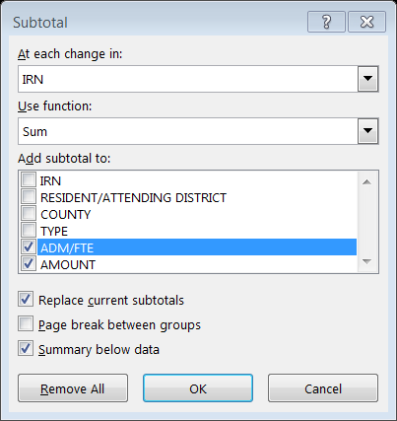

Make sure that you choose the “Sum” function. The result should look like this:



You now need to enter the ADM/FTE into column O of the SFPR tab starting in cell O31. The easiest way to do this is by clicking on box 2 in the left hand corner next to column A and row 1. This will give you a total for each IRN and this should make it easier to copy each IRN total by holding the control key down while you copy each individual cell over to the SFPR tab.



The next step is “Other Adjustments”. The “Other Adjustments” is your special ed and vocational contract students. Some of you may not have this. If you do, you will want to copy that data over into the “Other” tab just like you did with the open enrollment data. Go to the data tab, click on text to columns, go through the steps and your result will look like this.



Sort the data by TYPE, Z to A. This will be your result.



Delete the rows with no STATUS, etc. Insert three rows between the last SE or OTH, TYPE code. Copy the first row label above the first CTA row. Sort column A, A to Z. Insert a new column in A and label it IRN. You will need to look up the IRN numbers in the IRN tab and enter them. You will need to sort this data a second time by IRN number. Copy the results to column J, click on data, then click on remove duplicates. Copy the unique IRN numbers to the first row under “VOED-Other In” beneath the “Other adjustments” in the SFPR tab. Copy the formulas down as far as you need. Go back to the Other tab and subtotal by IRN. Copy the FTE total by district to the SFPR tab, column P.

**Phase Two:**

Open your FTE Detail Report. It should have one tab, and in that tab columns A to AL. **Stop**. Was the last column AL. Columns were increased to AL on or around May 12, 2017. If the last column is not AL the reconciliation may not work. It means that the detail report has changed and the reconciliation may need to be modified.

Place your cursor in cell B3, click on Sort and Filter and choose filter. Click on the “VIEW” menu at the top of the spreadsheet. Click on Freeze panes and choose “Freeze Top Row”. Now scroll to the very last row of this worksheet. Let’s say there are 4,140 rows. Go to cell column Q row 4,142 and put in the following formula =subtotal(9,Q2:Q4140). You can now filter any criteria you want and the number of Adj FTE’s for that criteria will subtotal. You are now going to copy the FTE detail report into the “FTE Detail” tab in the reconciliation workbook. Once you do that save the original FTE Detail report. I would recommend saving it in an FTE detail report folder and name it the date that you created it.

The reconciliation workbook should have populated with the FTE details. Variances between the FTE detail and the SFPR should be showing up in column P. You may be wondering why there are ten columns between D and M and some have numbers and some don’t. If you hover your mouse over D5 there is a comment in that cell that will read “Regular/Other District and Regular JVSD”. Each cell from D5 to M5 has a description of the type of student being captured in that column. In most cases the columns with the highest FTE count will be RGJV.

Let’s look at the FTE detail report to see what column combinations created the FTEs. Currently there are 38 columns from A to AL. Of those 38 I am using some combination of twelve of them to populate the reconciliation spreadsheet. Those twelve are:



Each cell being calculated at the minimum looks at the IRN in cell B4 of the SFPR tab to find a match in column A, I, or S of the FTE Detail tab. It then matches the Fund pattern code in row 5 of the SFPR to column M in the FTE Detail. If there is a match it adds the FTE amount in Column Q of the FTE Detail.

Some cell calculations will only include FTE INCL CODE FULL or PART in column AD of the FTE detail, some will include both. If a cell calculation is only looking at FULL or PART only, it will reference column AD in the calculation.

Your special education (SFPR b1 – b6), Limited English Proficient “LEP” SFPR d1 – d3), and economically disadvantaged (SFPR e1 and e2), funding lines look at columns AA (SPECED CAT CODE), AB(ECON DISADV FLAG), and AC (LEP CODE), in the FTE Detail tab respectively.

**CTE Reconciliation**

The CTE detail can be found in the data collector. For FY17 the manifest code is 2017L1S2R. I recommend saving this spreadsheet separately from the reconciliation. You will find 20 columns, A to T, of data when you open this spreadsheet. The number of rows will vary by District. You will have a separate line for each career ed class a student takes. Go to cell N2. It will have a =” followed by 1 through 5 and “. We will get rid of the =” and the “ in two steps. Highlight column N. Click on “Find and Select”, then click on replace all. Make sure you have column N only highlighted. If you don’t select an area it will replace every =” on the spreadsheet and you do not want that to happen. Type =” in the Find what and leave the Replace with blank just like below.

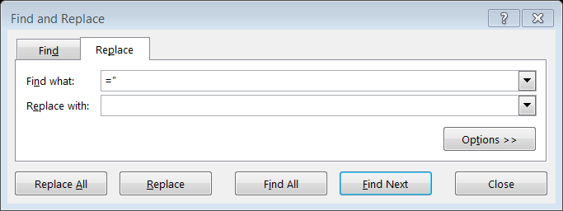

Click on Replace All. Once they have been replaced do the same step but just use “

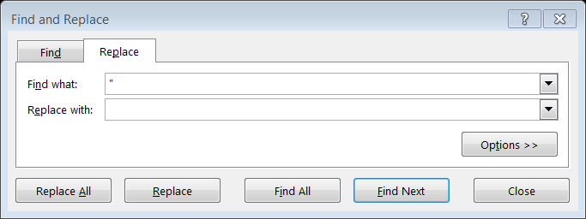

Next go to cell B2 and click on Sort and Filter, then click filter. Freeze the top row by clicking on view, then click freeze panes, lastly click on freeze top row. Click on the filter drop down box in column D, local classroom code, and click sort “A to Z”. You now have all the classes grouped together. I would then put a subtotal for most of the columns. Assuming the class data goes down to row 250 and you want a subtotal for column E the formula would be =subtotal(9,e3:e250). Now you can do different filters and the subtotal will change automatically.

You may want to add a couple of more tabs. Name one, “class”, the other “student”. Copy the entire data from the original download into both tabs. Sort the class code by column D and then subtotal column L and M by the classroom code. You can subtotal by “Sum” or “Count” depending on what you want to verify. This will give you your classroom roster that could be easily verified. Next go to your student tab and sort by SSID. This will allow you to check each students’ classes. Most traditional districts will not have many lines per student but JVSDs will have considerably more.

Now copy all the information from the original CTE download into the CTE detail tab of the reconciliation spreadsheet. Next, copy all of the class codes from “column D” in the CTE detail tab to cell A3 in the CTE analysis tab of the SFPR reconciliation. Go to Data and click on remove duplicates. You will be left with a single entry for each class. Most traditional districts won’t have more than 50 rows, if you are a JVSD or a large urban you may have over 1,000 rows.

In the CTE analysis tab copy the formula from column B, row 3 to column Y, row 3 as far down as you need for the classes you have. Go to cell AE3 and enter your state share index. You now have detailed information on each class that was offered. You have how many CTEs were generated by your resident students in column E, your open enrolled CTEs in column F, and your “other” CTEs in column G. You can also see how much funding a class generated in column I as well as how many students were in the class in column J. Column L tells you when the course started and ended. Column M through W shows how many students were in the different fund pattern codes. Put your cursor in cell B3, click on view, freeze panes, and then click freeze panes. You may also want to put subtotals at the bottom of selected columns.

Enter the FTEs in C1-C5 from the SFPR detail worksheet report to cells AE12 down to AE16 of the CTE analysis tab. In column AF the difference between the CTE detail and the SFPR will show. Next enter the open enrollment CTEs from the JVS open enrollment report into cells AE23 – AE27. They are at the bottom of the open enrollment report and look like the example below.



The “Other” CTEs can be found on the Other Adjustments report. You should have already copied this data into the “other” tab on the reconciliation spreadsheet when you were doing the FTE reconciliation. If you have not subtotaled them, please do so now. Enter those CTEs in cells AE32 – AE36.

**In Seat**

This tab was created for traditional districts because their detail report included students being educated elsewhere. This is not the case for a career tech center. It was included for career tech schools so that you could see your student counts by grade level and special education disability. It includes all students being educated by you.