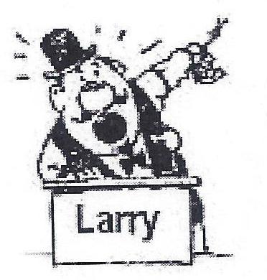 SCHOOL CLOSING AUCTION 
DEFIANCE CITY HIGH SCHOOL

2 – DAY SALE
FRIDAY 1-12-18, 10:00 AM and SATURDAY 1-13-18, 10:00 AM
Running 2 Rings Both Days

LOCATION: 1755 Palmer Dr, Defiance, OH 43512

OPEN HOUSE January 5, 2018
From 2:00 PM to 5:00 PM to view items

AUCTIONEER’S NOTE: Defiance City Schools has built a new Senior High School and will be offering the contents of the “Old” school at public auction. We will be auctioning to the “Bare” walls including doors, but no jams. There will be days, January 14, 16 & 17, to remove items (bring tools). Defiance City Schools and the Auction Team are not responsible for accidents. Announcements sale days take precedence over written material. Food & Restrooms available. Please go to auctionzip.com, auctioneer ID # 23656, for listing and photos or call Larry Plummer @ 419-782-3155

DAY ONE SELLING:

CAFETERIA EQUIPMENT: Including stoves – refrigerators, walk-in cooler, walk-in freezer, soup cookers, ovens, proofer cabinet, S.S. tables, S.S. tables/sinks, S.S. tray washer, hot tables, steam heater, convection systems, micro waves, Hobart mixers, wall cabinets, cafeteria tables, plus racks and more, 3 unit refrigerator & freezer (side by side) 2 each.

WOOD & METAL SHOP & MAINTENANCE SHOP EQUIPMENT: Including 4 maple top work benches, bench bandsaw, 6 bench drill presses, large wood bandsaw, bench grinders, table router, Index horizontal mill, large Fosdick floor drill press, large DoAll metal bandsaw, large anvil/base-welder, (new) metal pipe tubing, L’s, some rough sawed wood, maple hutch cabinet, refrigerator, CAD drafting tables & cabinets, plus more cabinets and racks.

GYM EQUIPMENT: Including 6 basketball backstops, all the powered fold-up bleachers, gym floor to sell and other equipment.

CHEMISTRY & LAB EQUIPMENT: Maple cabinets/exhaust hoods, maple tables, shelving, oscilloscopes, test equipment, air compressor, scales and balances.

HOME ECONOMICS EQUIPMENT: 6 Electric ranges, 6 micro waves, 4 refrigerators/freezers, 4 washers & dryers, 13 Janome sewing machines/cabinets, kitchen cabinets.

LIBRARY: Overhead ceiling projectors/wall screens, 6 home theater systems, Peavey PA system, lots of bookshelves, computer tables & chairs, white wall cabinets.

BAND & MUSIC ROOMS: all stands, chairs (40), etc. - No music instruments

DAY TWO SELLING:

All 1st & 2nd floor classrooms and equipment, student desks (500), teachers desks (50), blue chairs (90), audio & Video equipment, cabinets, white boards, chalk boards, cork boards, office areas and equipment, 1300 hall lockers (2 styles). Aluminum Flag pole, 2 skid sheds - 1 on slab

AUCTION TERMS: Cash or good check with proper ID on day of sale. No out of state checks unless pre-approved.

AUCTIONEERS: Larry L. Plummer – 419-782-3155 and Dan Baker (Tedrow) assisting.

