**Steps for New FIRE TCC Applicants**

The new IR Application for TCC is available on the FIRE page.

* If you have Secure Access credentials from applications such as e-Services, enter your existing Secure Access username and password in the IR Application for TCC.
* **If you don’t have** Secure Access credentials, complete the Secure Access process to create an account. See [Secure Access: How to Register for Certain Online Self-Help Tools](https://www.irs.gov/privacy-disclosure/secure-access-how-to-register-for-certain-online-self-help-tools) for more information.
* You must create a 5-digit PIN to sign the application.
* The IRS lets you access most tax tools with one account the same login and password.

Often, a TCC applicant will already have an IRS E-Services account with “Secure Access” authentication already set up (upon sign-in, a 6-digit security code is texted to your cell phone). If you do not already have an IRS account with Secure Access, you will have to CREATE an account with “ID.me” before acquiring a TCC (see Step 2 below). Refer to this IRS instructional webpage: <https://www.irs.gov/tax-professionals/fire-system-update-improving-the-process-and-security-for-information-return-ir-application-for-transmitter-control-code-tcc>.

The following IRS Tutorial webpage (for e-File Applications) will also provide practical information.  Although the Tutorial is not specific to the IR application, many of the IRS rules, application procedure, description of organization roles (e.g.,"Responsible Officials"), etc. are similar: <https://la2.www4.irs.gov/PeopleBooks/CRMPROD/Training/esam/eFile/index.html#creating-your-app>

If you have any questions, call the IRS FIRE System phone number at (866) 455-7438. Click [here](https://www.irs.gov/tax-professionals/fire-system-update-improving-the-process-and-security-for-information-return-ir-application-for-transmitter-control-code-tcc) for additional information.

**Acquiring a TCC**

1. Go to [IR Application for TCC](https://www.irs.gov/e-file-providers/filing-information-returns-electronically-fire). Click *Access IR Application for TCC*.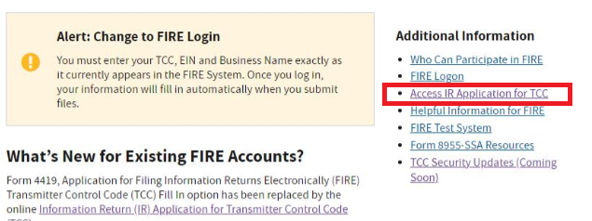
2. Login either with your irs.gov E-Services User Name and Password or ID.me User email and Password.

Note that the “Create a new account” option is for a new ID.me account—not a new IR application.

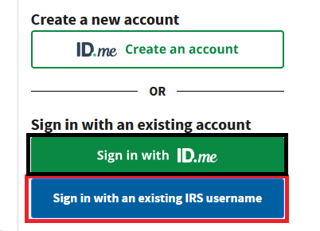

Note that while you can still Login (“Sign in”) with your existing IRS E-Services username, the IRS is encouraging (and may later require) Login with the new “ID.me” User email and Password. If you choose to Create a new “ID.me” account at this time, be aware that it can sometimes be a lengthy process.

Note that technical difficulties are not uncommon when creating an ID.me account. If you have phone camara difficulties under "Self-Service," choosing Video Chat Agent" is an option. Help links can also be found at the [ID.me Help Center](https://help.id.me/hc/en-us).

If you choose to Sign in with your existing IRS username, enter your IRS E-Services User Name next:

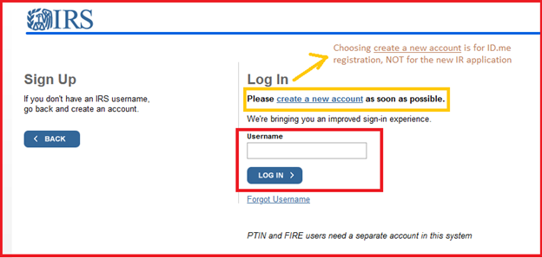

On the next screens, enter your IRS E-Services Password, the Security Code required, and continue past your login history.

If you signed in with your “ID.me” User Email and Password, you will also enter the Security Code required, and then continue past your login history.

1. **Select Individual**.

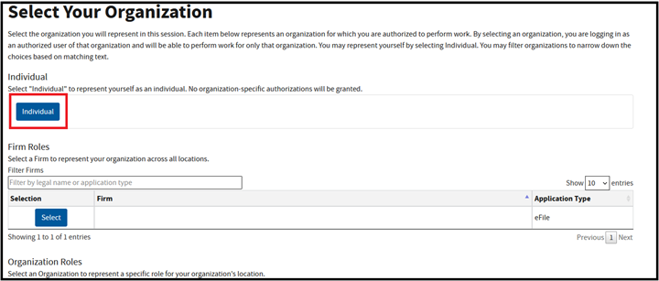

The External Services Authorization Management webpage will open.

1. Click **New Application** and then **IR Application for TCC**.

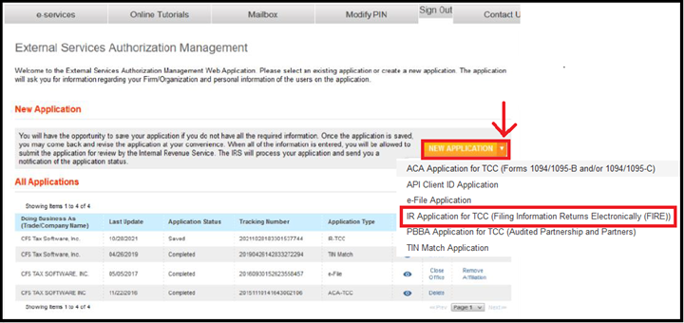

1. .Fill out the form and click **Continue**.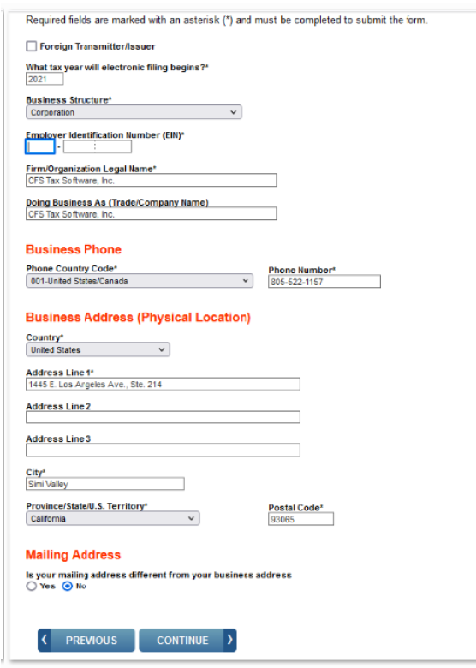

Important: Take note of the EXACT way you are entering your Firm/Organization Legal Name. It must be the same as associated with your EIN, and can ONLY include the following punctuation/symbols: ampersand (&), period(s) and comma(s). Some applicants omit periods and commas associated with their EIN (they are not required on the IR application). However you enter your Firm/Organization Legal Name **on the IR application** must also be entered the exact same way when later registering and signing on to the IRS FIRE System. (The IRS FIRE System website is where 1099's and similar information forms are e-filed.)

1. Select the types of form(s) you will be submitting (note that 1099’s are included in the first selection). Click **ADD** to select whether you are a *Transmitter* or an *Issuer*. Then click *Continue*.

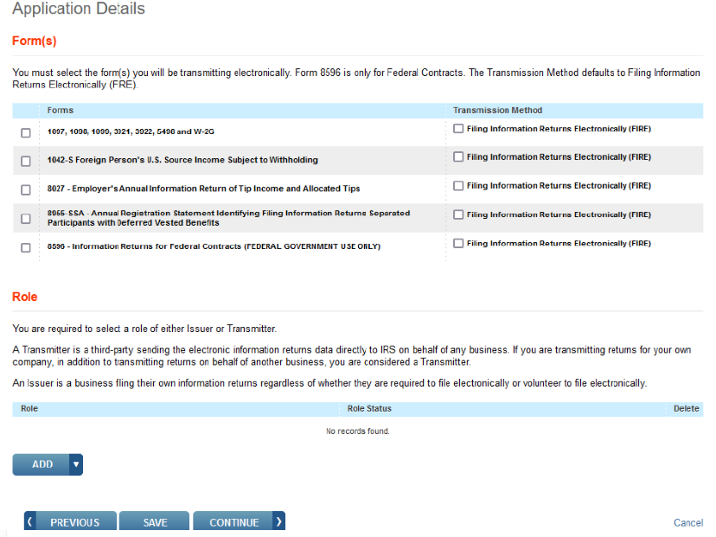

As you continue through Application Screens, you will add information regarding your “Responsible Officials” and “Contacts”. If you are a Sole Proprietor/Individual, only ONE Responsible Official and Contact are essential, whereas at least two are required for other Business Entities.

* 1. Add any application comments and click **Continue**.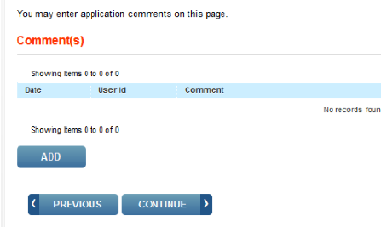
  2. Review the *Application Summary* and click **Continue** if it looks right.
  3. Check *I accept the terms of agreement*, input your PIN, and click **Submit**.

*IR Application* is subject to review before the approval to transmit electronically is granted and may require additional documentation at the request of the Internal Revenue Service (IRS).

When your *IR Application* for TCC is approved and processed, a five-character alphanumeric TCC is assigned to your business. An approval letter will be sent by U.S. Postal Service to the address listed when the IR Application for TCC was submitted, informing you of your TCC. Allow 45 days for processing, although if no additional information is needed by the IRS, it may be much faster. If you do not receive a TCC within 45 days, contact the IRS at (866) 455-7438.  
  
Your TCC will also be available to view online sooner than receiving the by mail approval letter. After logging in to your irs.gov E-Services account, on the *Select Organization* screen you may see an additional line selection: “(IR TCC) Your Business Name”. If not, select *Individual*. Then click on the *Eyeball Icon* to view your application, which will either contain your new TCC 5 digit number, or should show as *Submitted Pending Review*.

Unlike 941 e-filing, a test submission is not required by the FIRE System before

e-filing 1099’s.

**FIRE System Phone Support**

FIRE System Phone Support is called their “TSO line”.

Listen to all options before making your selection.

* Hours: Monday through Friday, 8:30A to 5:30P ET.
* 866-455-7438 (toll-free) this is the regular fire number
* 304-263-8700 (International) (Not toll-free)
* 304-579-4827 for Telecommunications Device for the Deaf (TDD) (Not toll-free)