# IRS requires existing TCC holders to complete the new IR application

The following is an announcement from the IRS:

Beginning September 2022, IRS will transition filers who received their FIRE Transmitter Control Codes (TCC) prior to September 26, 2021, to the new Information Returns Application for Transmitter Control Code (IR-TCC). As part of this transition, Form 4419, Revise Existing TCC for FIRE, will be phased out effective August 1, 2022. Your TCC will remain valid for use until August 1, 2023, after that date, any FIRE TCC that does not have a completed IR-TCC Application will be dropped and will not be available for e-file.

**What you need to do:**

* Beginning in September 2022, access the IR-TCC Application to submit your application and update your information.  
  Note: You will have to validate your identity using the latest IRS authentication process.
* If you do not plan to immediately complete the IR TCC application, you must take the following actions:
  + **By August 1, 2022**, ensure the information on your application (submitted via Form 4419) contains the current contact’s name, current email address and current telephone number. Also, please verify the company’s current legal name is correct (spelling, abbreviations, special characters and spacing) to match IRS records.  
    **IMPORTANT** - If your legal business name isn’t correct, you won’t be able to log into the FIRE System to file electronically. These changes must be **received** by August 1, 2022, to ensure the information can be updated timely. Once the transition is complete, the Form 4419, Revise Existing TCC for FIRE, will no longer be available. You’ll need to complete the online IR Application for TCC process to make updates to your application.
  + **By August 1, 2023**, you must complete the new IR-TCC Application process to continue to file electronically and retain use of your current TCC(s). If you complete the IR-TCC Application after this date you will be issued new TCC(s).

**__________________________________________________________________________________________________**

**If you need to access the IR application**

The IR application can be accessed at:

* <https://www.irs.gov/e-file-providers/filing-information-returns-electronically-fire>,
* ...then click the link for “Access IR Application for TCC.”

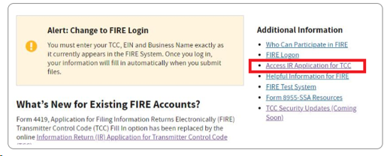

* Login either with your irs.gov E-Services User Name and Password *OR* ID.me User email and Password.

Note that the “Create a new account” option is for a new ID.me account—not a new IR application.

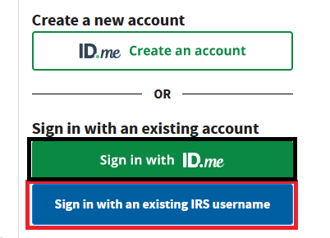

If you choose to Create a new “ID.me” account, be aware that it can sometimes be a lengthy process.

For more information on the IR application, see this article: <https://help.taxtools.com/article/sktq77vuha-applying-for-a-transmitter-control-code-tcc>.

More IRS information on TCC application process can be found here:

<https://www.irs.gov/tax-professionals/fire-system-update-improving-the-process-and-security-for-information-return-ir-application-for-transmitter-control-code-tcc>

Subscribe for the latest e-mail updates from the IRS at:

<https://www.irs.gov/businesses/qualified-intermediaries-qi-news>

After clicking the link just above, click Subscribe/Unsubscribe on the IRS webpage:

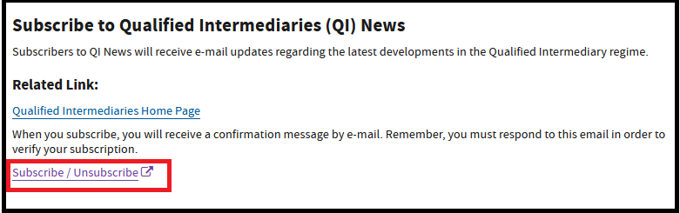

**How did we do?**

[IRS FIRE System is down for maintenance for a month every winter](https://help.taxtools.com/article/w2ci6qjy6p-irs-fire-system-is-down-for-maintenance-for-a-month-every-winter)

[Is the IRS website down?](https://help.taxtools.com/article/teh2hurpnk-is-the-irs-website-down)

**Related Articles:**

[Applying for a Transmitter Control Code (TCC)](https://help.taxtools.com/article/sktq77vuha-applying-for-a-transmitter-control-code-tcc)

[Is the IRS website down?](https://help.taxtools.com/article/teh2hurpnk-is-the-irs-website-down)

[Modifying Your IRS E-Services Application to E-file Forms 94X (Forms 941, 940, etc.)](https://help.taxtools.com/article/387v9iaorn-modifying-your-irs-e-file-application-to-e-file-forms-94-x)