### **Mass Change Compensation to Archive-True**

Archive Prior Year Compensations:

1. Core/Compensation - click on Contract Compensation tab
2. Make sure the grid includes
   1. Employee Number
   2. Last Name
   3. First Name
   4. Position Number
   5. Type - Contract
   6. Description - which should have contract period ex: 22-23 Teacher
   7. Compensation Code “Code”
   8. Archived - if you don’t see the header on your grid please find it in MORE.
3. Drag the header, Archived, to the center of the grid
4. Filter on Description - 22-23
5. **MOST IMPORTANT PART -** Click on REPORT button and run as an Excel-FieldName spreadsheet - this is important because if your mass change goes wrong, this is the only backup to restore your data back to before the mass change. We do not have a way to retrieve this information.
6. Click on Mass Change button
7. You will be in Maintenance Mode
8. Now go to Load Definition and select Archived Compensation
   1. In the Script definition you should see **archived** with a new value of **true**

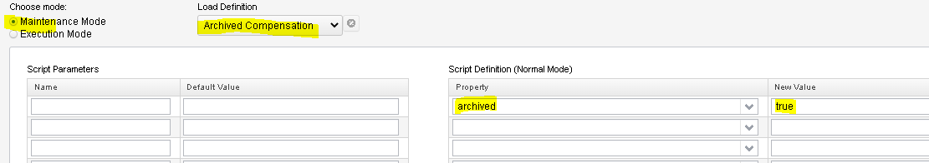

1. Click on EXECUTION MODE
   1. Verify the number of Compensations that are going to be modified, match the number of Compensations on your spreadsheet.
   2. Click Submit Mass Change button
   3. You will notice that all of the employees that were archived have been removed from the grid.

### **Mass Change Compensation to Archive True**

10. You have now completed your Mass Change to archive prior year compensations.

Please save the spreadsheet in the event you have EMIS errors that could occur because a compensation was archived too soon. This will be a good reference tool.

If you have any questions please email [helpfiscal@mveca.org](mailto:helpfiscal@mveca.org)

THANK YOU!!