### Changing Leave Accumulation from Daily to Hourly

Before changes are made.

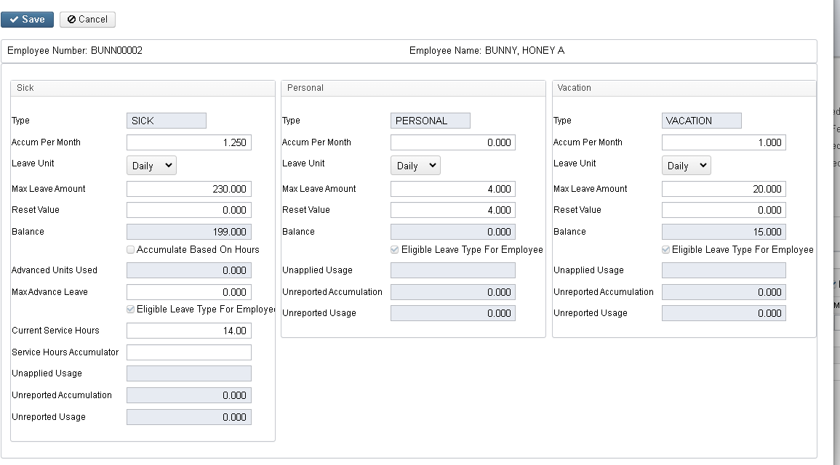

Change Leave Unit to Hourly for all eligible leave types - click Save. Don’t change any balances or accumulation amounts.

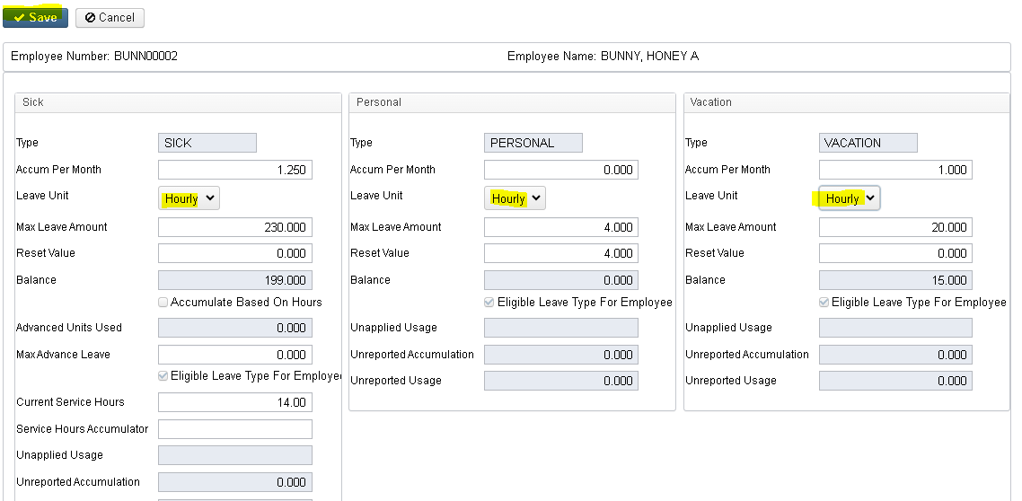

### Changing Leave Accumulation from Daily to Hourly

Next you will be prompted to enter Hours in Day, then click save

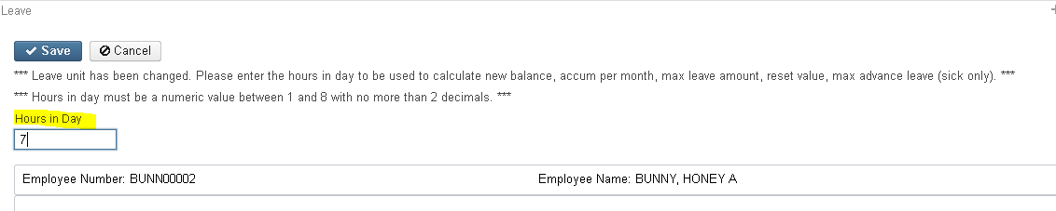

All of the Accumulations, Max Leave Amounts, Balances and reset values will be updated automatically to reflect hourly accumulations and balances.

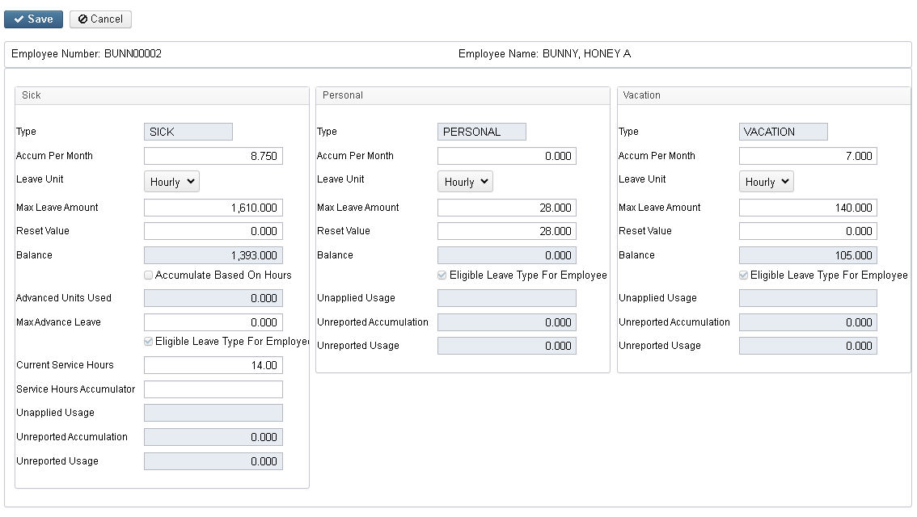

Note: This works exactly the same if you are changing from Hourly to Daily.