# **SSA to Change - How to Access BSO after March 25, 2023**

#### **Alert**

MVECA has acquired the information below to assist with updating your access and obtaining a verification code related to SSA/BSO. If you have any trouble getting through the process, please contact Social Security, the number is listed at the end of this document.

## On March 25, 2023, Social Security updated how you access a BSO account for the following services:

## Wage file upload

## W-2/W-2C online

## AccuWage online

## Social Security Number Verification Service (SSNVS)

## View wage report name/SSN errors

## BSO users will need a Social Security online account. You can use your personal

## ***my Social Security*** account that was created before September 18, 2021, or an existing [**Login.go**v](https://www.login.gov/contact/?utm_medium=email&utm_source=govdelivery) or [**ID.me**](https://help.id.me/hc/en-us?utm_medium=email&utm_source=govdelivery) credential.

## If you do not have a **Social Security online** account or a **Login.gov** or **ID.me** credential, you will need to create one from our [Social Security Sign in page](https://secure.ssa.gov/RIL/bso). This is a new requirement to access BSO employer services.

## Once the credentialing and authentication process has been completed, current BSO User ID(s) will be associated with your new credential.

## We appreciate your patience as we continue to enhance our system.

# **SSA to Change - How to Access BSO after March 25, 2023 continued**

# 

# Once you complete the verification process, you will receive a verification code in the mail at your home address.

## 

## 

## 

## 

## SSA/BSO Logging in After Receiving Verification Code 2023 continued

Go to SSA/BSO Login Website: <https://secure.ssa.gov/RIL/SiView.action?LVL=7&URL=/RIL/bso>

Click on either ***my Social Security*** account that was created before September 18, 2021, or an existing [**Login.go**v](https://www.login.gov/contact/?utm_medium=email&utm_source=govdelivery) or [**ID.me**](https://help.id.me/hc/en-us?utm_medium=email&utm_source=govdelivery) credential.

Then follow the prompts below.

1.

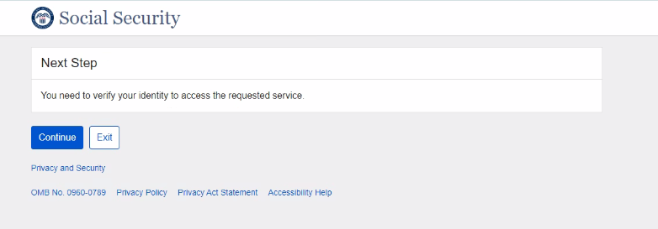

## 

## SSA/BSO Logging in After Receiving Verification Code 2023 continued

2.

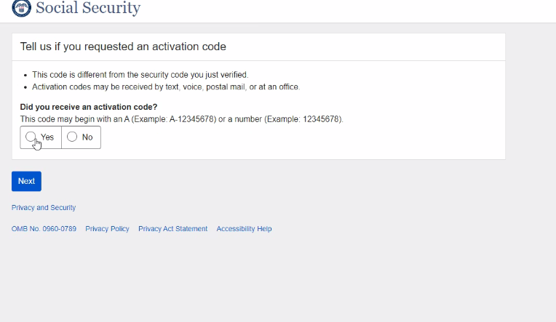

## SSA/BSO Logging in After Receiving Verification Code 2023 continued

3.

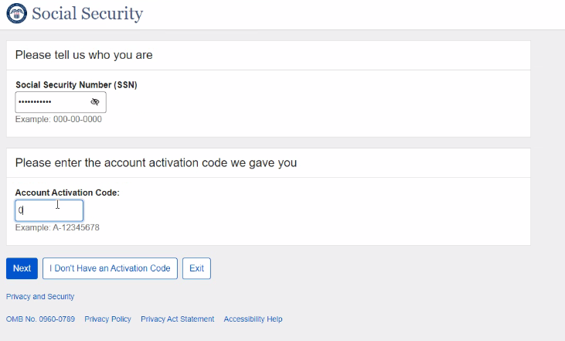

4.

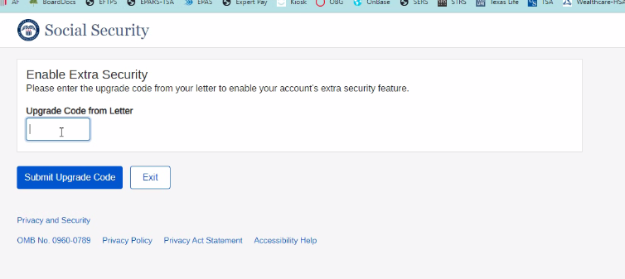

## SSA/BSO Logging in After Receiving Verification Code 2023 continued

5.

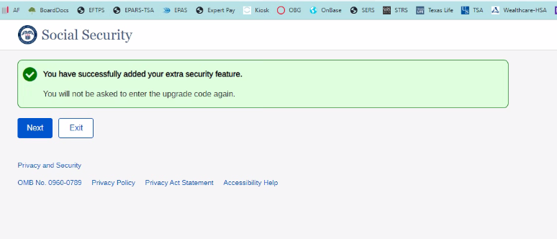

## SSA/BSO Logging in After Receiving Verification Code 2023 continued

6.

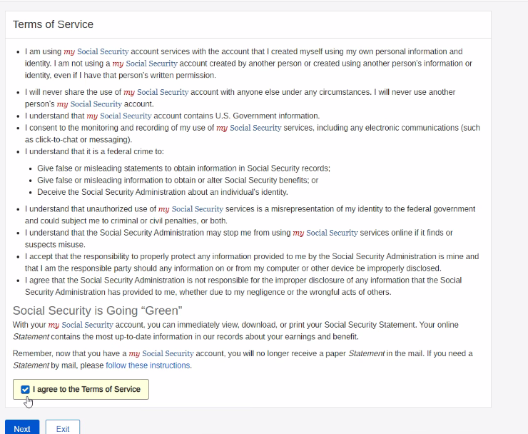

## SSA/BSO Logging in After Receiving Verification Code 2023 continued

7.

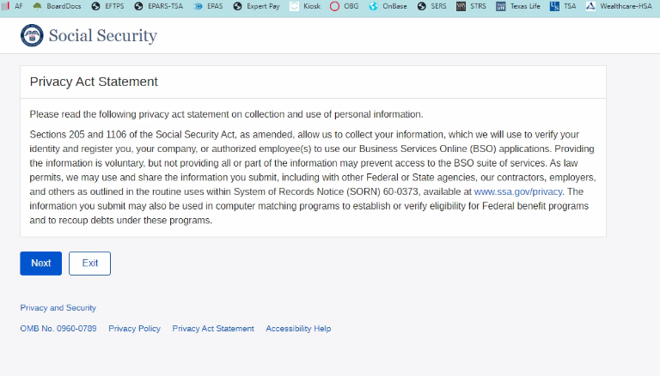

8. Go to SSA/BSO login website to log in as normal

<https://secure.ssa.gov/RIL/SiView.action?LVL=7&URL=/RIL/bso>

9. If you have questions please contact Social Security for further instructions

## **BSO hours**

Monday-Friday: 5 a.m. - 1 a.m. ET

Saturday: 5 a.m. - 11 p.m. ET

Sunday: 8 a.m. - 11:30 p.m. ET

**Questions or comments?**

Phone: 1-800-772-6270 (TTY 1-800-325-0778)

Monday-Friday: 7 a.m. - 7 p.m. ET