Log in to Ohio Business Gateway.
Select OH TAX eServices
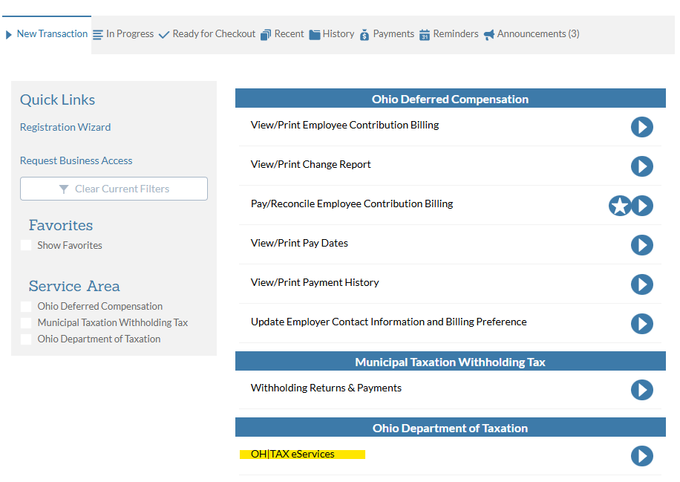

You will be taken to the screen below. Click on OH TAX eServices link.
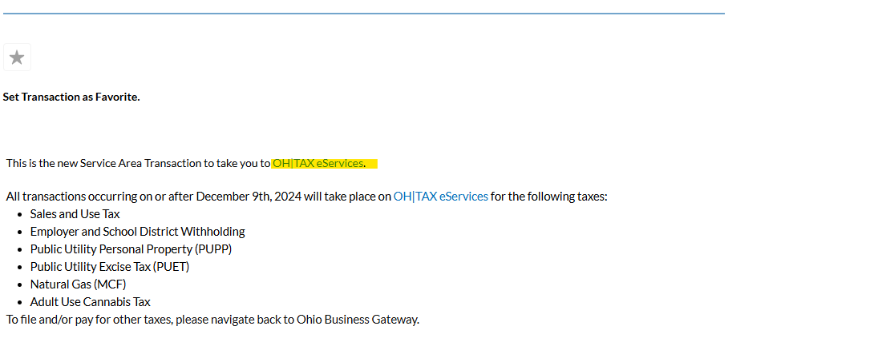

In the Section EMPLOYER’S PAYMENT OF OHIO TAX WITHHELD/Account section - click on MORE.
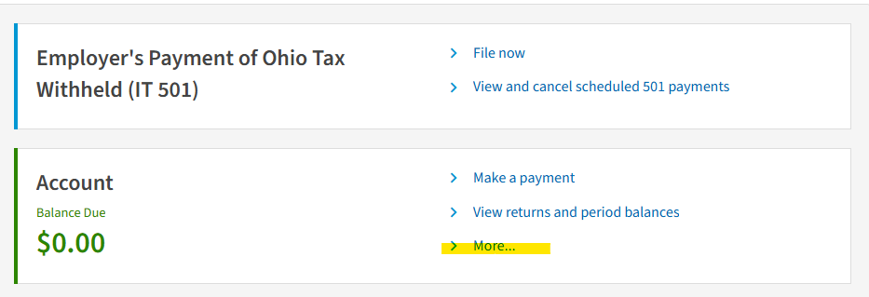

In this screen look for the field INCOME STATEMENT UPLOAD
Click on UPLOAD INCOME STATEMENT
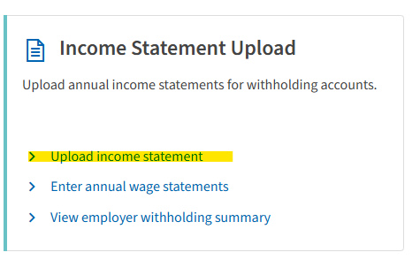

Find this section INCOME STATEMENT and click the carrot to view download options.
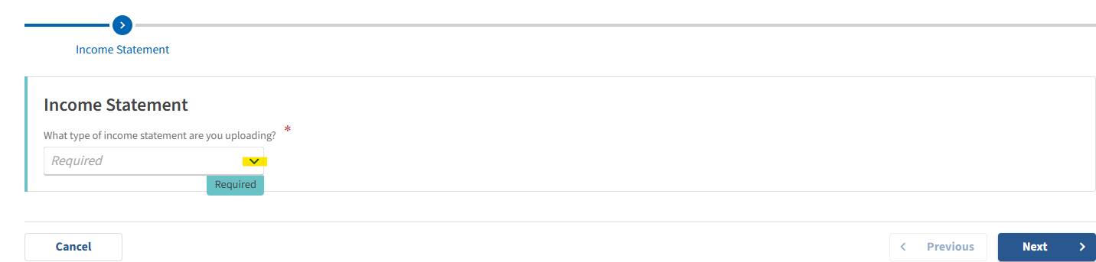

Select W2 then click NEXT
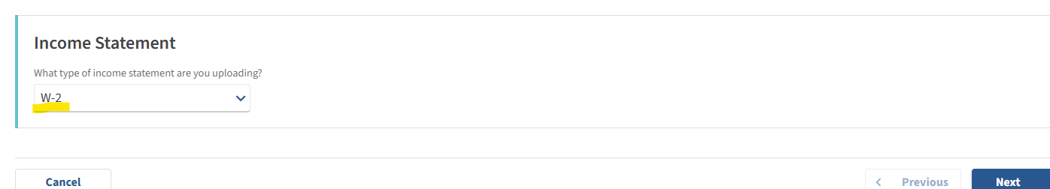

Click UPLOAD FILE button
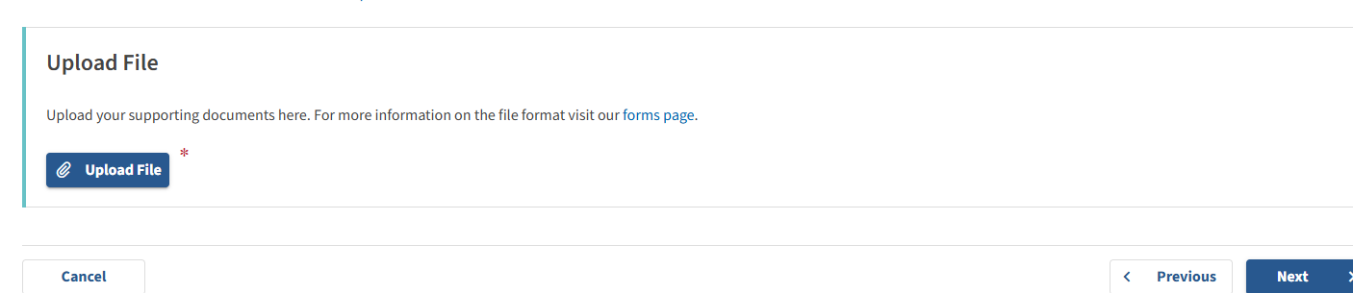

At this point you would have created your W2MAST_OH.txt file in USPS. Find the file in your downloads or desktop, where ever you saved it.
Choose the file and click OK.
Follow the upload instructions on the website from this point.

