

USPS: New Contracts-Import Option
New Contracts
If any employee's Compensation is Archived, the Compensation will not be included in New Contracts.
The New Contracts program is designed to calculate and update new contract information for employees. Features of the program include:
- The ability to build new contracts from existing contracts.
- Activate of pay account data.
- Activate data by pay group, contract start date, contract type (user-defined), appointment type, and calendar type.
- Multiple report sort options.
- Create Salary Notices
To ensure new contracts are calculated correctly, Job Calendars that apply to contracts must be in place before creating the new contracts.

Creating New Contract Compensations from Compensations
To create a template spreadsheet using the Compensations fields, which can assist in creating new contracts, you can import this json file into Reports > Report Manager - New Contract Compensation Worksheet.rpd-json (can specify start date and specific pay groups) With some manipulation to the spreadsheet this will then allow you to create new contracts using the Import option in Processing/ New Contracts. At this time, creating multiple Compensations for one Position in one load file is not available.
After the spreadsheet has been created, you can sort to obtain specific Pay Groups and remove all others if desired, or you can also sort the entire spreadsheet on Compensation Start and Compensation Stop Dates and then remove any records that will not require a new contract for the upcoming year.
The Excel file must be saved in .csv format for proper importing to take place in New Contracts.
**The CSV cannot have any " ' " symbols present. This would also be for any First or Last names with an apostrophe in it.**
The data under the column header contractType will need to be updated to 4. Also, any fields containing a TRUE or FALSE value need to be changed to a Y or N value for the import to successfully load.
After all manual changes Obligation, Amount, Start and Stop Dates, Contract Type, True/False to Y/N, etc. have been made to the spreadsheet, save it as a csv file for proper importing.
Sorting options are strictly the decision of the district and what data they wish to import into New Contracts.

Import New Contracts option.
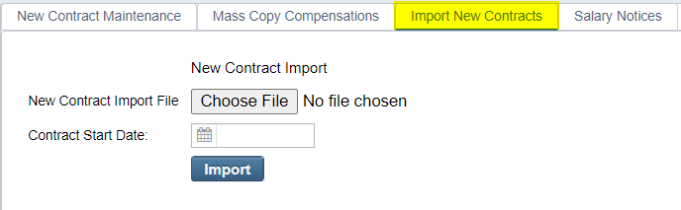
Click on to search for New Contract Import File
Contract Start Date field- This date can be used if a contract start date is not provided in the import file. This field can be left blank to pull in all New contracts.
Click on to Import the file into New Contract Maintenance option.
Click on the New Contract Maintenance tab to view imported new contracts.
To View/Edit New Contract, click on the view icon next to each contract.

Example of New Contract under New Contract Maintenance option:
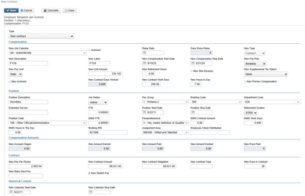

SSDT New Contract Payroll Accounts Report
The SSDT New Contract Payroll Account Report now includes the pay account for the new contract (if entered in the New Contract Maintenance grid), or if not entered in New Contract, it will use the payroll account(s) in the Payroll Accounts grid for the employee.
The report will only show Pay Accounts for New Contracts that are Active payroll accounts. **Active payroll accounts are when the payroll account status is Active or Maximum Amount in Effect. The Maximum pay amount must have its maximum > 0, and the historical amount paid to this account is less than the maximum amount. The charge/percent amount is not = 0, and the current date of running the report is between the pay account start and stop date **
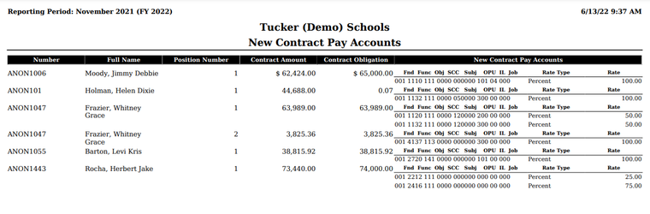
SSDT New Contract Summary Report
This report lists the data from New Contract maintenance. (summary)
Go to Reports > Report Manager > SSDT New Contract Summary to run.
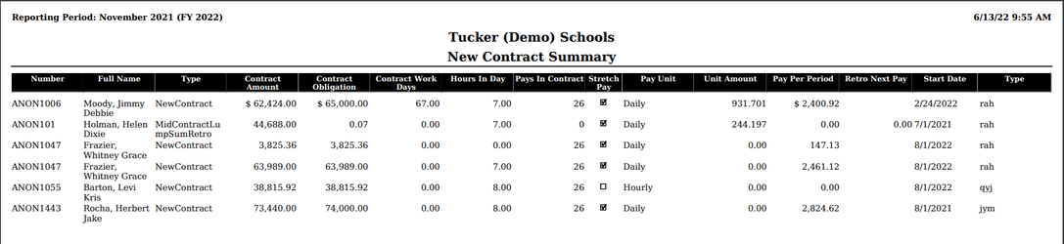
New Contract Report
This report lists the data from New Contract maintenance. (detail)Reports > New Contract Repo
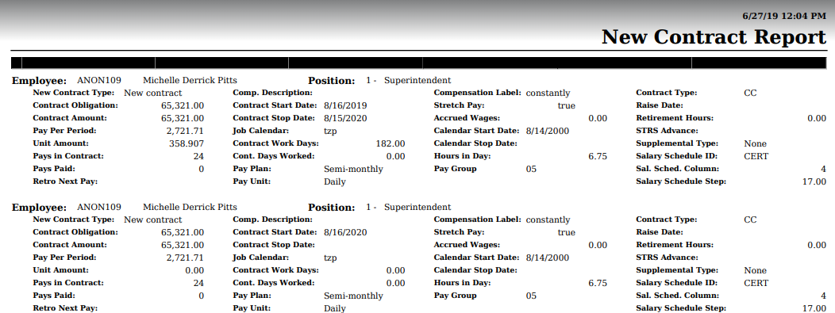

*Creating New Non-Contract Compensations
To create a new non-contract compensation record, the Reports/Report Manager/SSDT Non Contract Compensation Mass Load Extract can be processed to create an Excel file with the appropriate headers. The file can then be updated-removing unwanted records, updating unit amount, start/stop date, etc. Once the file has been updated, it will need to be saved in csv format. This will then allow the file to be loaded directly to Compensation. using Utilities/Mass Load/Compensation. *Email (helpfiscal@mveca.org) for help with proper headers.

