USPS COMP TIME PROCESSING

SSDT Comp Time Documentation Click Here
- Comp time Eligibility - Position Screen must be marked as True to "Eligible for Comp Time” (currently this is broken, ESS leave can be added even though the position is not set to Comp Time True. Waiting for a hotfix from SSDT)
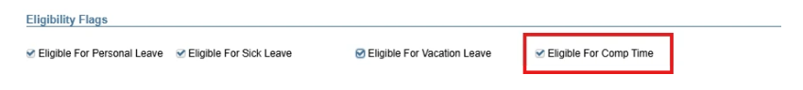

  - This allows comp time to be posted against the balance in the Attendance Screen
  - Comp Time Leave Unit must be the same as all other leave type daily/hourly)
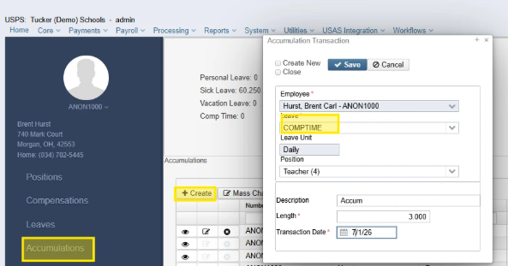

- Comp Time Leave can be mass loaded into the Attendance screen using Entity Type Attendance Journal (Absence Category CompTime)
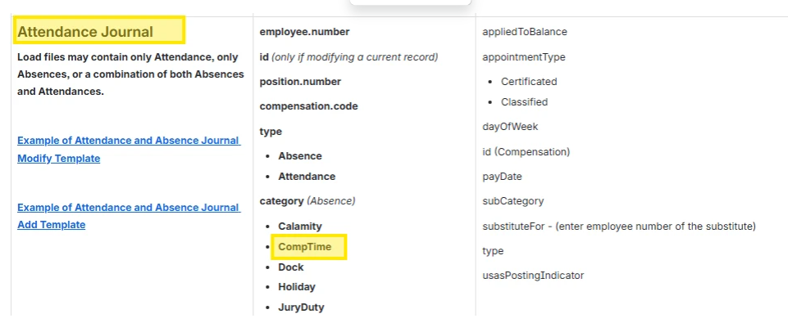

- Comp Time can be imported into the Attendance screen (CT Leave Type) using the same import spreadsheet used for Future/Current/Attendance.
  - Go To Utilities/Attendance/Absence Import option.
- Accumulations - Districts can accumulate Comp Time to track a Comp Time balance available to be used by the employee.
  - Accumulations can be added on the Employee Dashboard
  - Accumulations can be added in Core/Leaves/Accumulations
  - Accumulations can be mass loaded (Utilities/Mass Load)
- Job Calendars have been updated to include Comp Time
- Comp Time is on the Employee Dashboard with a total of unused Comp Time days or hours.
- Comp Time will display on default pay slips. Custom forms will need to be manually updated using “Merge Fields”
USE-COMP BAL
«compAdj»/«bal»

- REPORTS:
  - Comp Time will be included on the following reports
  - Attendance Report
  - Leave Activity Report
  - Leave Balance Report
  - Payroll Leave Report
  - GASB101 Report
  - AOS Employee Report
- Comp Time is available in Employee Onboarding
- Deferred Absence Posting
  - When the Deferred Posting option has been setup, AB entries for Comp Time, along with Sick, Vacation, Personal may be entered. When selecting Post to Current/or Future option, a Warning message will be issued if comp time leave balance will be negative:
  - Warning-Deferred comp time leave usage plus current entry will cause Comp Time Leave balance to be negative.

EMPLOYEE ENTERING COMP TIME DAYS
- Employees can add Comp Time in ESS, same as they enter other leave types.
  - Log into ESS
  - Leave Requests 
  - Create Leave Request 
  - Leave Type -Select Comp Time 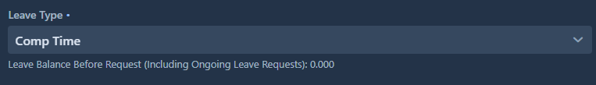
  - In ESS employees can see Leave/Absence/Accumulation balances by selecting Leave Information.
    - Comp Time has been included in these Leave Balances.

