MVECA 2015
USAS Calendar Year-End Procedure

The following checklist outlines the steps to be followed when closing out USAS for the month and calendar year-end.

Preliminary Calendar Year End Closing

- Run TINMATCH to create a file to send to IRS TIN Matching Program.
  - Requires an e-services user login
  - Registration asks for personal information
- Add new SSN/EIN field value for 1099 vendors
  - Required for printing 1099s
  - Values: S=SSN, E=EIN or BLANK
- Check 1099 vendor names. If the vendor wants a different name on the 1099 than the billing address or the check name; add it to the second name field with “1099:” before it.
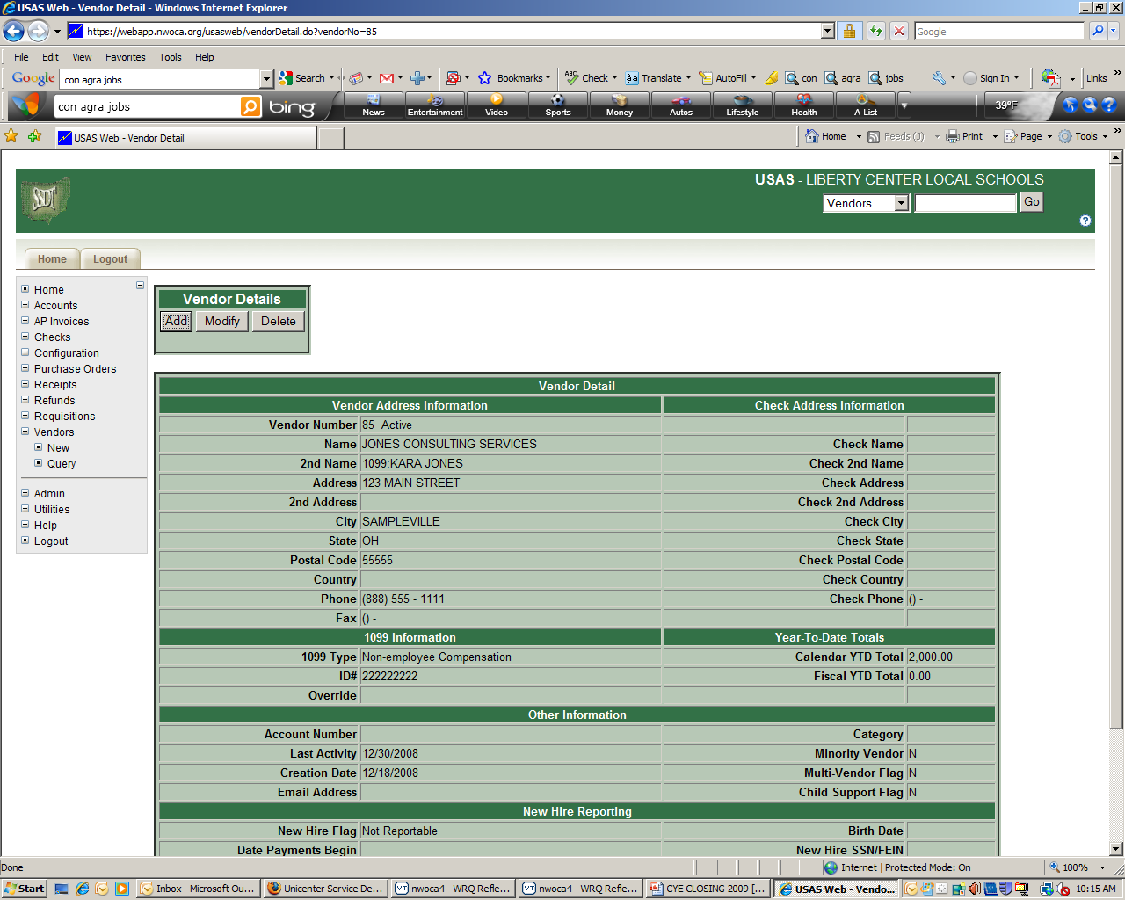

- Run CHEKPY choosing the following options to verify YTD totals for 1099 vendors. Compare the CHEKPY to the VENSSN totals. Vendor YTD totals will be more than the amount listed on the CHEKPY if yearend adjust was not executed last year. Contact MVECA to correct YTD vendor totals.
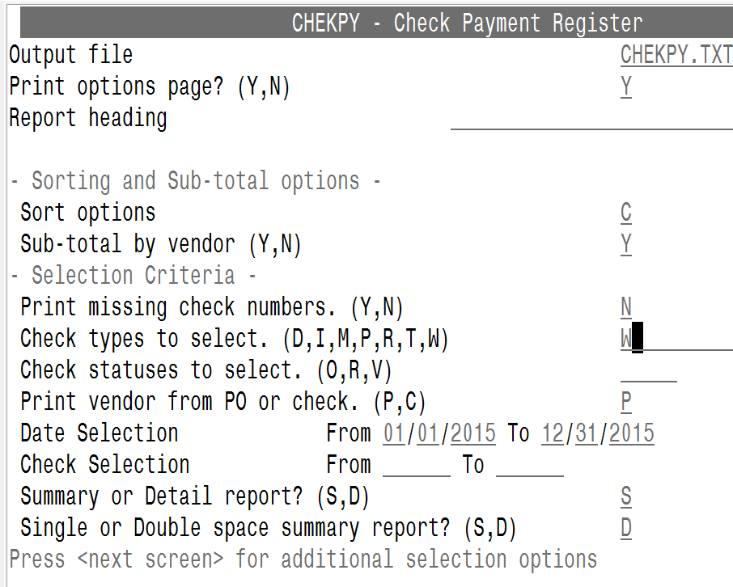
- Run VENSSN (MENU>VENSSN) with the following options to check 1099 data

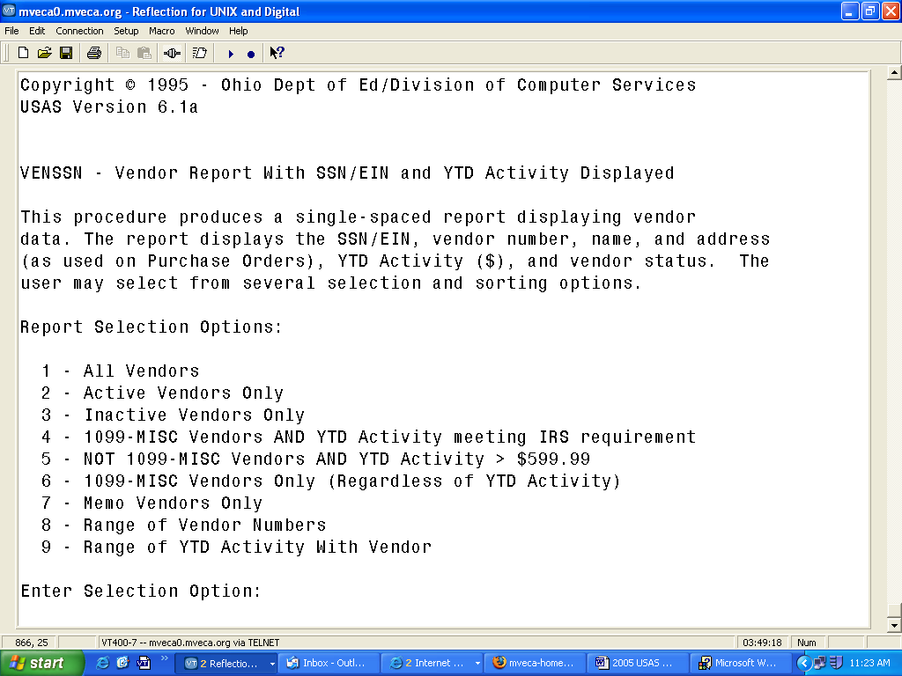

a. 1099-Misc Vendors only (Regardless of YTD Activity)- Option 6

b. 1099-Misc Vendors AND YTD activity > $599.00 – option 4

c. NOT 1099-MISC Vendors AND YTD Activity> $599.99 - Option 5 – check for vendors that have not been flagged correctly.

- Check that all vendors flagged to receive 1099’s have a social security or tax ID number.

NOTE: Attorneys who you have paid fees and who have received gross proceeds from a settlement will need 2 vendor records: One for non-employee compensation (1099 type1-fees) and one for Attorney Gross proceeds (1099 type 6). Fees are placed in box 7 of the 1099 and Gross proceeds are placed in box 14 on the 1099.
Month End Closing

- Enter all transactions for the current month.

- Reconcile USAS records with your bank(s). See the Bank Reconciliation Procedure described in the “Useful USAS Procedures” section of the USAS User Guide.

- Generate Cash Reconciliation (not required) (option 1. only of the USAEMSEDT program), FINSUMM, outstanding PODETL and BALCHK reports.

- Examine the MTD, YTD, and FYTD Expenditure lines on the BALCHK report. The dollar amounts for cash, budget, and appropriation accounts should be identical for each line on the report.

- Examine the MTD, YTD, and FYTD Revenue lines on the BALCHK report. The dollar amounts for cash and revenue accounts should be identical for each line on the report.

- Compare Current Encumbered totals from the BALCHK and PODETL reports. They should be identical. If they are not, execute the program FIXENC (Menu>FIXENC) to correct and then regenerate BALCHK and compare totals. If the totals still do not balance contact MVECA for assistance.

- Run FINSUMM, selecting “Y” to “Generate FINDET report for comparison” option. This will cause the FINDET report to be generated with identical selection criteria as the FINSUMM and will determine if it balances with FINSUMM. Please note that selecting “Y” will cause the report to take substantially longer to generate. The total will display on the screen therefore it’s not necessary to print the report. Compare the total from FINDET and FINSUMM. They should be identical.

If all the above steps are performed and totals all agree, you are in balance and may proceed.

- If desired, run the CALC option from the SM12 program. The CALC option works the same way as the SM2 calculate option – it calculates the SM2 for the month.

Calendar Year End Closing

- Generate all needed Calendar Year End Reports. The following is a listing of the recommended reports. Run any report that you would like to save to a local drive.

___USARPT/BUDSUM using YTD Budget Summary-All Funds
___USARPT/APPSUM using YTD Appropriation Summary-All Funds
___ Detailed PODETL -All Funds in Account Order
___USARPT/FINDET and USARPT/FINSUMM reports
___RECLED Reports-All Funds, All Options
___WORKCOMP (MENU>WORKCOMP) - Worker’s Compensation Report.
or
___BWCRPT(MENU>BWCRPT) – Worker’s Compensation Report

IMPORTANT STEPS BELOW!!!!!!

- Create a backup copy of your files. EVERYONE MUST BE OUT OF USAS!! From the menu prompt, type: USASBACKUP. If you get an error that the file is locked by another user; contact MVECA Fiscal at 937-767-1468 ext 3113. You should receive a confirmation email. Read it carefully to determine if it says the copy was successful.

- _________________Run VENHIRE/VHRESET to reset all vendors flagged as “REPORTED” to “REPORTABLE” ” indicating the vendor may need to be reported again if they are paid at least $2,500.00 during the next calendar year

- Run ADJUST (Menu>ADJUST) selecting the “Month End” option. MONTHLYCD will automatically run first before prompting for Adjust.

- Run the F1099 (Menu>F1099) program.

F1099.TXT is the text file created and F1099.FRM is the file that should be printed on the 1099 forms if you plan to file paper copies with the fed. You must create the tape file, regardless. If you have 250 or more 1099’s it is mandatory that you submit your data via tape. We will submit your 1099s electronically, unless otherwise instructed.

- Email helpfiscal@mveca.org when your 1099s are ready to process.

- Run ADJUST (Menu>ADJUST) selecting the “Year End” option and run for “Calendar”.
IMPORTANT!!!! No other programs (USAS or USPS) can be used when running ADJUST.

Processing 1099s After Closing Calendar Yearend

Email helpfiscal@mveca.org to request a copy of your yearend backup to a demo. You will be emailed the login to the demo. Process 1099s. Add a comment to the ticket that they are ready to be processed. MVECA will create a new backup with the updated info and copy needed reports to MONTHLYCD.

1099 CORRECTIONS

See 1099 General Instructions
If before MVECA submits to IRS, add a Unicenter request to copy the backup to a demo. Make necessary changes in the demo and re-process 1099s. The updated file will be submitted to the IRS.
If after submission to IRS, file paper Copy A of form 1099 and 1096 to:
Department of Treasury
Internal Revenue Service
Austin, TX 73301

