Directions for financial forecast certify and submit
- Create the 5-year forecast spreadsheet for the 3 prior years, average change and current year.
Redesign:
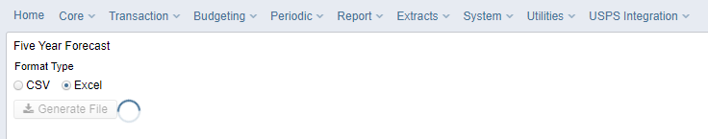
- Complete the forecast years on the spreadsheet.
- Save as a csv.
- Send an email to helpfiscal@mveca.org to request we convert the CSV file to a .SEQ file or convert the CSV to a .SEQ file using the flat file editor
Once MVECA has sent the SEQ file to you:
- Click on the Data Sources Tab in the data collector
- Click on Other Data Sources

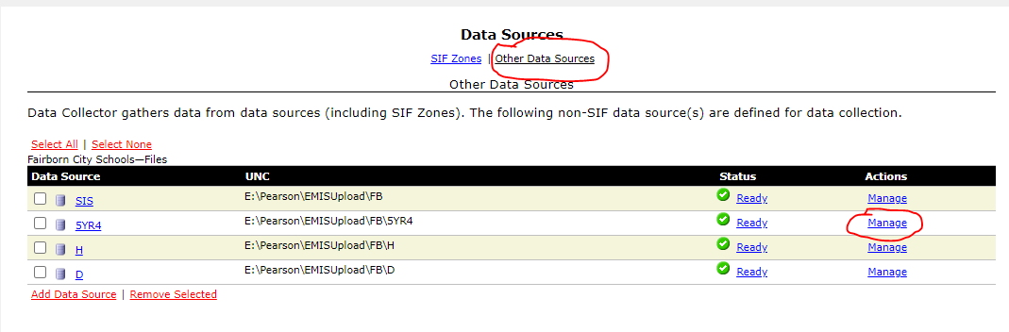
- Then click on manage under 5YR4, see above
- Click on Upload Files, then browse to find your 5 year forecast CSV file
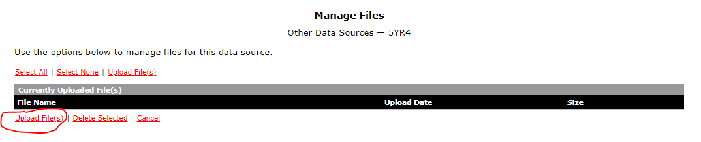

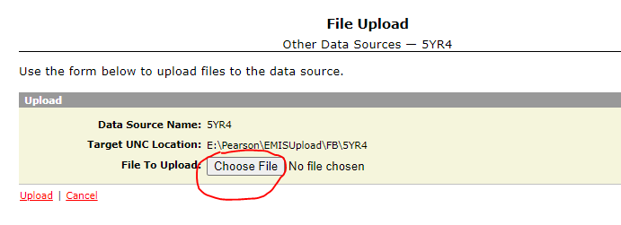

- Click Upload once you have chosen the CSV file
- Go to the Collection Requests tab and select the “FY25-P-FYF 1 Req”. This will bring the manifest to the top of the list.
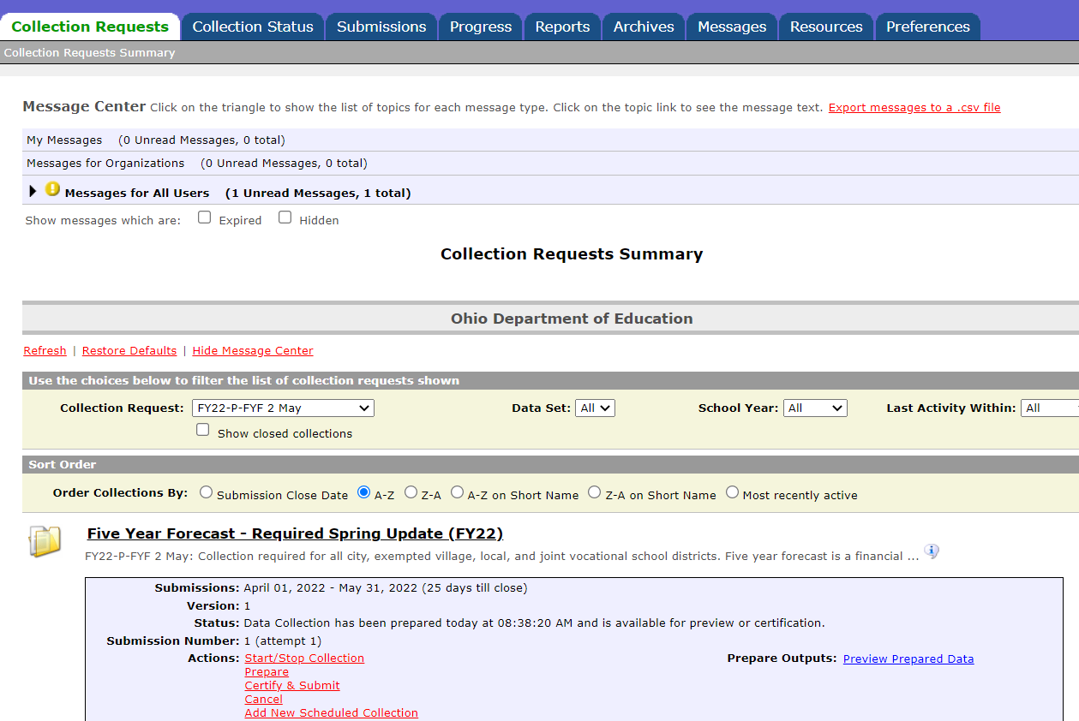
- Then click Start/stop Collection
- Check the 5YR4 Data Source and then click “Start Data Collection for all items checked below”.
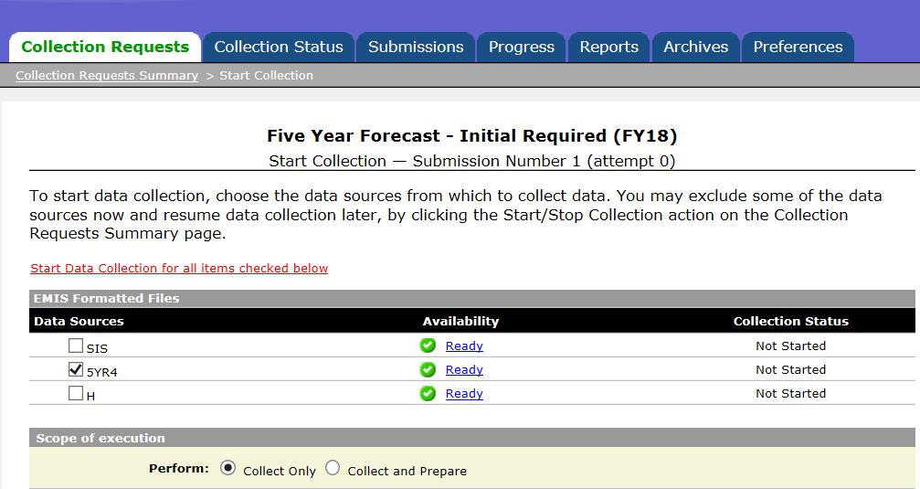
second
Frist
- Click refresh to see additional options
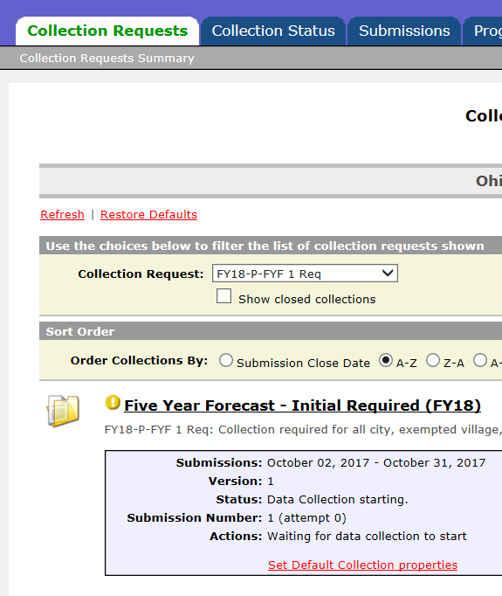

- Click Prepare and then OK when prepare completes.
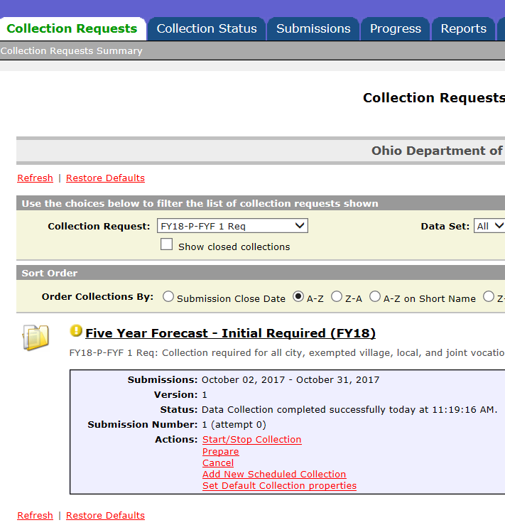
- Click Preview Prepared Data
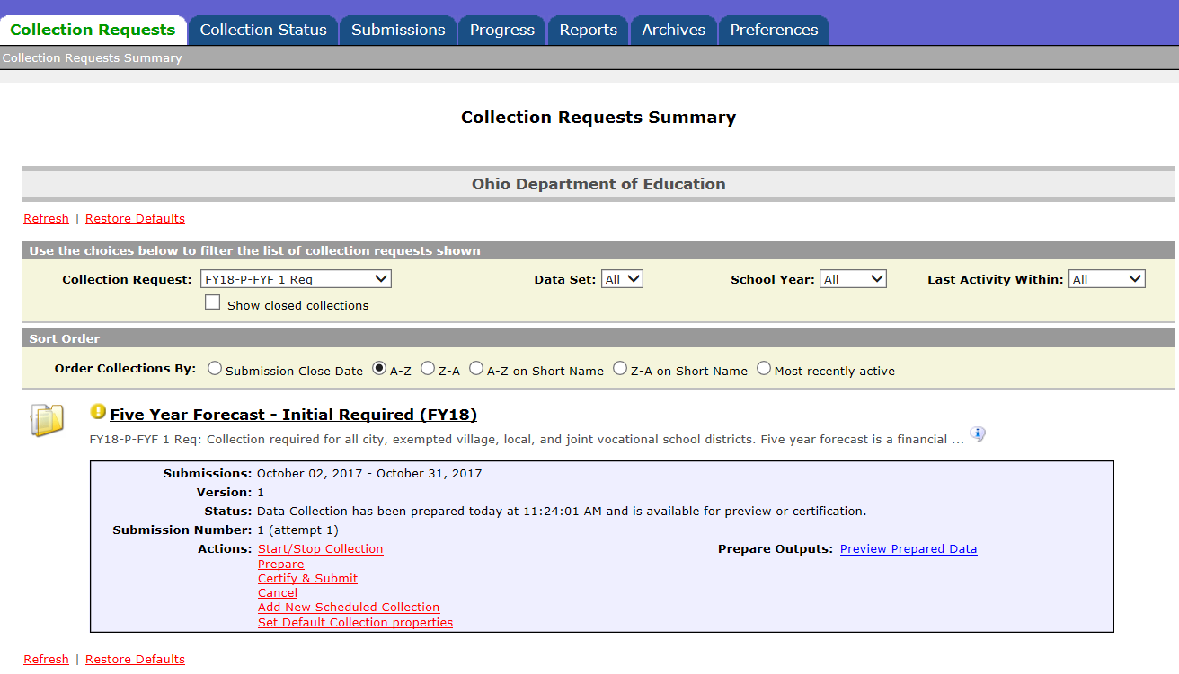

- Click Generate Preview –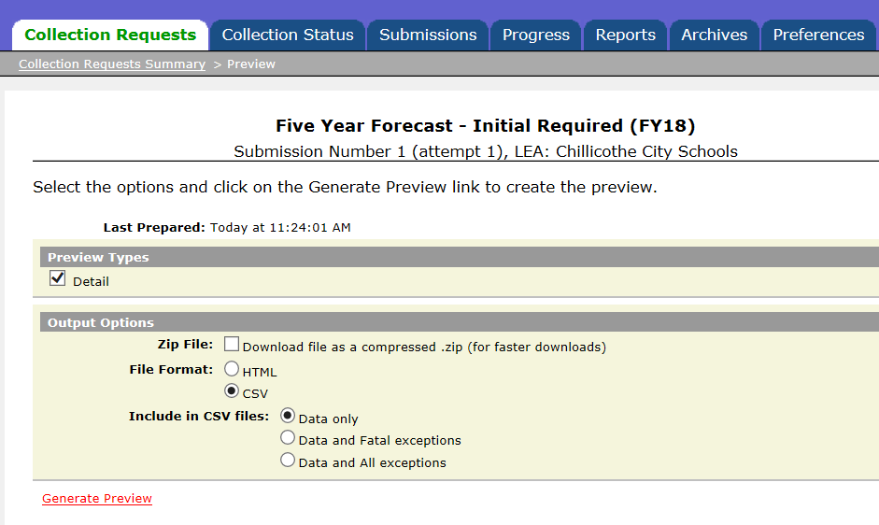
- It will display a record count. Click on the csv file to open it. Confirm that we loaded the correct forecast.
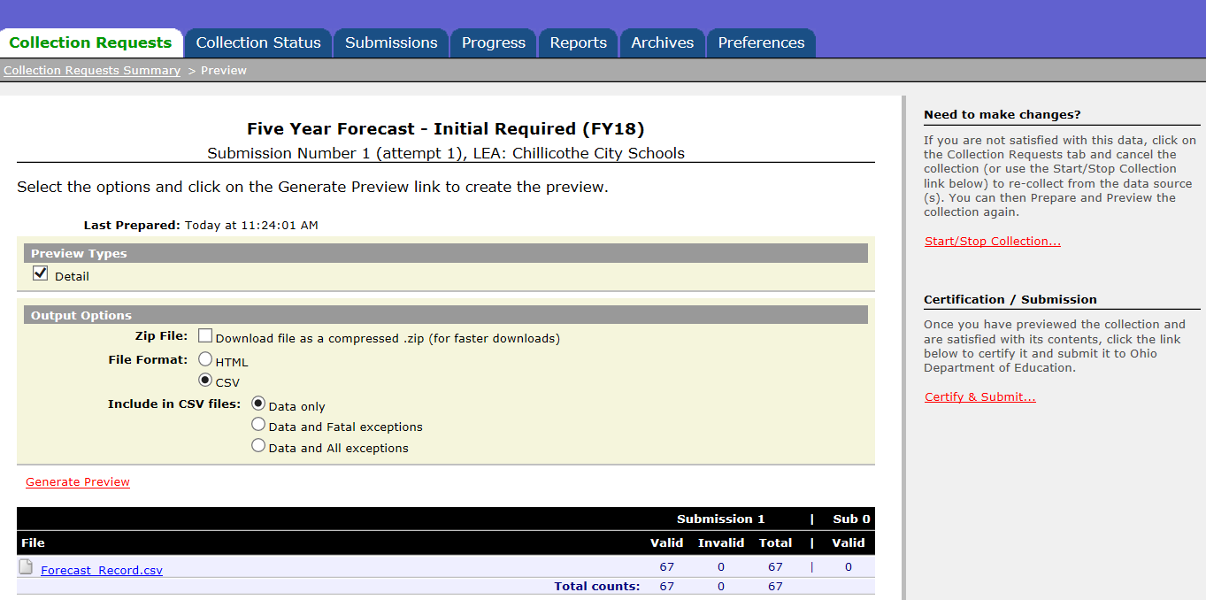
- There is a Certify & Submit option on this page or you can click the Collection Request tab and certify and submit from the first page.

- Add your pdf assumptions at this time. Browse to where they are saved and click Upload File.
Do not email your assumptions to ODE.
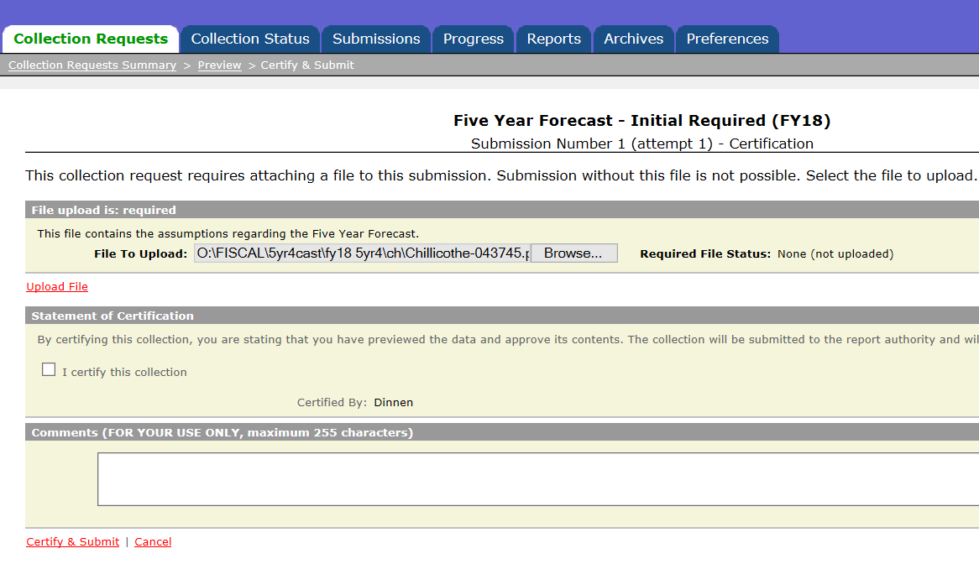
- The Required File Status will change to show that the file was uploaded successfully and will be included in the submission. Check the “I certify this collection” box and then Certify and Submit.
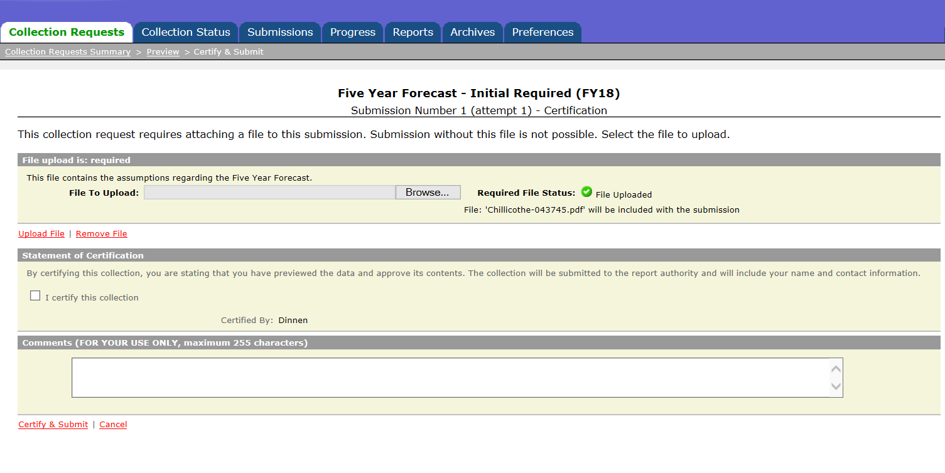
Process complete!!
Forecast will be available in a few days at https://education.ohio.gov/Topics/Finance-and-Funding/Five-Year-Forecasts/Five-Year-Forecast-Traditional-Districts-and-JVSDs.

