MVECA

2015 “L” EMIS

Reporting Requirements for Staff Data

(Who should be flagged “Y” to report to EMIS)

Staff (L) Reporting

- Individuals employed by the reporting entity.
- Individuals or companies contracted by the school district for duties normally performed by school district personnel (e.g., bus drivers, food service staff, IT, and special education therapists).
- Individuals who were employed during the current school year.
- Individuals who are on leaves of absence.
- Substitutes who become the “teacher of record.”
- Individuals employed during the previous reporting period as active, who are no longer employed, including individuals who have resigned over the summer
NEW
- Supplemental contracts as they are hired including individuals who their only job is a supplemental contract.

Do not report the following individuals to EMIS.
- daily (as needed) substitutes
- student employees
- board of education members
- adult education teachers
- game officials, ticket takers
- part-time help
- volunteers serving in the district

MVECA

2015 “L” EMIS INSTRUCTIONS

IMPORTANT

NOTE: When adding new staff, leave the State Assigned ID blank for classified staff and the Data Collector will fill in the blank with a Z-ID when a collection is done. If the field is blank for a certified staff member; the DC will, also, assign that employee a Z-ID. If a Z-ID is assigned it will not match up with the courses. Best practice is to add the credential ID in the biographical record prior to a collection.

___1. Optional: Run USPCHG to mass change REPORT TO EMIS flag to N for staff with separation date. It will allow you to add a separation date and will look for any date greater than or equal to that date. Use this option with caution. If you do not have many records to change; modify the records individually.

___2. Run MASCHG/MASINC to increment employee’s years of experience (total and authorized). 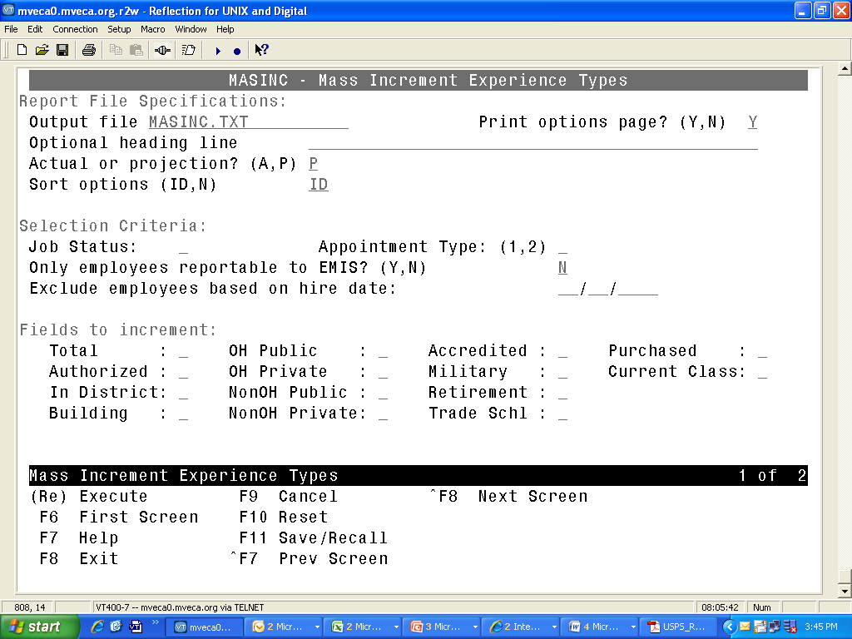
Not EMIS elements. District may elect to maintain this info
District may opt to only increment Active and/or Appt Type =1
Run as a projection first; review MASINC.TXT

This can be run as a projection or actual
___3. IMPORTANT – VERIFY that the CLRATD program was completed at Fiscal Year End by checking the EMIS Entry screen in USPSWEB. If there are values in the attendance days and absences then run CLRATD. This program will clear long term illness on demographic record. (LTI and attendance are reported at the end of the year.)

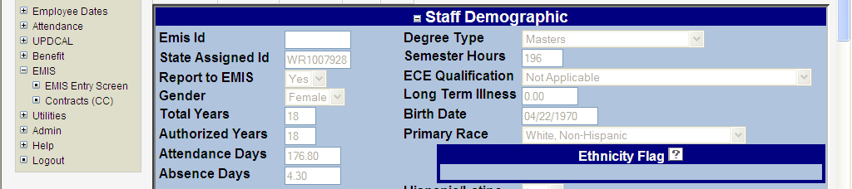

___4. Run USPEMS/PERDET to review any errors or missing data. Make corrections in USPSWEB or the alpha.

___5. Update Summer Separations – Change the position status to U and add a separation reason and date to the job records for anyone that was not reported as left the district in yearend, N, reporting that did not return to the district this school year. These records can not have attendance for the current school year. Add a calendar stop date that is after the last day of school last year and prior to the first day of school of the current year FOR ALL JOBS in USPS for this employee. Summer separations are collected by the SIF agent and will be listed on the CI and CK preview/review reports in the Data Collector. (If using the FFE for reporting staff, add the CL record and do not report a CI or CK record.)

___6. Add Contract Only records in USPSWEB for any out-sourced school positions

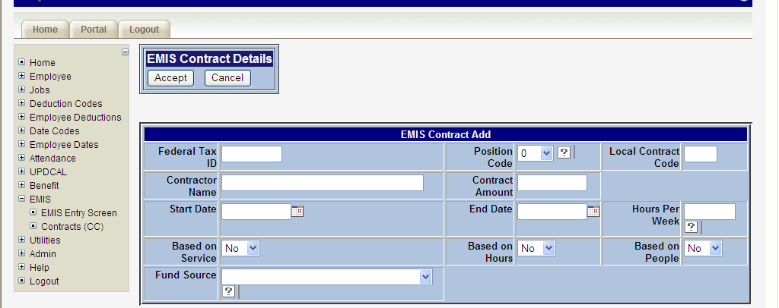

___7. Update/Add Contractor Staff Employment Records (See EMIS Manual Chapter 3.2) in the EMIS Entry screens in USPSWEB

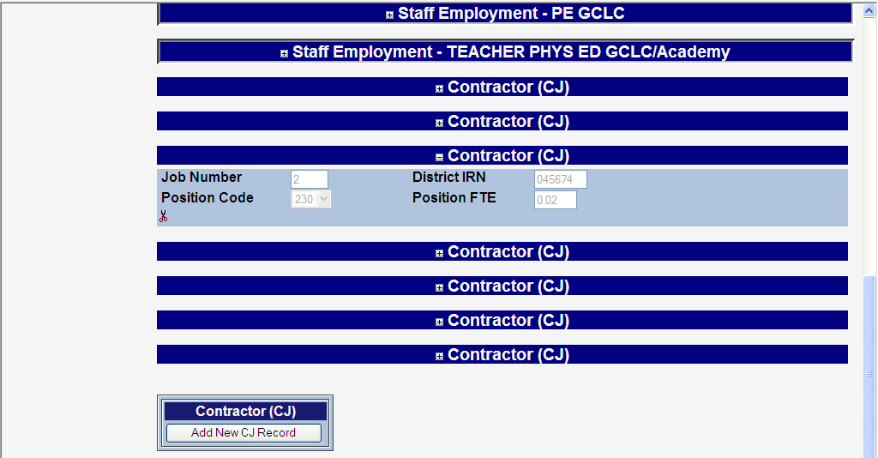

___8. Run USPEMS/USPEMX if you have CC (Contract Only) or CJ (Contractor Staff Employment) records to create a file to load into the Data Collector (USPEMX will assign Z-IDs to any blank STATE_ASSIGNED_ID field for records flagged “Y” to report to EMIS)

___9. If step 9 performed, execute EMISRSTAFF to transfer the file to the Data Collector. Inform the LEA Collector that Staff flat file was loaded so that they can include this in the collection

___10. Complete Collection, Prepare, Preview, Certify and Submit in Data Collector

