STAFF EMIS 15L Reporting Update
June, 2015

Before purging any new contracts for July, 2015

- Add Long Term Illness (LTI) and Highly Qualified Professional Development (HQPD) in USPS.
- Run USPEMS to create the needed FY15 flat files for staff data submissions
  - Creates USPEMX.SEQ
    - CI- Staff Demographic (bio) records
    - CK- Staff Employment (job) records
  - Creates USPEMS_EMISR.SEQ only if the following record types exist
    - CC- Contract Only records
    - CJ- Contractor Staff Employment records
- Transfer the output files from the oecn$dta directory to your local drive for archiving

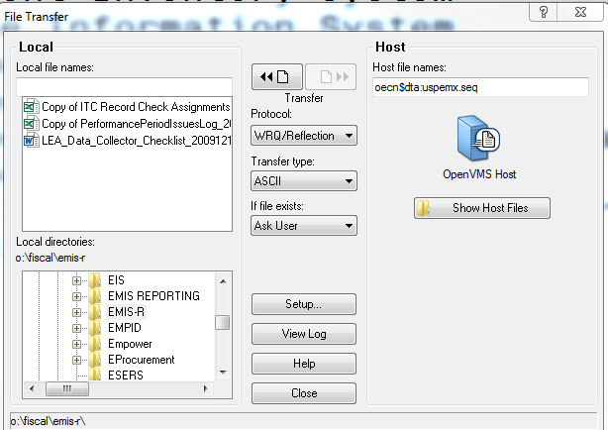
The files created by USPEMS are written to the oecn$dta directory. Transfer them from that directory to a local directory.
Host file names= oecn$dta:USPEMX.SEQ and oecn$dta:USPEMX_EMISR.SEQ
- Send email to helpfiscal@mveca.org to let us know that the USPEMX file(s) are available. We will transfer the files to the Other Data Source in the Data Collector.
- Once steps 1-4 are completed, do not do a SIF collection for 15L.

If updates are needed for any staff member already included in the USPEMX file:
(You will need a user account for the Flat File Editor and the Data Collector. Contact MVECA, if needed)
- Reply to the Cherwell email requesting to have your file uploaded to the Flat File Editor (FFE). Changes must be made in the FFE. Once changes are complete, export the file making certain to select FY15 and reporting period "L". Save the export file to a local drive.
- Upload that exported file to the data collector/Other Data Sources.
- Process the 15L collection request. Do not select the option for a SIF collections. Submit updated data to ODE.

Send email to HELPFISCAL@MVECA.ORG if you need to ADD staff to your 15L staff file.

