OnBase Document Retrieval
W2/1099

Must use one of the following compatible web browsers:
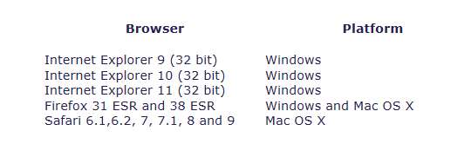

All pop-up blockers must be disabled from every toolbar on the browser.
Go to this link, https://obweb.hccanet.org/OnBase/Login.aspx.
Click the HTML radio button
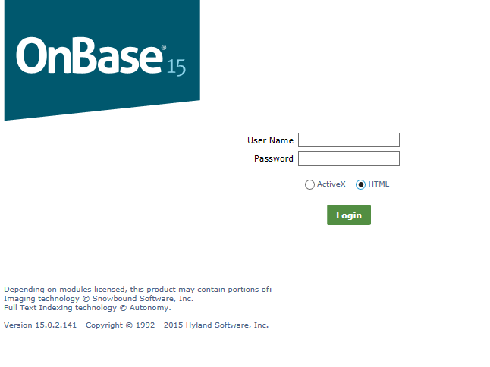
I will email you the login credentials. Enter your user name and password in lower case. It will be displayed on the screen in upper case.
You will be prompted to change your password
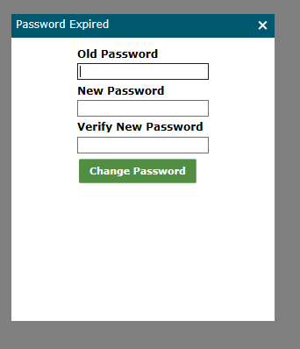
Once in OnBase you will retrieve your documents (W2s and 1099s) by choosing Document Retrieval. When you click on the document type, the indexed fields will appear. Type in the filter and click the binoculars.
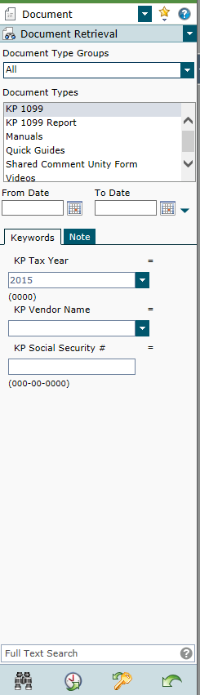
Click on the document type you wish to retrieve.
Then filter using the keywords. Use “*” as a wildcard.
A list will appear matching your filter. Double click on the form you need.
Your browser may, automatically, send it to your downloads or ask if you want to Open or SAVE AS. If you do not see these options, a pop-up blocker may still be enabled or you are not using a compatible browser. Send an email to helpfiscal@mveca.org if you cannot resolve your browser issues.
Print from if needed.

