SERS PER PAY REPORTING

REPORTS

When you run SERSREG starting in February, it will produce SERSREG.TXT and SERSDET.TXT. The SERSDET.TXT is the detail report needed by SERS broken down by earning codes for each employee (This report will show voids and unvoids). If you have any warnings or errors, it will produce SERSERR.TXT. Once you have verified the information on your reports and you do not have any fatal errors, you can run a final SERSREG by saying “Y” to the prompt to produce the SERS output tape file(s) (the tape file will create as long as there are no fatal errors). It will produce SERSccyymmdd##.SEQ. This is the file you will upload to eSERS. If there are any adjustments, it will produce SERSccyymmdd##A.SEQ. SERS is requesting that the user review the information for all adjustments to ensure that the correct period begin and end dates, along with days and hours (if needed) are correct.

You will notice that the SERSREG.TXT report no longer provides FYTD totals, this is now listed on the SERSMONTH report. Please note that running the SERSMONTH report is **MANDATORY** at the end of each month.

IMPORTANT: Any voids from pays before going to SERS “per pay” reporting will not be picked up on SERSREG. These voided pay checks will need to be reported to SERS by calling them.

EARNING CODES

When you create your SERSDET.TXT report, you will notice that each pay type is assigned a Payroll Earning Code. Earning Codes 01 – 04 appear on the SERS output tape file and Adjustment Earning Codes 51 – 54 appear on the separate SERS Adjustment output tape file. Please see the boxes below that describes each Payroll Earning Code:

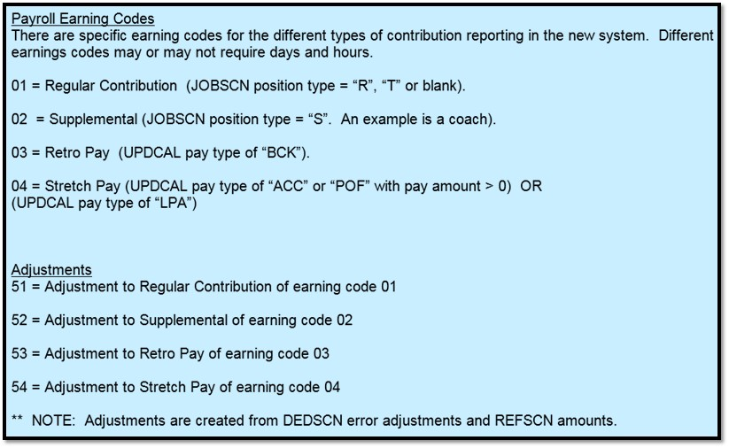

EARNING CODE VALUES

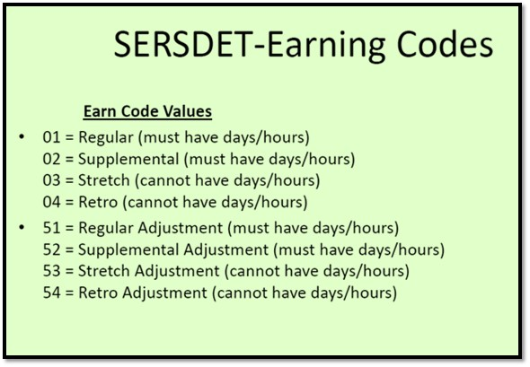
Please use the green box as your guide when checking for days and hours on the SERSDET.TXT report. If you find that the Earning Codes are incorrect, the only place to make that correction is through eSERS, once you upload the file.

The best method to make sure the SERS hours and days are correct is to carefully review the FUTPAY or CURPAY reports to verify the hours are correct and the PAYRPT report (at the top of each employees record under SERS DAYS) to verify the days are correct before completing the payroll process.

Once you have completed the payroll and began RETIRE/SERS, many of you have noticed errors on the SERSERR.TXT report that needed corrected before you could create your tape file. Sometimes the errors are INFORM messages (ex: INFORM: Service days will need to be adjusted on eSERS, ATDSCN or the calendar OR: INFORM: Service hours will need to be adjusted on eSERS or ATDSCN). That prompted many of you to make an adjustment to the SERSDET.TXT report using the ATDSCN (ex: AD RE (using the payroll date) to adjust the days or AD RH (using the payroll date) to adjust the hours), but the INFORM messages do not go away.

IMPORTANT: If you were not able to adjust the days or hours on the SERSDET.TXT report, you should use this error page to remind you to make the adjustments in eSERS, once you upload the file.

SUPPLEMENTAL JOBS

When you pay an employee on a supplemental job, you will need to make sure the pay is considered “Regular” with an earning code of: 02. That will be the only way you will be able to give that employee credit for days and hours. Please check your reports carefully to make sure this is correct. One thing to note about the supplemental job, if you have it set to a default calendar and mark it “Y” to equal pays, the system will likely pay the job as “ACC” accrued wages. To fix this problem, you will want to mark the job “N” to equal pays.

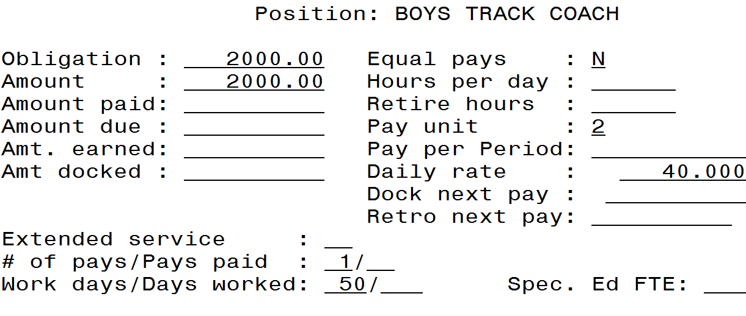

DOCKED PAY – retire hours are positive number

I have tested a few options when docking an employees pay to see what method gives the least amount of SERS errors while running payroll. I have found that if you enter the dock first starting at the ATDSCN and set it to post to FUTURE (using CTRL F6). Enter the date, AB DO, and the length of time (days or hours or both) in the attendance screen (using positive amounts for days and hours) and it will automatically post to FUTURE once you press enter, then press F8 to return to ATDSCN. You will receive minimal INFORM messages using this process.

You can achieve this same result if you upload your spreadsheet and answer COLUMN U: “Y”. Then, when you run USPIMPORT you should answer “F” to Post to UPDCAL Future.

IMPORTANT: If you need to hand enter the retire hours into future or current pay for a “DCK” docked job, please be sure to make those a positive number. The system will subtract those hours from the employees service credit.

CONTRIBUTION CYCLE CODE
When running the SERSREG report, the “Pay Cycle” code should match the code you have in eSERS from when you created your payroll cycle schedule. If you have .seq files already created with the incorrect cycle code, the only way to fix it now is to transfer the file out of the payroll system, then open it in the Notepad program and edit that top line to include the correct cycle code. Please see the example below that shows where the cycle code is entered when going into SERSREG.

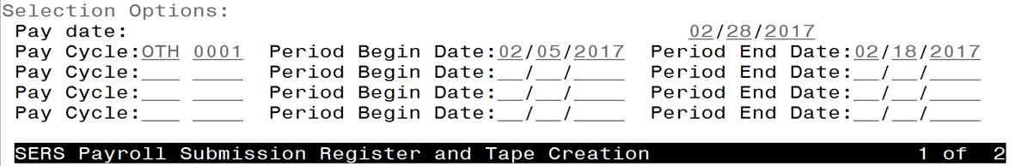

TRANSFERING THE FILE
Once you have created the .seq file for SERS, you need to include “ocen$dta:” before the file name when using the File Transfer Tool. This will allow you to successfully transfer the file out of the payroll system. Please see the example below:
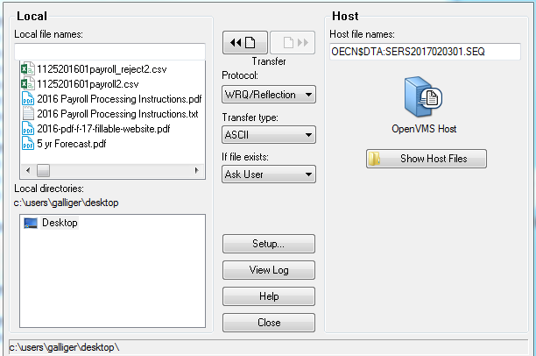
You may need to uncheck the “Delete Trailing Spaces” box before transferring your .seq files out of the payroll system. Please go to Setup and then the Translation tab. Make sure the “Delete trailing spaces” in unchecked. This will allow the file to be in the correct format that is needed by eSERS.
