USPS-R ROUND TABLE AGENDA 3/22/2023
- Report Writing from the Grid
- Mass Change
- Mass Load
- V-Lookup
- New Contract Import
- Discussion - tips and tricks districts are using

- Report Writing from the Grid - Payroll Item Annuity Benefits
  - Core/Payroll Item/Payroll Item
  - Top left corner select ANNUITY ITEM
  - Headers should include:
    - Number (Employee ID
    - Last Name
    - First Name
    - Code (Payroll Item Number)
    - Type (Annuity)
    - Rate
    - Employer Rate
    - Name (Name of Payroll Item)
    - Start Date
    - Stop Date
    - Rate Type
    - FYTD Gross
    - Pay Cycle
  - Filter Code 511..533
  - Filter FYTD >0
  - Advance Query to remove records with Stop Date
    - Click on Advance Query Button
    - Properties - click Active Date Range to see options
    - Double Click on Stop Date to Move to Display Name in center of screen
    - Operation - Select IS_NULL
    - Click Apply Query Button
    - If you are finished with Advance Query just click the Advance Query button on the right side of the screen to hide the query
  - Now click the REPORT button
    - Select Format (PDF will have subtotals, spreadsheets you will have to enter a subtotal calculation if you want subtotals by payroll items)
    - Page Size: Letter
Report Writing from the Grid - Payroll Item Annuity Benefits continued
    - Orientation - Landscape
    - Enter Name of Report Payroll Item Benefits
    - Copy and Paste the name of report in the SAVE AS field then click on SAVE REPORT - this will create a report in File Archive.
  - Go to Reports Manager and select your report
    - Click on the eye to change Properties and Configuration of the report.
    - In the Select Properties Tab - remove any headers not needed in the report like FYTD Gross.
    - Sort Priority - Code is set as 1 so the report will sort by the payroll item code
    - Sort Priority - Number is set to 2 so after the payroll item is sorted the employee ID will be filtered in order within each payroll item code.
    - Set a CONTROL BREAK on CODE so each payroll item will subtotal.
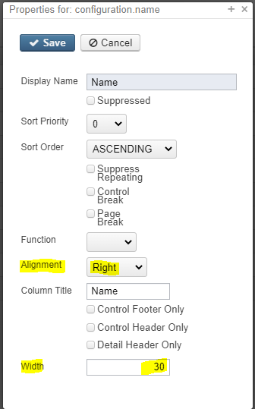
    - By clicking on the 3 dots on the right side of the grid you have additional options for the format of your report: for instance aligning the column to the right and making the width of the column 30 characters
    - Click SAVE REPORT
    - Now generate your report. If additional changes are needed come back to Select Properties.
    - If you want to change what information is being filtered click on the Configure Filter tab.

- Mass Change -example Change Benefit Rate and Employer Rate for the 511 payroll item
  - Go to CORE/PAYROLL ITEM/PAYROLL ITEM
  - Select Annuity Item top left corner (if this is an annuity item)
  - Filter by Payroll Item Code (example = 511)
  - Filter Rate to be changed- (example 100.00 is the amount I want to change in the rate field enter =100 to see only premiums that are 100.00
  - Click the Report button create an Excel Data spreadsheet as a backup (there is no way to recover mass change accidents)
  - Click Mass Change Button
  - In Maintenance Mode select the Load Definition (in this case employee and employer rate)
  - In the New Value field enter the new employee and employer rates

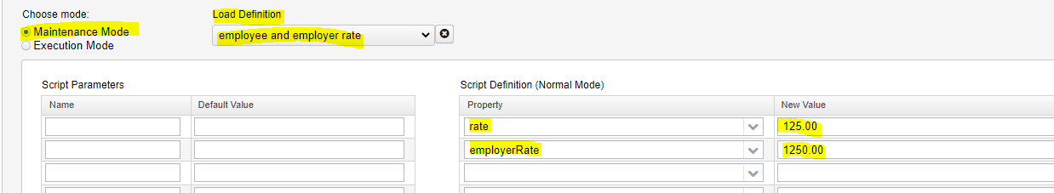
Click on Execution Mode:
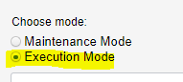

Verify the number of records that are going to change match the number in your spreadsheet

Click Submit Mass Change Button

Repeat the above procedures for Mass Change to change all benefit amounts

- MASS LOAD - New 506 Annuity Payroll Item
  - Use Mass Load Template Payroll Item Mass Load New or Existing
  - After entering data needed save file as .csv
  - Go to Utilities/Mass Load
  - Choose File
  - Importable Entities: Payroll Item
  - Click Load
  - Verify the correct number of records loaded
  - Spot check a few employee’s payroll items to verify all of the data loaded.

- Excel V-Lookup - Example add employee ID to a spreadsheet from a third party vendor
  - Third party vendor sent a spreadsheet with SSN’s but you need Employee ID’s to mass load
  - Go to Core/Employee/ Filter by Last Paid Date to reduce number of employees that will pull into the report.
  - Click Report Button - Run Report as Excel Data
  - On theThird Party Spreadsheet Insert a blank column in Column B
  - SSN’s will be in column A
  - Filter SSN’s so they are in numeric order
  - On the Employee Spreadsheet filter the SSN’s so they are in numeric order also
  - On the Third Party Vendor spreadsheet click on cell B2
  - Next go to FORMULAS at the top of the spreadsheet
  - Click on Lookup and Reference
  - From the drop down list select VLookup
  - Lookup Value is SSN so click on cell A2
  - The Table Array is the EMPLOYEE spreadsheet Column A and B (select all columns until you have included the lookup value (in this case SSN and the value you want to add to your Third Party Spreadsheet in this case Employee ID)
  - Col_index_num - on the EMPLOYEE spreadsheet start counting from Column A - how many columns from column A to the column where the employee ID is located. In this case it is 2 columns.
  - Range Lookup - enter False - which means only find exact matches

Excel V-Lookup continued

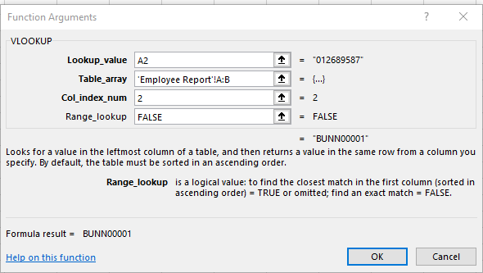

Click ok

On the Third Party Spreadsheet you will now see the employee ID in cell B2

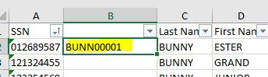

Double click on the green dot in the right lower corner of cell B2 and this will copy the formula to all of the other cells.

REMOVING THE FORMULA
If you don’t want the formula in the spreadsheet
- Highlight the column with the employee ID
- Press Ctrl key and C key at the same time
- Then Press Shift key and F10 key at the same time
- Press V key
The formula has now been cleared leaving just the employee ID.

- NEW CONTRACT
  - You can use the .json file listed below. If you don’t already have this in your Report Manager please send me a request for the file and I will send it to you. NEW CONTRACT BY PAY GROUP 2022.rpd.json
  - Go to Report Manager
    - Run NEW CONTRACT BY PAY GROUP 2022.rpd.json
    - Click Query Options tab and enter pay group(s) separated by comma, no spaces example pay group 2
    - Immediately copy and paste the header from NEW CONTRACT IMPORT TEMPLATE ( the header will line up perfectly with the report) If you don’t have this please send a request to helpfiscal@mveca.org requesting the New Contract Import Template
    - Please look at each header with a red flag in the top right corner for specific instructions for that column.
    - To enter the Contract Period in the description: ex 23-24
HOW TO INSERT WORD ON ALL ROWS OF A COLUMN IN EXCEL IN FRONT OF EXISTING WORDS:
- Select all cells to change
- Right click and select Format cell
- In Category select CUSTOM
- In Type select General and insert this formula
“22-23” @ (be sure to enter a space between items in parentheses and @ sign)
    - Once the spreadsheet is updated with the correct information, save as a .csv file
    - Go to Processing/New Contracts
    - Click on Import New Contract tab
    - Choose the .csv file
    - Contract Start date field is optional (leave it blank and the date will default the start date on your spreadsheet.
    - Click on Reports Menu/ Select NEW CONTRACT REPORT
    - If you want to see everything in New Contract Maintenance then don’t select any options, just run the report
    - Please also see a report in Report Manager/ SSDT New Contract Summary Report.
    - Once you are satisfied everything is balanced you can activate the New Contracts NOTE: IF the Compensation Start date is included in the pay period dates being processed for the final pay on the contract, then you MUST wait to ACTIVATE the New Contracts.

NEW CONTRACT continued

    - Activate New Contracts - In the New Contract Maintenance tab, select all New Contracts to be Activated. Click on Activate button.

    - A window will open called ACTIVATE NEW CONTRACTS
      - The prompt is - Are you sure you want to activate new contracts?
      - Transfer Primary Compensation Flag to New Compensations? Leave this flagged.
      - Click Activate
    - We have a report called Compensation Filtered by Description.json, if you are interested. This would pull all of your New Contract Compensation information into a spreadsheet to verify the contract amount activated from New Contract. In Query options enter the contract period you used in the description ex. 23-24

