Mass Change Compensation Calendar Stop Date
To begin the process to mass change the Compensation Calendar Stop Date

- Core/Compensation - click on Contract Compensation tab
- Make sure the grid includes
  - Employee Number
  - Last Name
  - First Name
  - Position Number
  - Type - Contract
  - Calendar Stop Date
  - Description - which should have contract period ex: 22-23 Custodian
  - Compensation “Code”

- Drag the header, Calendar Stop Date, to the center of the grid
- Filter on Description – example 22-23 Custodian
- Filter Pay Group - only those that will begin paying on their New Contracts.
- Position Number
- MOST IMPORTANT PART - Click on REPORT button and run an EXCEL DATA spreadsheet - this is important because if your mass change goes wrong, this is the only backup to restore your data back to before the mass change. We do not have a way to retrieve this information except to load your backup files from the prior day
- Click on Mass Change button
- You will need to be in Maintenance Mode
- Import Mass Load Definition Calendar Stop Date - Compensation
- Select the Calendar Stop date definition from Load Definitions
- Enter the Calendar Stop Date in the New Value field at the end of the script.

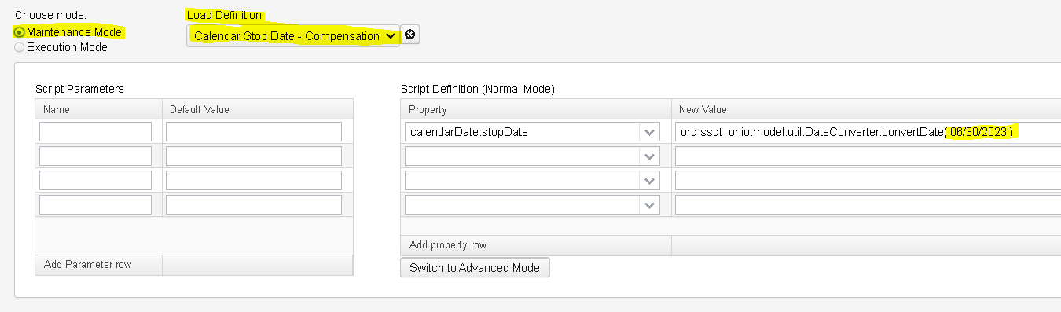

Mass Change Compensation Calendar Stop Date

- Next click on Execution Mode
  - Verify the number of Compensations that are going to be modified match the number of Compensations on your spreadsheet.
  - Click Submit Mass Change button
- Verify the Calendar stop date changed on the Compensation grid.

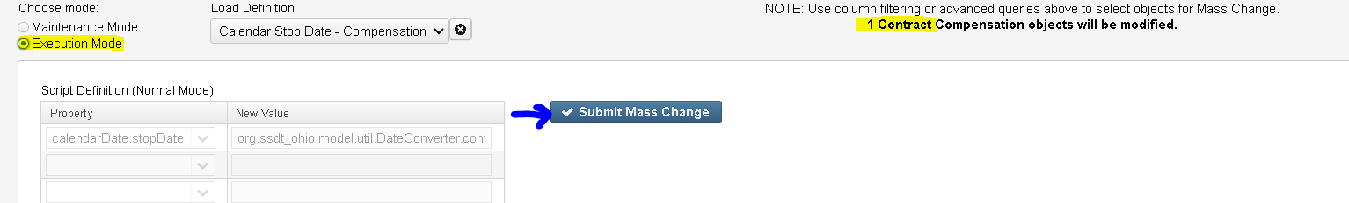

- You have now completed your Mass Change Compensation Calendar Stop Date.

