SSA to Change - How to Access BSO after March 25, 2023

Alert
MVECA has acquired the information below to assist with updating your access and obtaining a verification code related to SSA/BSO. If you have any trouble getting through the process, please contact Social Security, the number is listed at the end of this document.

On March 25, 2023, Social Security updated how you access a BSO account for the following services:

Wage file upload

W-2/W-2C online

AccuWage online

Social Security Number Verification Service (SSNVS)

View wage report name/SSN errors

BSO users will need a Social Security online account. You can use your personal

my Social Security account that was created before September 18, 2021, or an existing Login.gov or ID.me credential.

If you do not have a Social Security online account or a Login.gov or ID.me credential, you will need to create one from our Social Security Sign in page. This is a new requirement to access BSO employer services.

Once the credentialing and authentication process has been completed, current BSO User ID(s) will be associated with your new credential.

We appreciate your patience as we continue to enhance our system.

SSA to Change - How to Access BSO after March 25, 2023 continued

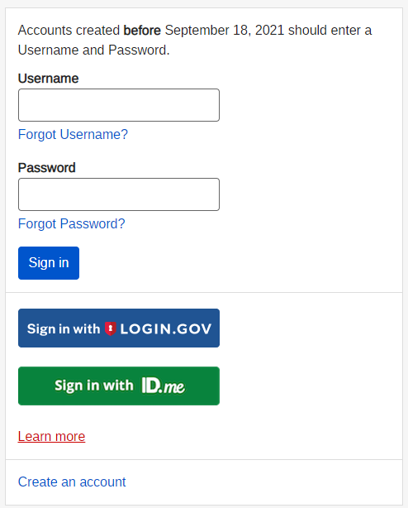

Once you complete the verification process, you will receive a verification code in the mail at your home address.

SSA/BSO Logging in After Receiving Verification Code 2023 continued

Go to SSA/BSO Login Website: https://secure.ssa.gov/RIL/SiView.action?LVL=7&URL=/RIL/bso

Click on either my Social Security account that was created before September 18, 2021, or an existing Login.gov or ID.me credential.
Then follow the prompts below.

1.
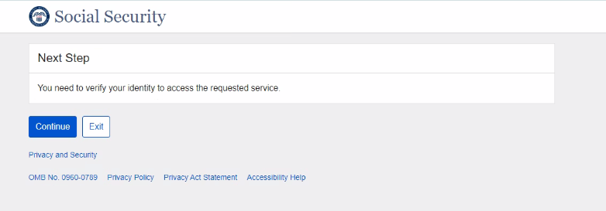

SSA/BSO Logging in After Receiving Verification Code 2023 continued

2.
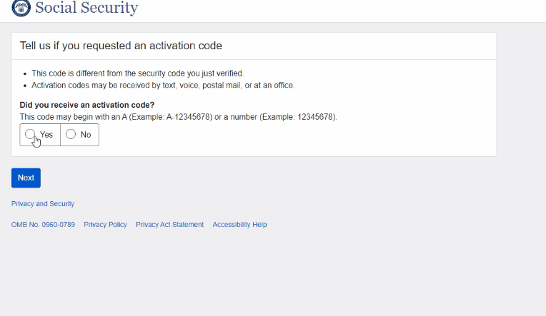

SSA/BSO Logging in After Receiving Verification Code 2023 continued

3.
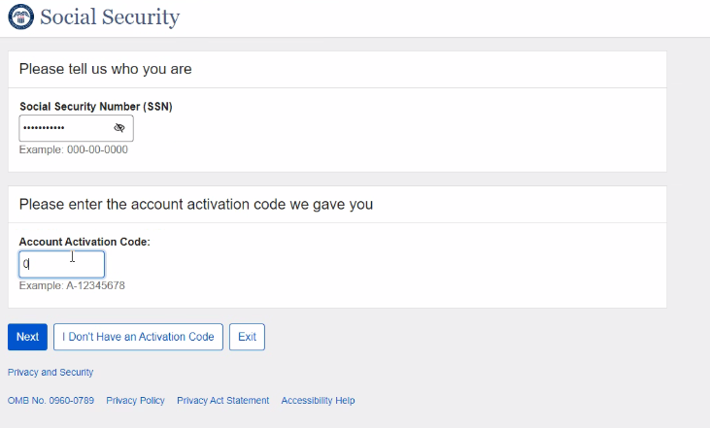
4.
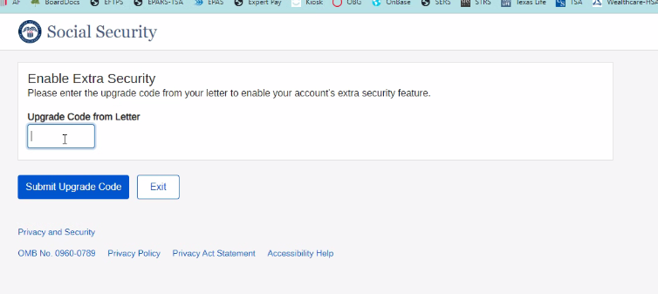

SSA/BSO Logging in After Receiving Verification Code 2023 continued
5.
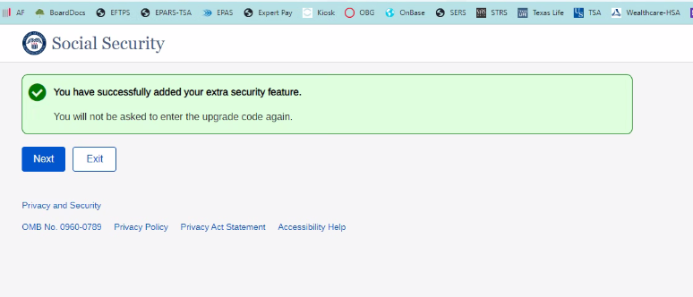

SSA/BSO Logging in After Receiving Verification Code 2023 continued

6.
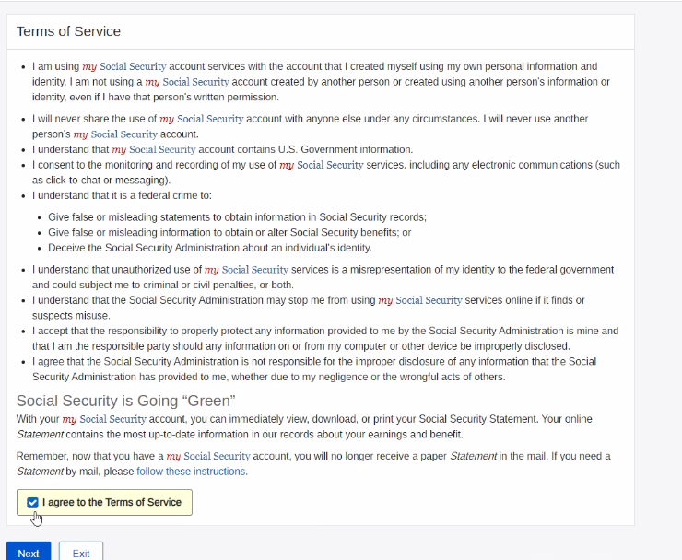

SSA/BSO Logging in After Receiving Verification Code 2023 continued
7.

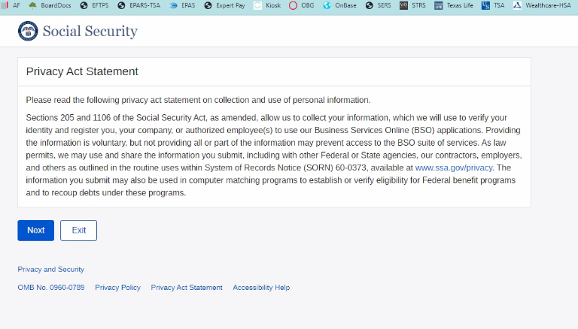

8. Go to SSA/BSO login website to log in as normal
https://secure.ssa.gov/RIL/SiView.action?LVL=7&URL=/RIL/bso

9. If you have questions please contact Social Security for further instructions

BSO hours
Monday-Friday: 5 a.m. - 1 a.m. ET
Saturday: 5 a.m. - 11 p.m. ET
Sunday: 8 a.m. - 11:30 p.m. ET

Questions or comments?
Phone: 1-800-772-6270 (TTY 1-800-325-0778)
Monday-Friday: 7 a.m. - 7 p.m. ET

