USXS-R Reports (Beginner)

- Template and favorite reports (those that a user has access to) are listed on the USAS and USPS home page
- Report Manager: Contains all reports
- Custom Report Creator: Allows the user to create a report Definition
- Canned Reports: Reports listed in the reports drop down menu; these reports cannot be customized/changed
- The "Tag" is a field you can use to categorize your reports.
- If you use a report frequently, checkmark the box in the 'Favorite' column. When you log into USAS-R, it displays your "Favorites" on your home page so you can quickly and easily access them

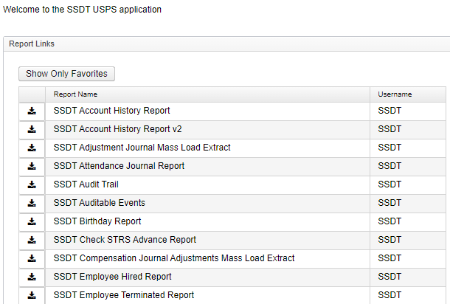
The view above of the USAS home page shows all reports in the report manager, to toggle to only see favorites click on “show only favorites” then it will only show reports marked as favorites and the home screen will show like the screen-shot example below (Note: generally when all reports are showing the report list is much longer than if you are toggled to only see favorites):
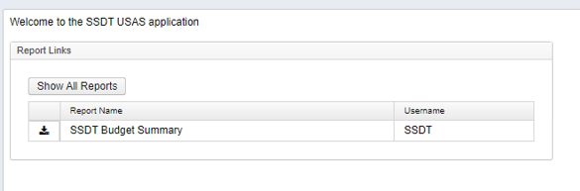

Generating Template Reports
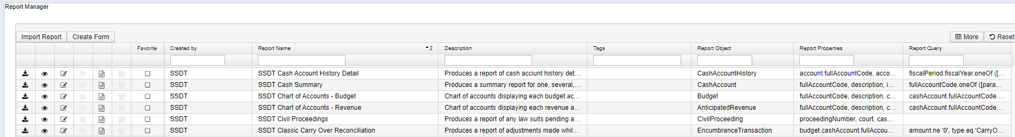
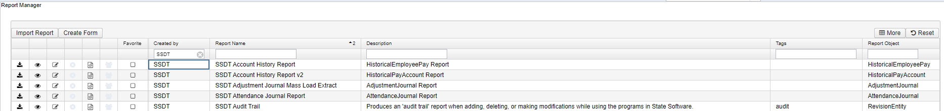

Icon Definitions from the Report Manager
Used to generate the report with the current report definition (where you don’t need to customized/change anything about the report)
Used to open the report definition where you can see what properties are being pulled into the report and what query options are built into the report. This is where you can also go into a template report to tweak/customize what properties display on the report, change/add query options/ and how the report is sorted/subtotale.
Used to edit the name, description or tag of the report you created
Allows you to delete the report definition you created
Allows you to download the report definition to your computer so it can be sent to others via email where they can then import it into the Report-Detail to be generated as well as save the report to show in their 'Report Manager' grid.
Allows you to share a saved report definition with users who have a specific role.

Report Generation Options (What you see when you click to download/generate the report)
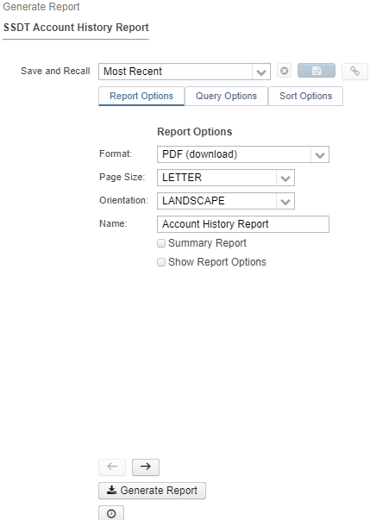

Format: Define the general format settings and the title on the report.
Name: The entered text will will appear as the Title at the top of each page of the report
The checkbox will generate a summary version of the current report. The summary will include any property designated as a Control Break or a Control Header and the related total and subtotal amounts.
Thecheckbox includes a printout of the report options selected for the report run. This option applies for PDF format only.

Query Options: The Query Options determine how to filter the information that will be included on the report. The Query Parameters vary by report and can be customized by modifying the Report Template
Sort Options:
- Date Short Cuts
YeaR (Calendar)
Y - Jan 1 of current calendar year
R - Dec 31 of current calendar year
FiscaL
F - July 1 of current fiscal year
L - June 30 of current fiscal year
MontH (based on current system date)
M - first day of current system month
H - last day of current system month
WeeK
W - Sunday
K - Saturday
PerioD (Posting Period)
P - first day of current posting period
D - last day of current posting period
Quarter
Q - first day of quarter
U - last day of quarter
T - today
+ tomorrow
- yesterday

Sort Options: The Sort Options will determine how the information in the report is sorted, subtotaled, and if there will be page breaks.
- Sortable Properties - Any Properties that are included in the report definition would be available to use as a Sortable Property
- Selected Properties - The properties showing in this section will determine the order in which the report will be sorted. The property listed highest in the list will determine the first sort priority. By default, the report will show the Selected properties based on the Sort Priority order defined on the report definition.
  - Ascending - When checked the sort on this property will display in Ascending order - from smallest to largest for numerical fields and A to Z for alphabetical fields. If the box is unchecked, the sort on this property will be displayed in Descending order
  - Control Break – Used to add subtotals each time the property changes for any numerical fields that are configured with the Sum Function.
  - Page Break- When checked for a property, the report will advance to a new page each time the property changes.

Save and Recall options:
- Most Recent: By default, it will remember the entries you made from your previous report run.
- Default: If you want to select the 'default' settings of the report, select 'default' from the drop down menu.
- To Save current report settings (in order to be used again), select the blank option and enter a save name. Once you tab off the field, the 'save' icon will be active. Click on to save your report and parameter settings. Your saved report name will now be included in the 'save and recall' drop down menu. To delete an existing saved report, select the saved report and click on .
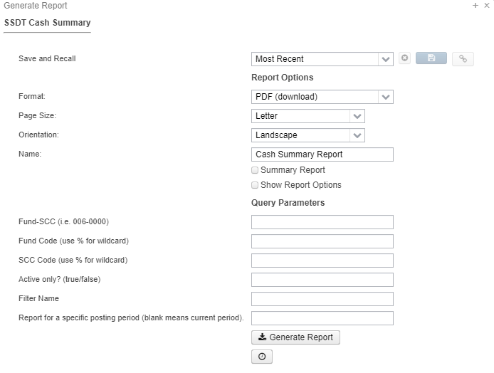
Report Direct Link:
The Show Report Link icon will become available for any report parameters saved via the Save and Recall option. The icon will open a window containing a direct hyperlink to execute the report. The link may be bookmarked, sent via email, placed on a web page, etc.
- Include Parameters? checkbox can be used to include all of the current parameters in the report link. When used, the report link will always use the original saved parameters. If this is not checked, the report link data will be run with the currently saved parameters for the Save and Recall name. If the saved parameters are changed and saved, the changes will affect future invocations of the link.
- The report direct link can be shared with other users. Each user will be required to login with their USAS-R credentials when the report link is accessed.
- Example/Documentation: Creating a running financial detail

Scheduling Reports (Used to schedule a single report to generate based on a cron job)To schedule a template or custom report to run for a specific day and/or time, the job scheduler icon can be used in the 'Generate Report' window. This is a one-time setup which will then generate the report based on the cron expression and automatically email it to a specified recipient. You can use a free online cron expression generator to generate your cron expression.
Example: Generate a Financial Summary report for the cafeteria fund to be emailed to the Cafeteria manager every Monday morning.
- Click to open the Generate Report window for the Cash Summary Report
- Enter the desired parameters. For our example, enter 006-0000 in the 'FUND-SCC' parameter.
- Click on the job scheduler icon which will open the Schedule Report window
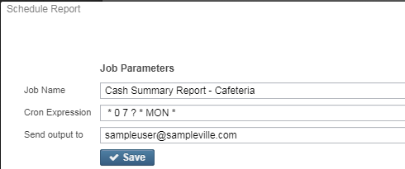
- Job Name: Defaults to what is displayed in the 'Name' parameter. You can overwrite the default job name.
- Cron Expression: is a command set up to run periodically at fixed times, dates, or intervals. Cron Expressions can be set up by using a free online cron expression generator (see links below). Here is an example of a Cron expression to be run every Monday at 7:00 AM
  - https://www.freeformatter.com/cron-expression-generator-quartz.html
  - http://www.cronmaker.com/
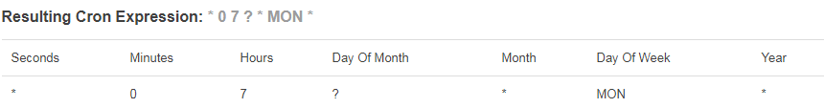
- Send Output to: enter the email of the intended recipient; you can enter multiple email addresses by separating each with a comma.
- A pop-up message will briefly appear stating the job has been created. Cancel or 'x' out of the 'Generate Report' window.
- The job is stored under UTILITIES/Job Scheduler. It will be displayed here until the job completes (if there is an end time specified in the cron expression) or if the job is deleted using .
  - In the job scheduler you can edit/modify/add the email address on who the report is generated to
  - If you need to change the cron expression on how often/when a report is scheduled you need to delete the current job in the job scheduler and re-create a new job

Report Bundles (Used to bundle and schedule reports to be emailed out based upon a cron job or event)
- From the menu, select 'Report' and click on 'Report Bundles.'
- Click on
  - Report Bundle Name: Name of the Report Bundle that will show in the grid and on scheduled Report Bundles.
  - Description: Option to add additional description detail that will show in grid by default
  - Tags: Tags are user-defined words that mean something to the user to help categorize report definitions. For example, a tag could be 'YEAREND' or 'MONTHLY' reports. Then they can use these tags for several other reports , enabling them to search for them easily in the Grid.
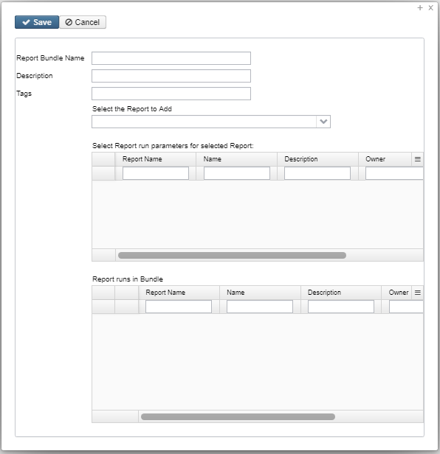
- To create a bundle of Reports, click on or start typing the report name under Select the Report to Add to the Bundle.
  - SSDT Template Reports and Custom Reports in the Reports manager are available to add to Report Bundles
  - The following Canned Reports are also available to add to Report Bundles
    - SSDT Accounts Payable Report
    - SSDT Account Status Report
    - SSDT Amend Certificates Report
    - SSDT Appropriations Resolution Report
    - SSDT Audit Report
    - SSDT Budget Summary Report
    - SSDT Certificate Available Balances Report
    - SSDT Disbursement Detail Report
    - SSDT Financial Detail Report
    - SSDT Financial Summary By Fund
    - SSDT Purchase Order Detail Report
    - SSDT Revenues and Expenditures Report
  - The SSDT Cash Reconciliation report is also available to add to a Report Bundles
    - When adding this report to a bundle it must be scheduled to run on the PostingPeriodCloseCompleted event so that the report is able to determine which month should be used.
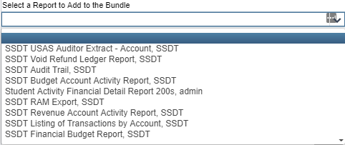

- Once selected, this report will then show under Click + to Add this report with the desired Report Options to the Bundle. This grid will show one row for each of the saved parameters (created from the "Save and Recall" option) that exists for the chosen report. Use the icon to select which version of the report to add to the Report Bundle.
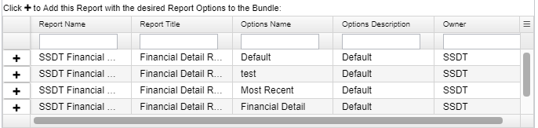

- The report will show that it has been added to the 'Reports currently in the Bundle' box below.
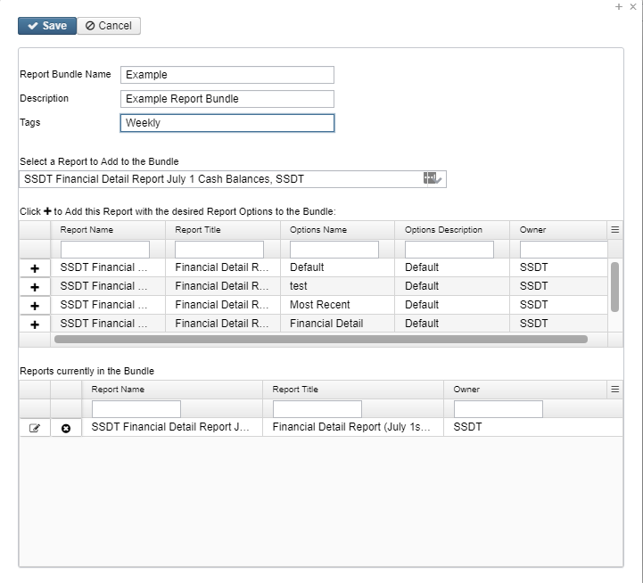

- To add more reports to the bundle, select another report from the 'Select the Report to Add to the Bundle' option. Then click the next to the report under 'Add this Report with the desired Report Options to the Bundle' box. This report will then show with the others in 'Report currently in the Bundle' box.
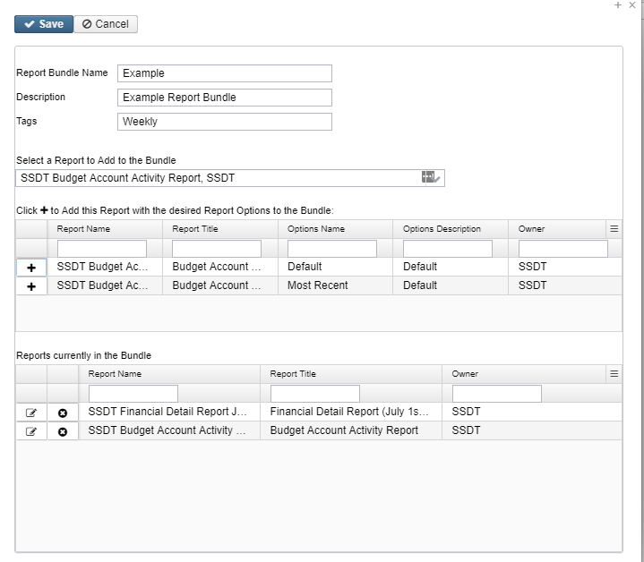
- To modify the report parameters for reports included in the Report Bundle, click on the icon next to the report in the grid at the bottom of the pop up window.
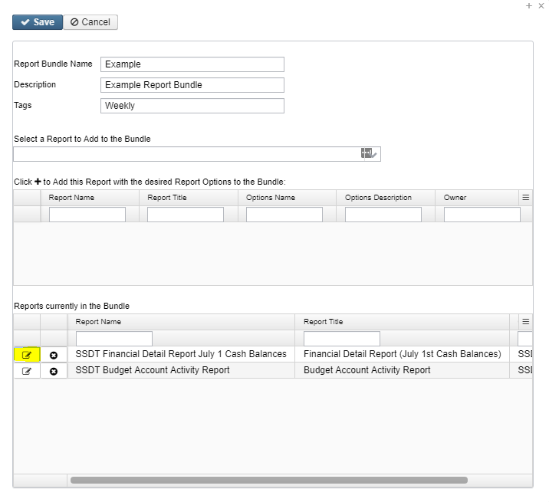

- Update the report parameters as needed
  - Click to save the updated report parameters
  - Click to continue with the original report parameters
  - Click to generate the report on demand with the entered parameters
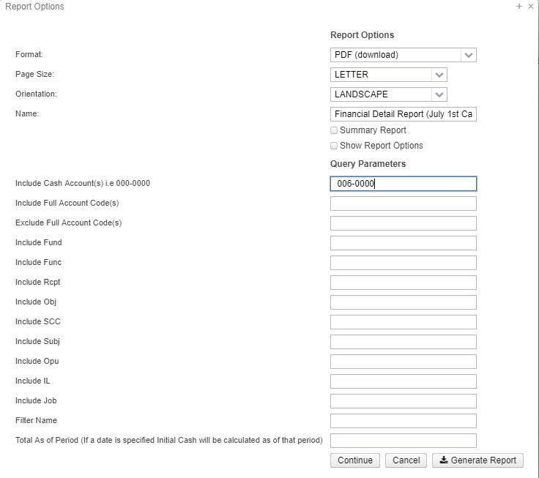
- Click on to save the Report Bundle.
- To Exit out of the report bundles selecting option, click on the x in the right had corner.
- After the Report Bundle has been created, it will show in the Report Bundle Manager grid.

