USXS-R Reports (Part 2)
Report Manager Grid: Shows any reports that a user has access to (Shows SSDT template reports, reports you have created, and reports that others created that have been shared with your access level)
- A template report can be a 'starter' report available for a user to generate as is or customize to a user’s specifications.
- When searching the grid by report name use the wildcard symbol (%) before and after the name (or part of the name) of the report.
- You can filter only tagged reports by using the value “true” under the tags column on the report manager grid.

Importing Reports:
An option to import reports that you or other users/districts have previously saved/shared.
SSDT has a USAS report Library and a USPS report Library in the documentation. Also, we have started a MVECA USPS report Library located on the USPS Fiscal MVECA webpage.
- From the Report menu select 'Report Manager'
- Click on 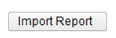
- Browse to find the desired report and once it has either been double clicked or selected and open clicked in the browser pop-up window the report definition is applied immediately.
- Make any desired changes and create the report by clicking the tabs 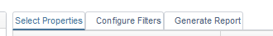 to select and customize properties, configure filters and generate the report.

Building Reports from the GRID

- Grids are best to use when you want to pull in data and need to update information based upon the data pulled or to do a quick search. In addition, they are a great starting point on building a customized report.
- You can generate a report from any of the grids. The report automatically includes all columns on your grid and pulls data from what you have entered on the filter row. For example, the screenshot below, you can generate a quick report of active 1099 vendors containing a YTD amount of $600 or higher.
  - After selecting your report options, click on to generate the report.
  - If you want to save the report for future use, enter a report name in the box and click on . Your saved report will be automatically added to the Report Manager grid.
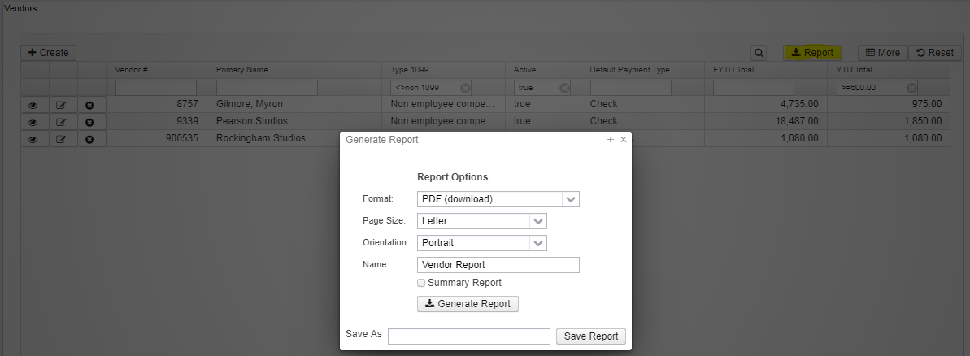

Advance Queries

Advance Query is a more elaborate search where a user selects the property to search on, the operation to search by, and enters what they are searching for. This may be useful for complex queries or to search by information without having to first add columns to your grid.
https://youtu.be/sfMK6W0w2ms?list=PL_dc8YSNxpKqslHMcb2ZxtyflF4FmIxMl
- To add properties the user can either double click the desired property from the "Properties" box on the left, or drag and drop it to the center section of the screen. In this example, the property 'defaultPaymentType' was selected and thus appears in the "Display Name" column. The user would then select an Operation from the dropdown box and enter in a Filter Value. For example, selecting an operation of '.eq' and entering a Filter Value of 'electronic' would result in searching for all vendors with a default payment type of electronic. The user can add as many search lines as desired by double-clicking or dragging and dropping more properties from the "Properties" box into the center section. The last step is to click on to apply the search criteria to the grid.
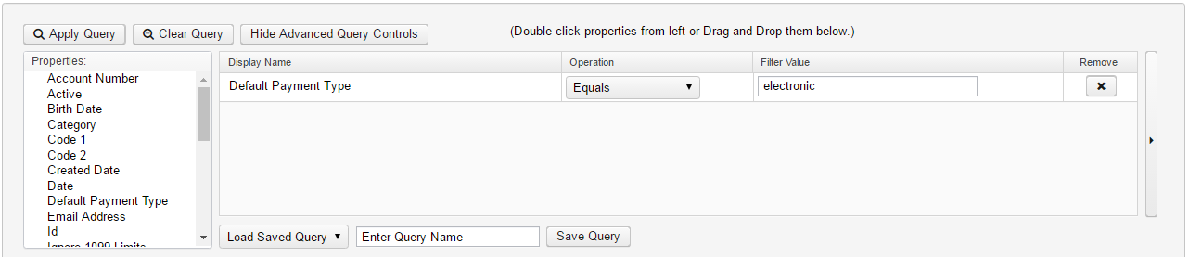
The can be used to remove a search line, and can be used to clear the entire advanced search query.
As properties, operations, and text are entered there is an expert box on the right side of the screen that fills in automatically. The expert search box may also be used by itself if the user prefers to write their own query using the properties and operations, or to copy and paste a query you have received from someone. The expert search is useful for troubleshooting and for easy sharing of queries with other users.
The advanced searches can be saved and recalled later, and will also be available as filters in the detail reports. If the user chooses to save the search they would enter in a Query name and click on . To recall a previously saved query select the desired one from the drop down box on the right hand side of the advanced query and all previously saved criteria is loaded in. At this point the user may make changes if desired and once satisfied with the query they would then click on the .

Customizing Template Reports
Report Definition
Opens a template or existing custom report definition details in order for a users to see all of the options chosen for the report. Users can then modify it by adding, changing or deleting properties or filters so you get the report wanted. Save the changes made under a new report name in order to create a custom report.
- From the Report Menu select 'Report Manager'
- Click on beside the desired report to make any changes. To save the changes under a new report name, enter a report name in the 'Save As' box and click on .

Select Properties: Reportable properties are available for nearly all possible related data types. Properties are selected by either double clicking on the properties on the left or drag and drop them into the box on the right. Once the user has selected the desired properties, they can order them in the box on the right as they wish the columns to appear on the report by drag and drop. Properties may be removed by clicking on the beside the property.

Within the properties selected, the user will need to determine how to sort the report. Sorting is accomplished by choosing a number under the Sort Priority column. In order to control break or page break by a property it must first be assigned a sort priority.

Extended/Customized Properties – For each property, the user may customize the following:
- Sort Priority: the order in which the report will be sorted
- Sort Order: sort the property in ascending (lowest to highest) or descending order
- Control Break: if the property changes, it will bold the change. For example if you run a budget report and sort/control break on the fund every time there is a new fund it will bold the fund number.
  - If the user wants to 'Control Break' by a particular property it must be included in the 'Sort Priority' column.
- Function: available on a numeric property which will allow the user to get Sum (subtotals), Average, Min or Max
- The option sets extended properties for the each of the column fields.
  - Suppressed: the property will not appear on the report. This is useful if the user selects a property for control break purposes but does not want it to appear on each detail line of the report (if a property is a header and not suppressed the report will generate a column without any data).
  - Suppress Repeating: If the same value appears on consecutive detail lines, suppress the repeating value. Example: This may be useful if the user were creating a listing of employee checks. They may want the employee number and name to print on the first line, but not print again until the employee changes.
  - Page Break: advance to the next page when the property value changes
  - Alignment- able to change the alignment of the data within the columns.
  - Column title: customize the default column title
  - Control Header Only: Checkmark if the property should appear in the control header instead of as a column on the report.
  - Control Detail Only: Checkmark if the property should appear in the detail header instead of as a column on the report
  - Width will allow the creator to adjust the width of the columns in the report.
Configure Filters
Allows the user to include or exclude specific properties within the object.
Updating/changing configure filters:
- Open the report definition (click on the eye icon from the report manager grid)
- Click over to the configure Filters Tab
  - To add in an additional property to query by select (by double clicking a property or clicking and dragging it over under display name on the tab). Next set an operation on how you want to query and then create/copy a param in the filter value field
  - To edit your query options you can change the operation.
  - Example: If you have a param set to “like” then you can use wild cards to query by but if you want to be able enter multiple value you want to change the operation to “one of”

Operation is a process or validation to determine a particular presence or quantity:
    - Equals - equal
    - One of - list of possible values; must be separated by commas
    - Not equals - not equal
    - Like - begins with
    - Contains - consists of; searches for the word used anywhere in the description fields.
    - Between - range; values must be separated by commas
    - is Null() - blank
    - Not Null() - not blank
    - Greater than- greater than
    - Greater or equal - greater than or equal to
    - Less than- less than
    - Less or equal- less than or equal to
    - Not one of - exclude list of possible values; must be separated by commas
    - sort - to place in order; always places in ascending order only
    - Type - See Property Fields on the next page

Parameter values: param("xxxxx"),param("xxxxx")
- Using existing param from existing report is a great starting point
- Examples:
  - param("startDate"),param("endDate")
  - param("startDate"),param("stopDate")
  - param("startDate")
  - param("endDate")
  - param("startDate","m"),param("endDate","h")
  - param("startDate","Y"),param("endDate","R")
  - param("beginningEffectiveDate"),param("endingEffectiveDate")
  - param("employeeNumber")
  - param("jobStatus",,"Job Status (Active, Inactive, Deceased, Terminated)")
  - param("apptType",,"Appointment Type (Certificated, Classified)")
  - param("type",,"Type (Attendance, Absence)")
  - param("username")
  - param("buildingCode")
  - param("payGroups",")
  - param("fund")
  - param("object")
  - param("function")
  - param("SCC")
  - param("subject")
  - param("operationalUnit")
  - param("instructionalLevel")
  - param("job")

How to build a filter for a report
- From the Utilities menu select 'Account filters'
- Click on
- Enter in the required information:
- Filter Name: Enter the name for the filter (this is a required field and is CASE SENTATIVE).
- Click on to add accounts and check all boxes that apply (hover over the letter C, R, U etc and it will display a tool tip of what each letter means.) Leaving a checkbox blank indicates that access will not be granted.
- C = Create which allows the user to create accounts for that filter
- R = Read which allows the user to view the accounts for that filter
- U = Update which allows the user to modify accounts for that filter
- D = Delete which allows the user to delete accounts for that filter
- P = Preencumbrance which allows the user to post requisitions against that filter
- E = Encumbrance which allows the user to post purchase orders against that filter.
- 'Wildcards' (% symbol) can be used in the account dimensions when giving access to more than one account. For example,
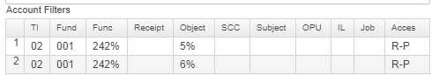
- Ranges (value1..value2) can be used in the account dimensions when giving access to ranges of accounts. For example,
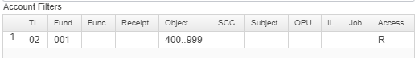
- Enter the Order number in which the information should be entered and processed. When assigning order numbers, it is important to assign the more detailed accounts with lower order numbers (e.g. 1, 2, 3 ...) and the less detailed accounts a higher order number.
- Click on to create the account filter, click on to not create the account filter and return to the Account filter gird.
Adding a filter to a report
- Go to the report manager under the report menu
- Open on the report definition on the desired report you need to add a filter for
- Click on the configure filters tab and drag over the filter property or double click
- Set your operations (Equals/One of/Greater Than/Etc) and paste the filter name in the filter value field from the filter you created (suggest pasting as this is case sensitive).
Click Save Report

