SALARY NOTICE AND DIRECT DEPOSIT CUSTOM FIELDS

How to change the documents

Salary Notice
Salary Notice Field Options in link below:
https://mcoecn.atlassian.net/wiki/spaces/uspsrdoc/pages/2492266/New+Contracts#NewContracts-CreatingSalaryNotices

1.Open the SALARY NOTICE TEMPLATE as a word document located at www.mveca.org
Fiscal/Redesign USPS/USPS Custom Fields for Salary Notice and Direct Deposits.
2. Click the location where you want to add the new field on the Word document.
3. Go to INSERT menu in the Word Document
4. Click on QUICK PARTS drop down
5. From the Quick Parts drop down – Click on FIELD

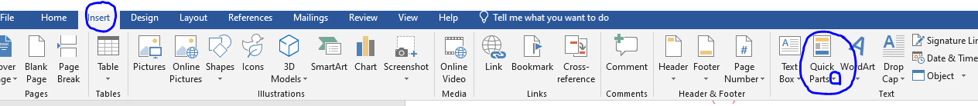

6. In the Field Names section click on MERGE FIELD
7. In the Field Properties section - Copy and Paste the FIELD NAME, from the Field Options section of the New Contract/Salary Notice SSDT Document
https://wiki.ssdt-ohio.org/display/uspsrdoc/New+Contracts#NewContracts-SalaryNotices

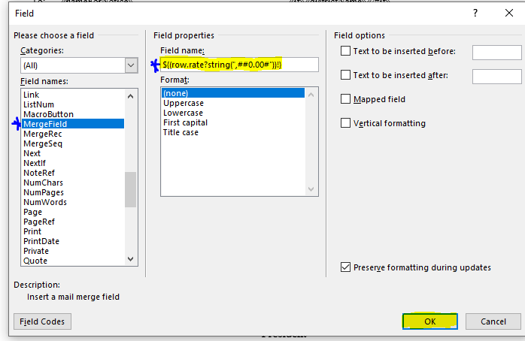
8. Click OK

Creating and Printing Salary Notices in USPS-R
- Once the Salary Notice changes are complete, save the Word Document.
- Go to Reports/Report Manager
- Click on CREATE FORM 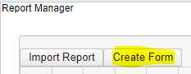
- When the Create Form Window opens enter:
  - Report Name
  - Description
  - Tags – optional
  - Entity Type – NewContract
  - Click SELECT FORM – select your Salary Notice Word Document
  - Click Save
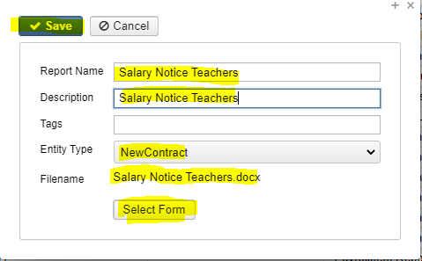

- Now go to Processing/New Contract
- Make sure you have an employee’s information in New Contract Maintenance
- Click on SALARY NOTICE tab
  - Enter Output File Name
  - Statement Date – can be todays date
  - Sort Option
  - School Year 2023 – 2024
  - Contract Start Date – optional
  - Appointment Type – optional
Creating and Printing Salary Notices in USPS-R continued

  - Select Specific Employee – optional
  - Include District Information on Salary Notices – if not included in your Logo then you might want to select this.
  - Form: Search for the Salary Notice you want to use from the drop down list.
  - Click Generate Salary Notices
  - Determine if any additional changes need to be made, if you need to make changes, go back to your original Word Document and repeat adding field names, or delete spaces if you have a page after your salary notice.
  - If changes are needed, you will delete the Salary Notice form you created in Report Manager, Repeat steps in section SALARY NOTICE (to add fields)
  - After changes have been saved Repeat – Creating and Printing Salary Notices in USPS-R
Emailing Salary Notices
- Go to System/Configuration
- Edit “Salary Notice Configuration”
  - The From Email will be the email address of the person sending the notifications. This should be an valid email that your Stmp email server will recognize.
  - The Subject line to be used for emailed salary notice.
    - For example - Salary Notice for {POSITION_DESC} {COMPENSATION_LABEL
  - The Body is the text to use for the body of the email salary notice.
    - For example - Attached to this message is your salary notice for {POSITION_DESC} {COMPENSATION_LABEL}
  - he Send Notification To All Addresses allows districts to choose whether to send the email salary notices to the 'Primary Email Address,' the 'Secondary Email Address,' and the 'Other Email Address' (located on the Employee record) or only the 'Primary Email Address.' By default, this checkbox is marked and the employee will receive their emailed salary notice to all email addresses.
  - The Exclude Employee Number From Emailed Salary Notice will exclude the Employee Number from the email salary notice. By default, this checkbox is marked and the Employee ID will not be printed on the email salary notice.
  - Select the appropriate form for generating the email salary notices by using the Default Salary Notice Form dropdown. The default form listed is based on the form selected in System>Configuration>Salary Notice Configuration.

Emailing Salary Notices continued
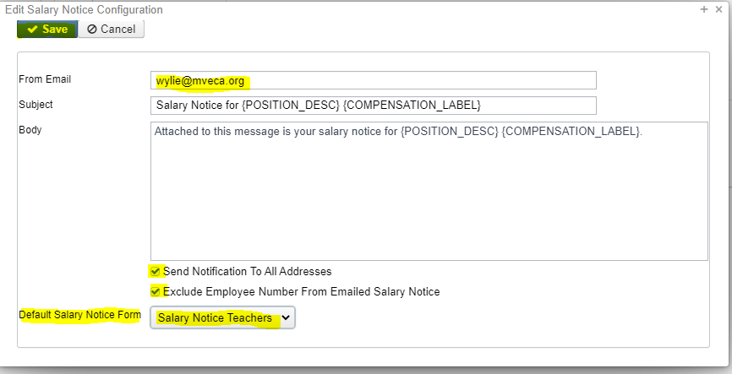

Sending the Salary Notices
Districts have the option to email salary notices directly to their employees by clicking the 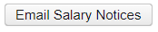 option. A pop-up box will appear that allows the delivery of the email salary notices to be scheduled. From the calendar, select a date and then enter the time to send the notices.
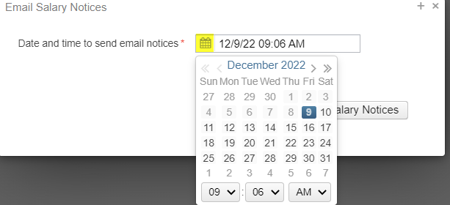

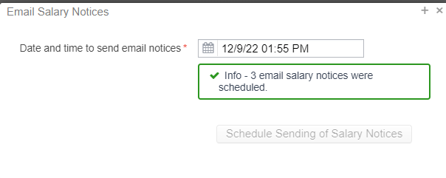
Once the email salary notices have been scheduled, the job will be listed under Utilities/Job Scheduler.

Direct Deposits – Creating Custom Form
Direct Deposit Field Options:
Go to bottom of page in the link below:
https://wiki.ssdt-ohio.org/display/uspsrdoc/Creating+Custom+Forms

1.Open the DIRECT DEPOSIT NOTICE TEMPLATE as a word document :located at www.mveca.org Fiscal/Redesign USPS/USPS Custom Fields for Salary Notice and Direct Deposits.
2. Click the location where you want to add the new field on the Word document.
3. Go to INSERT menu in the Word Document
4. Click on QUICK PARTS drop down
5. Click on FIELD

Direct Deposits – Creating Custom Form continued
6. In the Field Names section click on MERGE FIELD
7. In the Field Properties section - Copy and Paste the FIELD NAME, from the Field Options section of the New Contract/Salary Notice SSDT Document
https://wiki.ssdt-ohio.org/display/uspsrdoc/New+Contracts#NewContracts-SalaryNotices
- Click OK

Creating and Printing Direct Deposit Notices in USPS-R
- Once the Direct Deposit Notice changes are complete, save the Word Document.
- Go to Reports/Report Manager
Click on CREATE FORM
- When the Create Form Window opens enter:
  - Report Name
  - Description
  - Tags – optional
  - Entity Type – PaymentDetailPayrollDirectDeposit
  - Click SELECT FORM – select your Direct Deposit Word Document
  - Click Save
To test the Direct Deposit Notice
- Go to PAYMENTS/PAYROLL
- Stay on Payroll Payments tab
- Select a Payment
- Click on “Print Payment Checks and Direct Deposit” button

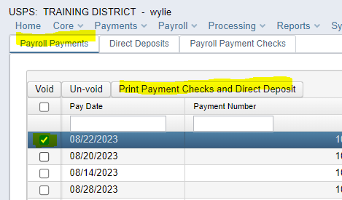

Creating and Printing Direct Deposit Notices in USPS-R continued
- When the Print Payments window opens select:
  - Direct Deposits
  - PDF
  - File Name – let it default
  - Direct Deposit Form – Select Direct Deposit with Logo
  - Click Process Payments

