**Log in to Ohio Business Gateway.**

**Select OH TAX eServices**

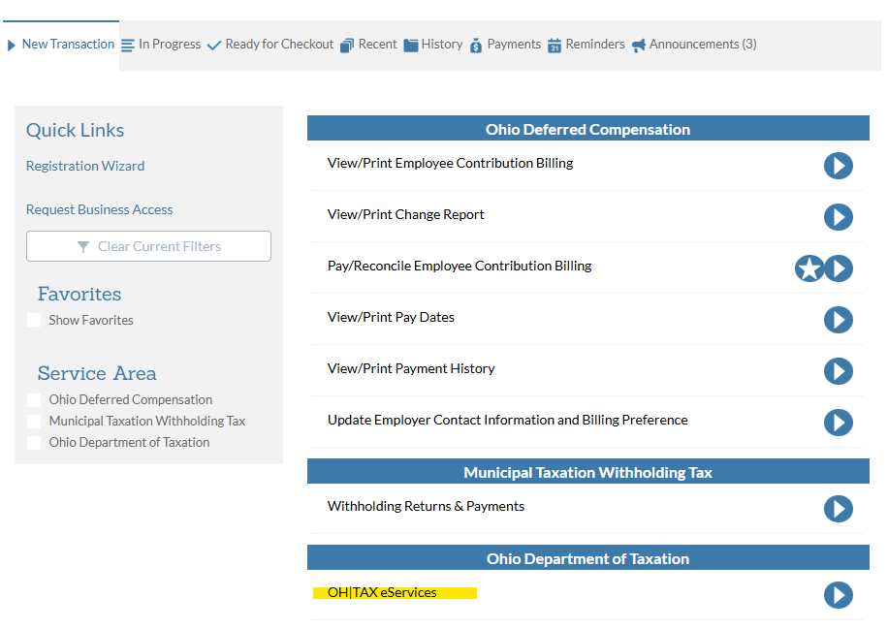

**You will be taken to the screen below. Click on OH TAX eServices link.**

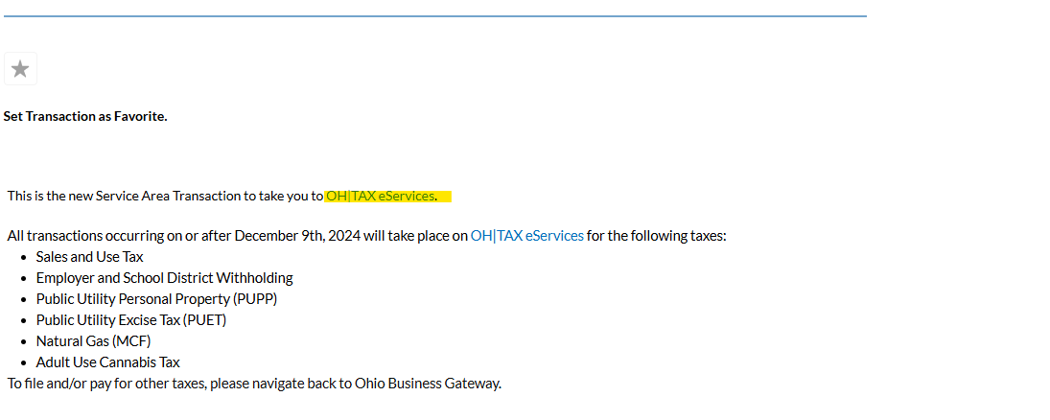

**In the Section EMPLOYER’S PAYMENT OF OHIO TAX WITHHELD/Account section - click on MORE.**

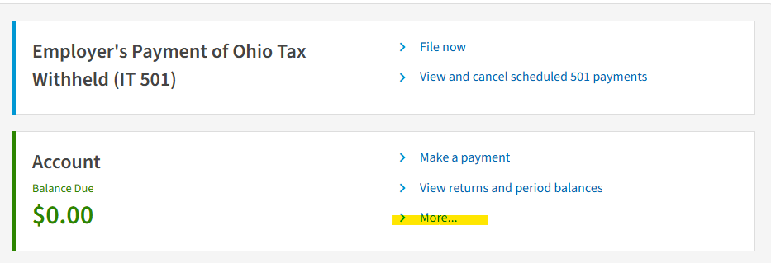

**In this screen look for the field INCOME STATEMENT UPLOAD**

**Click on UPLOAD INCOME STATEMENT**

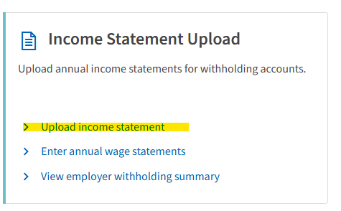

**Find this section INCOME STATEMENT and click the carrot to view download options.**

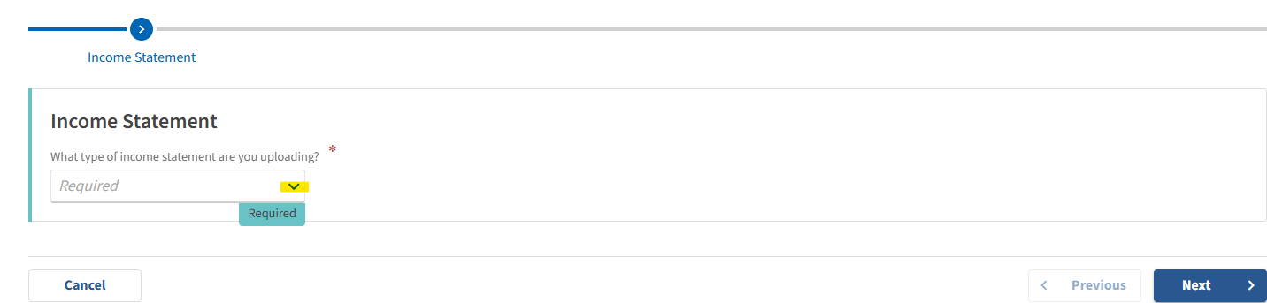

**Select W2 then click NEXT**

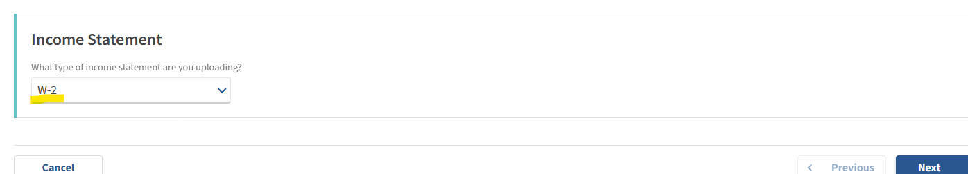

**Click UPLOAD FILE button**

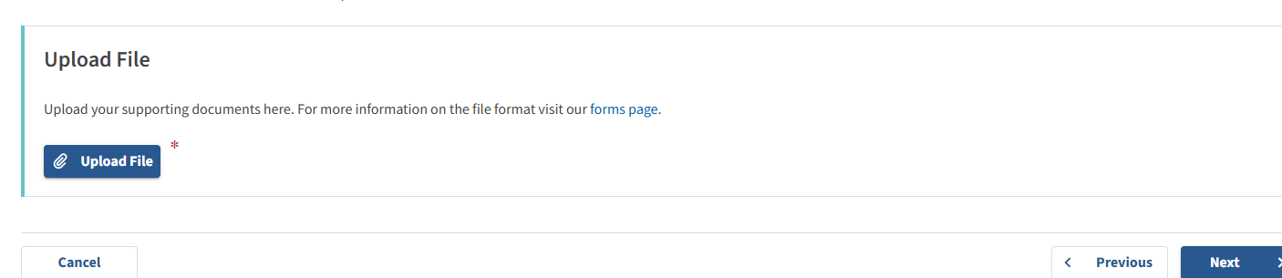

**At this point you would have created your W2MAST_OH.txt file in USPS. Find the file in your downloads or desktop, where ever you saved it.**

**Choose the file and click OK.**

**Follow the upload instructions on the website from this point.**

