Contents
Getting Started 2
Login 3
First time verification 4
Select Verification method 5
Email Verification 6
Security Questions 7
Google Authenticator 9
Push Notifications 10
DUO Security 11
Adding/Managing Verification methods 12
Change Password 17
Forgot Password 18
Unlock Account 21

Getting Started
This document will provide you information on how to login to ADSelfService Plus, change your password and set alternate MFA (Multi Factor Authentication) verification methods. The remainder of the document will use ADSSP as an acronym for ADSelfService Plus.
To begin you access the portal by browsing to https://pwdrset.dsl.mveca.org:9251. Since you only need to reset your password about every 6 months it may be easier to go to MVECA’s web page (https://www.mveca.org), click on Quick Links and then click on Password Reset.

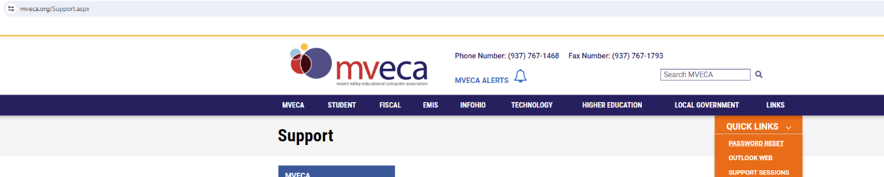

This brings up the ADSSP login screen.
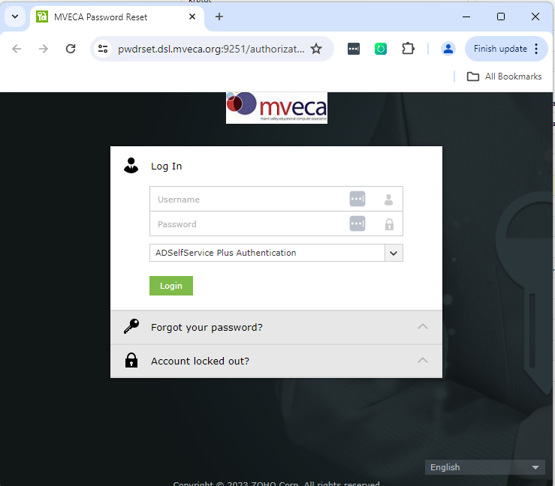

Login
Enter your credentials (username and password). The account is your DSL account (also known as your Active Directory (AD) account, Student Information account or your Fiscal AD account). This is all one account linked to all the systems.
Click the green Login button to continue.

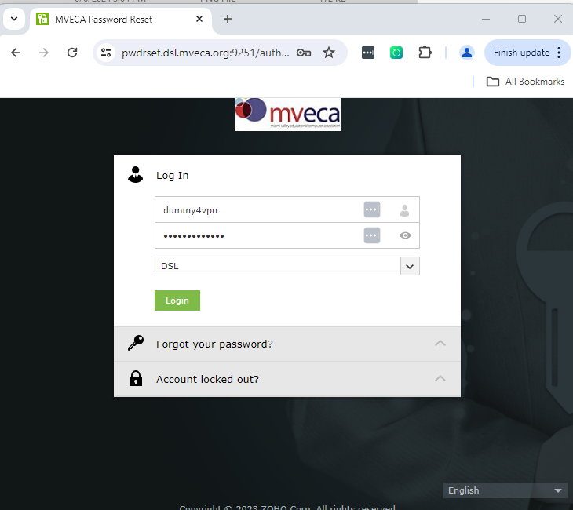

First time verification
If this is the first time you have logged into the portal you will need to answer the security question that was assigned when we set up the account in ADSSP. Additionally, you will need to enter the characters shown in the CAPTCHA image to prove you are human and not a BOT. Sometimes its hard to discern exactly what the characters are. There is a refresh button to the right of the text box which can be used to generate a new CAPTCHA image.
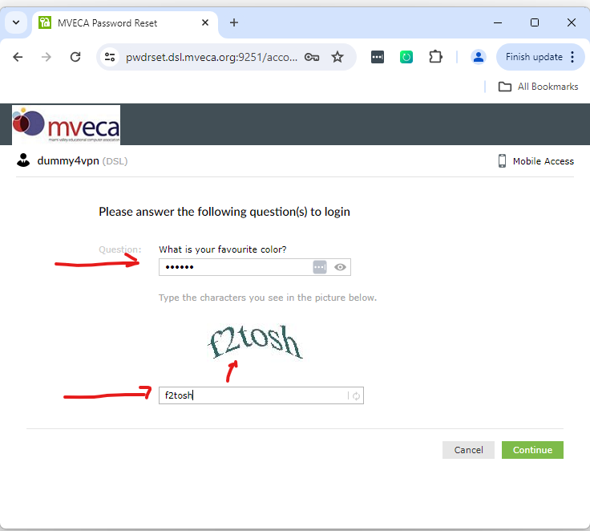

Select Verification method
Next you will be presented with the MFA Enrollment form. You must select one of these to be your MFA.
A common selection is “Email Verification”. We highly recommend you use an email that you have access to at home and work. It can be a work email or a personal email. When you login a verification code will be sent to this email address and you will need to enter the verification code sent in the email into the verification screen. NOTE: MVECA and Greene County ESC employees should NOT use their MVECA/GCESC email account since it is likely you wont be able to access it to obtain the verification code when you have forgotten or need to change your password.
Security questions can also be used for verification. There are some fixed questions of which you will need to choose 2. The down side of using this method is the answers to the questions quite often are forgotten.
DUO can be used if you already have a DUO account. If you do NOT have a DUO account and do not have DUO installed on your phone do not choose this option.
If you already have Google Authenticator for other applications and it is already installed on your phone you can choose this option.
Push notifications is another option. This will send an SMS text to your phone. You must install the ADSelfService Plus App from your device’s App Store.
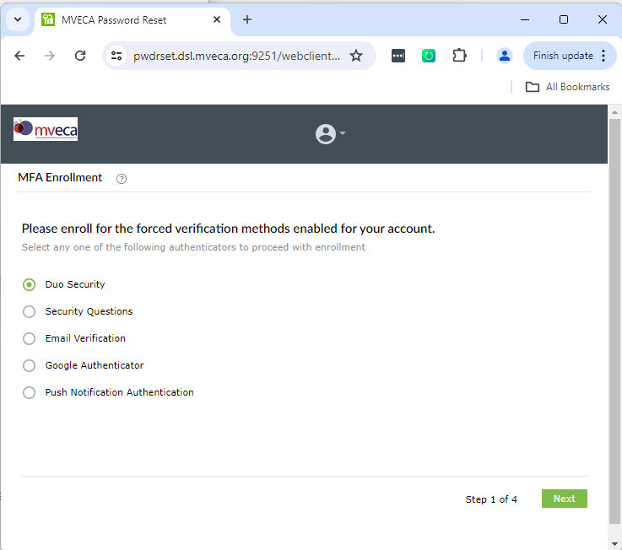

Email Verification
If you chose “Email Verification” enter the email address to receive the code and press the green “Send Code” button. Open the email you received and find the verification code and enter it in the 2nd text box below. Then press the green “Verify Code and Continue” button.

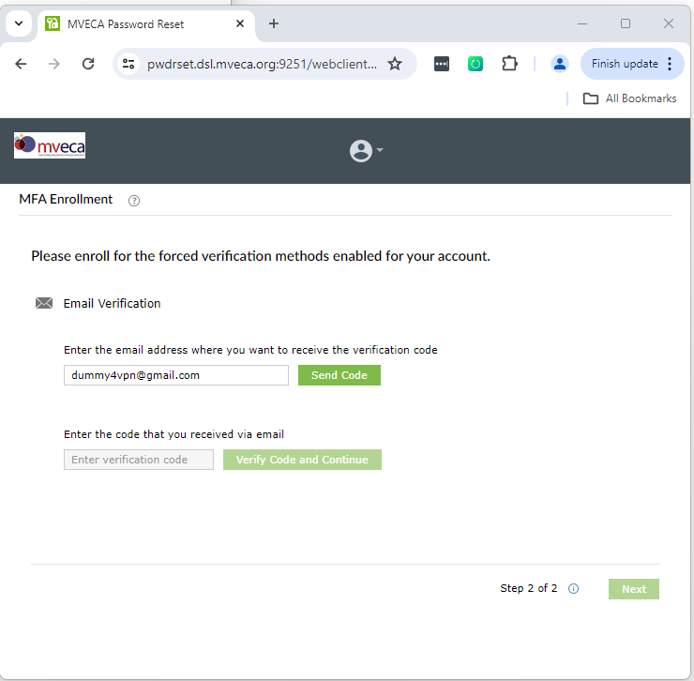

Security Questions
If you chose “Security Questions” click the first drop down box and choose a question that you will NOT forget the answer to. You will need to enter the answer in the “Answer” text box AND the “Confirm Answer” text box. Note the minimum length is 3 characters to a maximum of 255 characters.
Repeat the process for the 2nd question. After both questions have been selected and answered click the green “Update” button at the bottom.
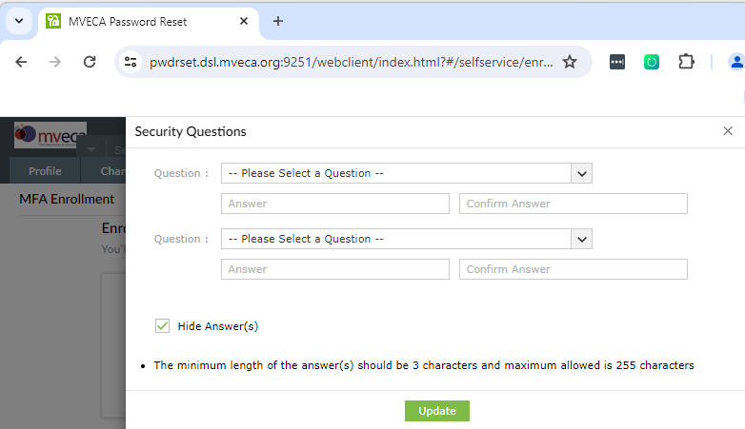
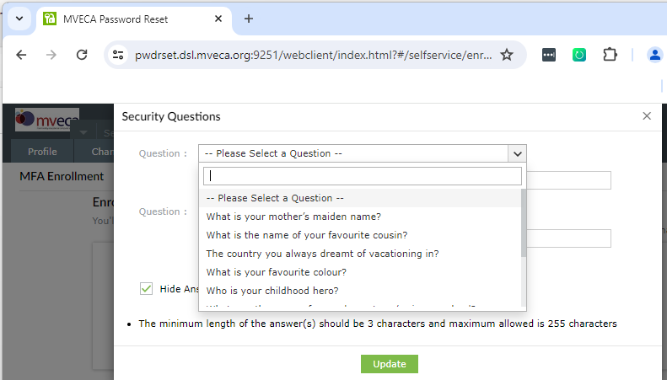
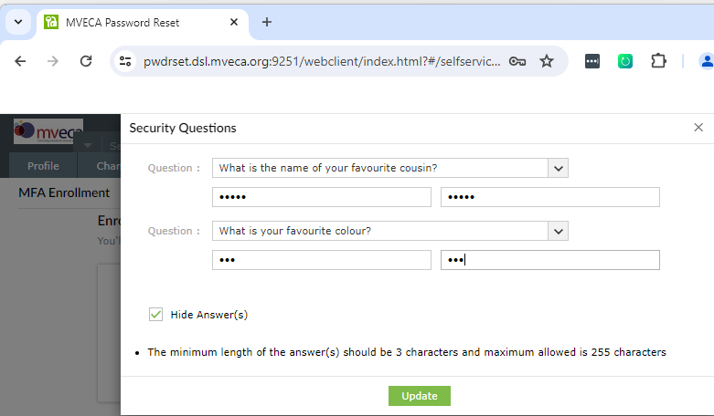

Google Authenticator
If you already have Google Authenticator installed on your phone/device for other applications you can use it for ADSSP too. Just follow the instruction shown.

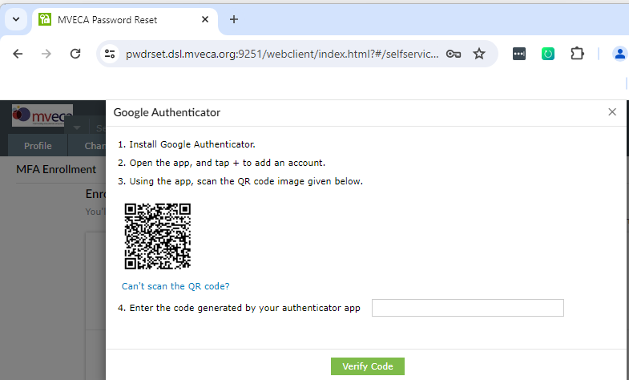

Push Notifications
If you choose “Push Notifications” follow the instructions shown on the screen. NOTE: You must have ADSelfService Plus Mobile App installed on your device. You can download it from your device’s App Store.
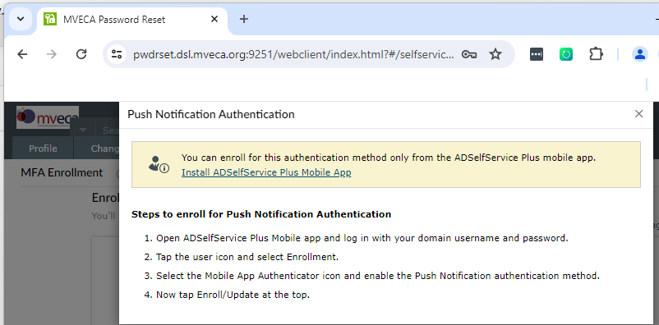

DUO Security
For DUO you must already have a DUO account AND the DUO app already installed on your device. The set up screen will take you to DUO to complete the set up for ADSSP. Click the green “yes” button to continue to DUO.

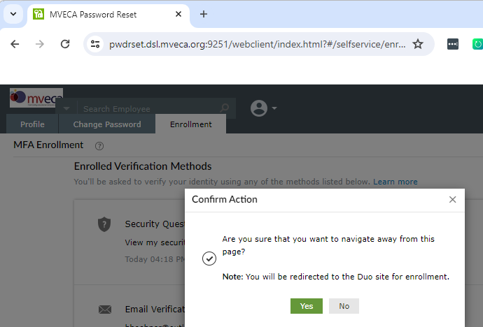

Adding/Managing Verification methods
Once you have completed setting up one of the verification methods you will be logged into ADSSP and presented with your Profile page. You do not have to enter anything further, but can if you want.
Click on the “Enrollment” tab.

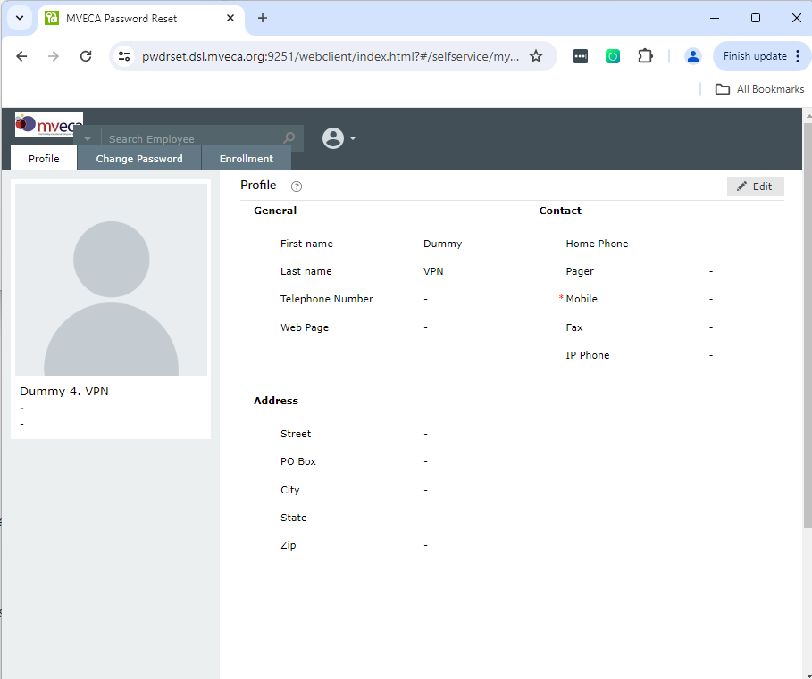

This will show the “Enrolled Verification Method” chosen. Below that will be alternate verification methods you can choose. This is useful so if your preferred method is an issue (email not working, can’t remember security question answers, etc.) you will have another option. Just click the “Set up” link in the method you want add.
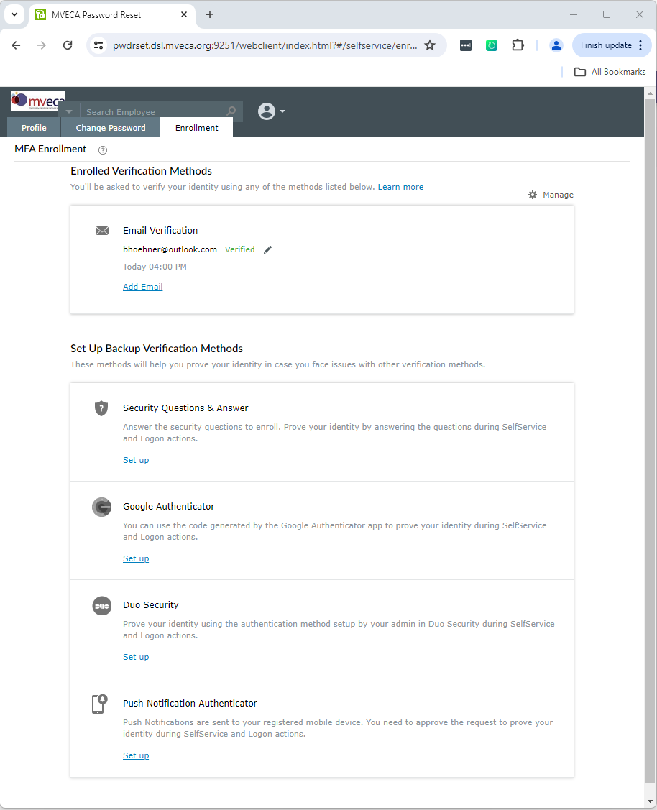
Below you can see we have chosen all 5 methods as options. You can remove any of the options by clicking the “pencil” icon to edit the method or for DUO simply click the “Remove” link in the DUO Security section. On the next screen you will be able to click a “remove” button to get rid of it. Note you CANNOT remove the last method. You must have at least one method.
Another option is to temporarily disable one or more options by clicking the “Manage” icon in the upper right.
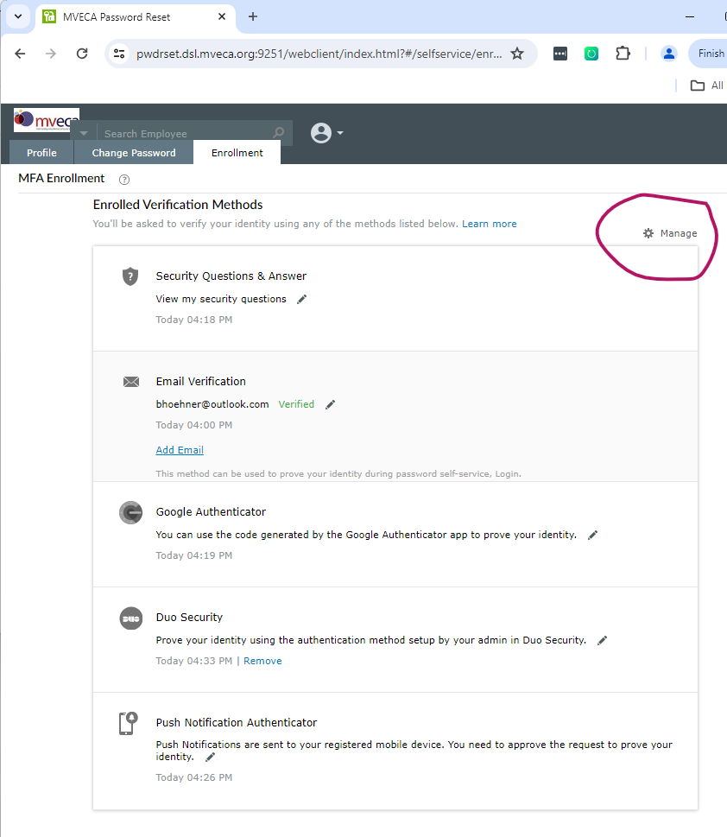
Under the “Login MFA” column click any of the green checkmarks to disable it. Then click OK to save the changes.
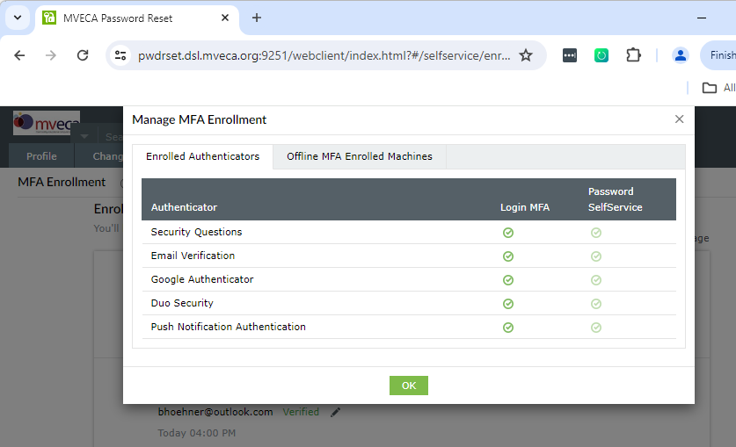

You can re-enable the methods by clicking the red disabled icons and clicking OK to save the changes.
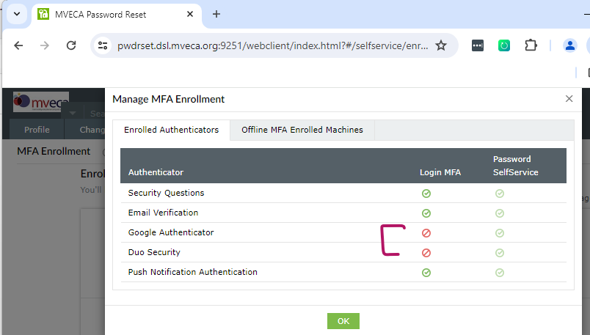
After disabling the Google Authenticator and DUO Security methods and logging into ADSSP we now see only the 3 remaining choices to choose from. Select one and click the green “Continue” button.

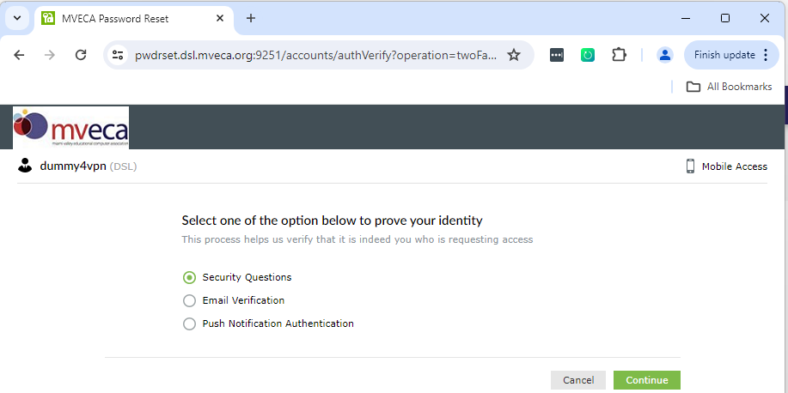

Change Password
Of course, the primary purpose of ADSSP is to change your password. Your password is valid for up to 182 days. If you have an email address in your Profile, you will receive notifications that your password is expiring starting 14 days before the expiration. If you do NOT have an email address in your profile you will NOT receive notifications.
Once logged in click on the “Change Password” tab. This requires you to enter the old password followed by the new password (twice). Notice the password requirements list at the bottom of the screen.
After you have entered your old and new passwords click the green “Change Password” button.
! Please note that the password minimum length has changed from 12 to 15 characters
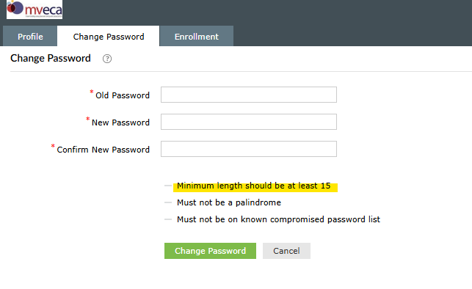

Forgot Password
If you have forgotten your password altogether and are unable to login to ADSSP you can still reset your password. At the login to ADSSP notice the “Forgot your password?” below the green Login button. Click this line (you do NOT need to enter a username/password on this screen) and you will be taken to the “Forgot your password” screen.

Enter your username in the first text box and fill in the CAPTCHA text box and click the green “Continue” button.

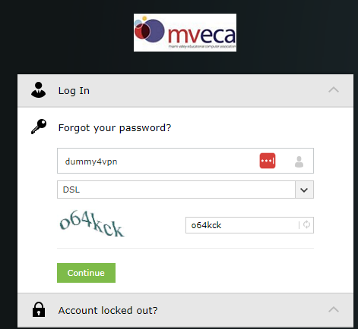

If you have only one verification then you will be prompted to provide that verification information. If you have multiple methods you will be prompted to select the verification method to use.

After verification is complete you will be prompted to enter the new password. Enter the password in both text boxes. Then enter the CAPTCHA characters in its text box. Then click the green “Reset Password” button.

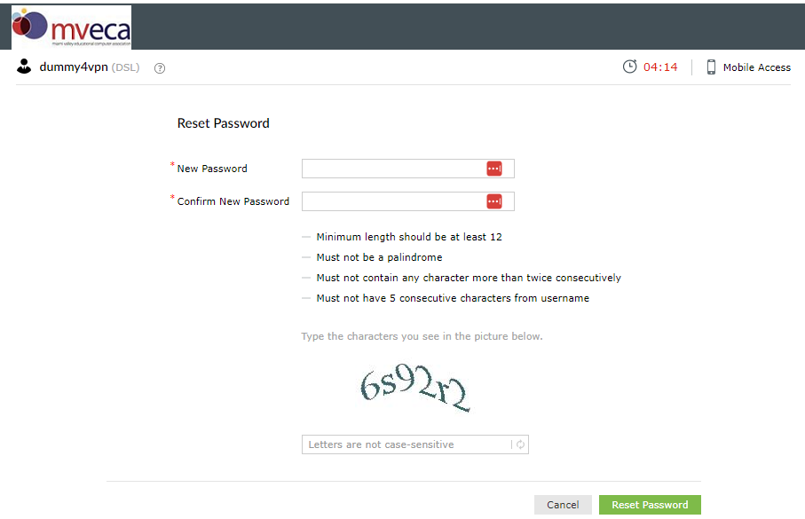

Unlock Account
Another feature of ADSSP is the ability to unlock your account. If you entered an incorrect password a certain number of times consecutively your account can become locked. To unlock it and attempt another login click the “Account locked out?” line on the Login screen.
You will then be prompted to enter your username and a CAPTCHA code. Press the green “Continue” button to go to the Unlock Account screen. You will be then taken to the verification screen specific to the method you have set. Note: If you have multiple verification methods you will be asked to select one to complete the verification.

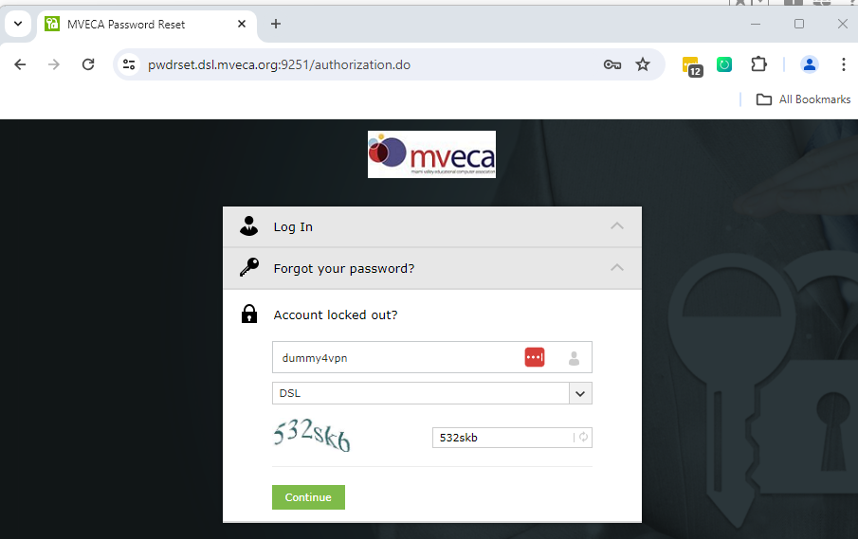

Once your username has been verified all you need to do is complete the CAPTCHA entry in the text box and click the green “Unlock Account” button.

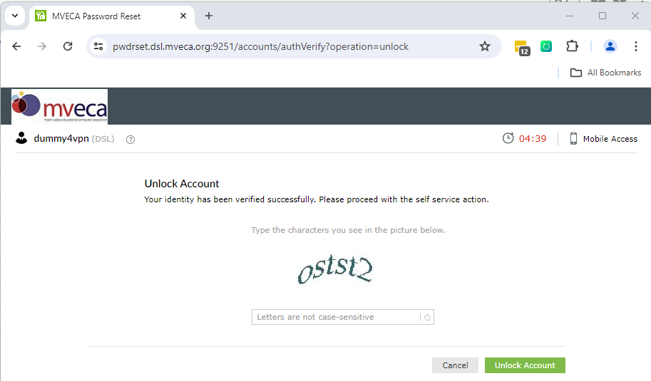

If your account is NOT locked you will receive the following error message. Click the “Back to home” link in the bottom right portion of the screen to return to the Login screen.

