Steps for Processing Digital W2’s 2025

Employees can receive Digital W2’s in ESS instead of a printed copy.
Not all employees have to agree to Digital W2’s.

To Proceed:
- Notify MVECA - we will set the USPS configuration to Digital W2’s. This will place the acknowledgement signature and date field on each employee screen in USPS.
- Districts will go to ESS/System/Configuration/W2 Configuration. Set the flag to Allow Digital Onlyl W2 and click SAVE.
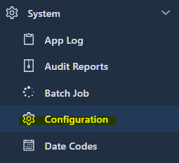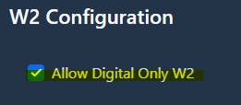

- The employees can now log in to ESS, click the down arrow by their name and select PROFILE.


  - Select the tab in profile called W2 Acknowledgement.
  - There they will enter their Digital Signature. It has to match exactly what is listed under that field. Either all Uppercase or Upper and Lowercase.
  - Select the date they are acknowledging
  - In the Decision field they will select from the dropdown to Consent to Receive only Digital W2’s. This will remain in place until a time when they change their mind and revoke the decision.

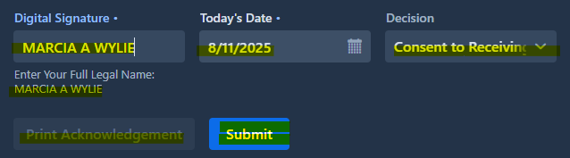

- In USPS the acknowledgement will display at the bottom of the Employee screen.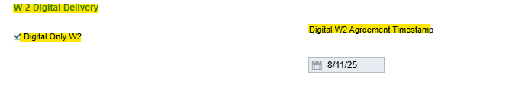

- If needed, an Acknowledgement Form can be printed either from the employee profile, or the district can go to District W2 Acknowledgement grid and print a single copy for any employee requesting a copy of the form.
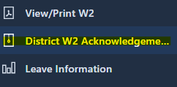

If the employee has not Acknowledged Digital W2’s then the option to print the Acknowledgement Agreement is not available. Currently only one agreement at a time can be printed. If an employee wants a copy of the agreement, have them go to their profile to print or view a copy.

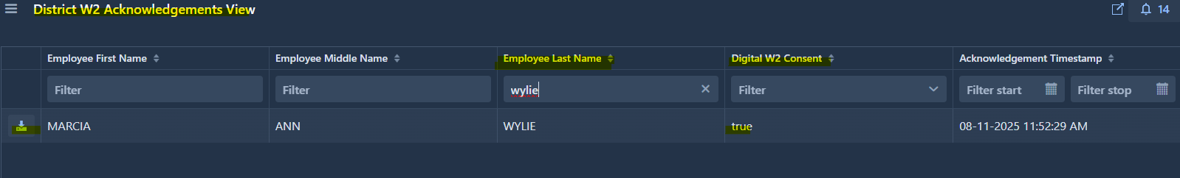

Digital W2 Acknowledgement

08/13/2025, 3:40 PM Digital Only W2 Acknowledgement Form

You are being asked to consent to receive your IRS Form W-2, Wage and Tax Statement,
electronically through the Employee Self Service portal. By providing your consent, you agree
that:
- You will not receive a paper copy of your W-2.
- You will be notified by email when your W-2 is available.
- You can access your W-2 securely through Employee Self Service at any time.
- You may withdraw your consent at any time within the portal.
- This consent remains in effect for future tax years unless you revoke it.

To access your electronic W-2, you will need a device with internet access, a supported web browser, and a PDF reader. It is your responsibility to keep your contact information up to date to ensure proper notification and access.
Employee Digital Signature: MARCIA ANN WYLIE
Decision: Do consent to receive my W2 in ONLY a digital format
Date:08/11/2025
W2 Acknowledgement Report

- In the ESS menu, View/Print W2 - you will see in the top right corner the option to download IRS Employee Notice, which is the information typically on the back of the W2.
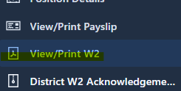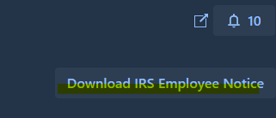

PROCESSING W2’S
Below are the links to instruction for processing W2’s

- W2 Archive Individual Forms - This process will place W2’s in Utilities/File Archive/W2 Archive and will also import W2’s into ESS. (including Digital W2’s)

- W2 Form Output Files - The W2 Form Output Files will store the processed W2 Forms (Employee), W2 Forms City and W2 Mailable Forms

- W2 Mailable Forms - The W2 Mailable Forms option can generate a 8 1/2" x 14" paper form for all employees included on the parameters. (excluding Digital W2’s)

- W2 Report and Submission - The W2 Report module creates a report used for reporting W2 wage information at calendar year end. (Digital W2’s will be included in these reports.)

