

Reporting Overtime January 1, 2026 through December 31, 2028
NOTES:
- Rules for Reporting overtime are the same as FLSA
- SSDT Over Time Documentation OBBA located in USPS USEFUL PROCEDURES for step-by-step instructions how to process overtime (this will be updated on a regular basis)
- Employers are required to report overtime for non-exempt employees
- Employees can deduct overtime up to 12,500 single and 25,000 those filing jointly.
- Overtime will be located in Box 12 TT on W2’s
- The system will use the Position>Overtime Classification flag along with the Payroll Payments - Future/Current>FLSA Overtime value to arrive at the total printed on the W2.
- If Position is set to Exempt and OVERTIME should be included on the employee’s W2, then Core>Adjustments using the W2 Overtime will need to be created.
- Unions sometimes pay OT that would not apply for Fair Labor Standards Act (FLSA). The Pay Amount and Historical Pay Amount will now include a checkbox to determine if FLSA should apply. This is only available when selecting Blended Overtime and Overtime

Initial Setup:
- Position screen has a new field called Overtime Classification. that must be updated as: Exempt (Does not Qualify for Overtime) or Non-Exempt(Qualifies for Overtime)
  - If the field is left blank the system will assume Non-Exempt
- A Mass Load spreadsheet is available to update this field.
The only headers required are: (you can add first and last name just remove the header before loading)
employee.number
number (this is position number)
overtimeClassification
NON_EXEMPT
EXEMPT

Save the spreadsheet as a CSV
Go to Utilities/Mass Load
Select File
Importable Entity: Position
Click Load

Processing:
- Once this is setup, when creating a Future/Current Payment, the FLSA flag will automatically set to INCLUDED when processing an Overtime or Blended Overtime Pay Type.
- IMPORTANT: The system will then use the Position>Overtime Classification flag along with the Payroll Payments - Future/Current>FLSA Overtime value to arrive at the total printed on the W2.
- If Position is set to Exempt and information should be included on the employee’s W2, then Core>Adjustments using the W2 Overtime will need to be created.

- What is the recommended way to process blended rate overtime? Please add’l document:
“BLENDED RATE CALCULATION FOR PAYROLL PROCESSING SO OVERTIME WILL REPORT CORRECTLY ON W2’s”

  - A Miscellaneous Pay Type can be used for the '1' part of the 1.5 overtime payment and the BOT Pay Type for the 0.5 part.
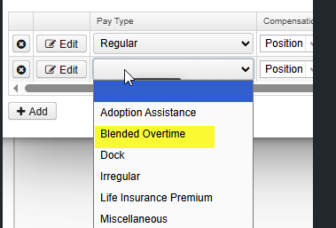

- If using Attendance import, this will be a required field for OT and BOT pay types and FSLA has to be either Excluded or Included in the csv. (This field will be available with the 2025.26.0 release
  - Column Z in the load file represents the FLSA OT value and is only valid for OT and BOT Pay Types (Column Q). In the load, IF the Pay Type (Column Q) is set to OT or BOT and the FLSA value (Column Z) is left blank, when the file is loaded the value will be set to the default of Included.
    - Valid field values are:
      - TRUE, T
      - FALSE, F
  - Entries in the load file with Pay Types (Column Q) that are not equal to OT or BOT will ignore this column and the value will always be set to false.

- CURRENT ENTRY

- FUTURE ENTRY
