

Reporting Overtime January 1, 2026 through December 31, 2028
BLENDED RATE CALCULATION FOR PAYROLL PROCESSING SO OVERTIME WILL REPORT CORRECTLY ON W2’s

An employee is paid on Position 22 (Custodian) at a rate of $20.00 per hour and also Position 32 (Aide) at a rate of $25.00 per hour.
The employee works 3 hours per day on Position 22 and 4 hours per day on Position 32.
Week one of the pay period the employee worked the following:
Week One Sample Timesheet:
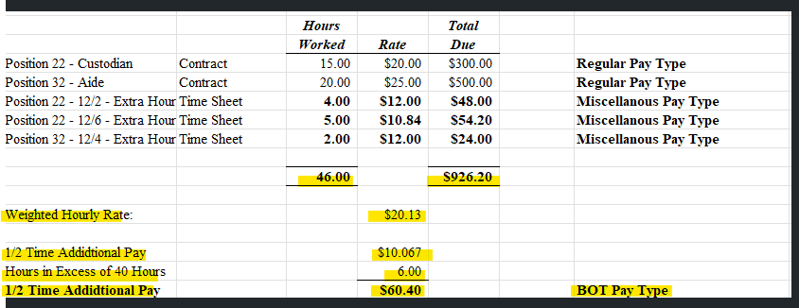
- Position 22 - Custodian:
  - 5 days X 3 hours per day = 15 hours (Paid from their stretch paid Compensation - Reg entry on the Pay Report)
  - 12/2 extra hours = 4 hours (Paid using a Miscellaneous Pay Type - 12/2 entry on the Pay Report)
  - 12/6 extra hours = 5 hours (Paid using a Miscellaneous Pay Type - 12/6 entry on the Pay Report)
- Position 32 - Aide:
  - 5 days X 4 hours per day = 20 hours (Paid from their stretch paid Compensation - Reg entry on the Pay Report)
  - 12/4 extra hours = 2 hours (Paid from the Miscellaneous 12/4 entry)
The following calculation would be used to arrive at the blended rate to pay the overtime:
- $926.20 Total Gross/46.00 Total Hours Worked = $20.13 Hourly Rate
- $20.13 Hourly Rate/2 = $10.07 Blended Overtime Rate
- 46 Total Hours Worked - 40 Hours = 6 Overtime Hours
- $10.07 Blended Overtime Rate x 6 Overtime Hours = $60.40 (Paid using the BOT Pay Type - BOT entry on the Pay Report)

Week two of the pay period the employee worked the following:
Week Two Sample Time Sheet:
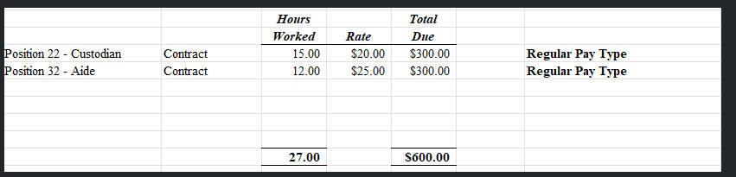
- Position 22 - Custodian:
  - 5 days X 3 hours per day = 15 hours (Paid from their stretch paid Compensation - Reg entry on the Pay Report)
- Position 32 - Aide:
  - 3 days X 4 hours per day = 12 hours (Paid from their stretch paid Compensation - Reg entry on the Pay Report)
15 hours + 12 hours = 27 Hours. No overtime paid.
Week One and Week Two Combined:
- Position 22 - Custodian:
  - 30 Regular Hours
  - 9 Extra Hours
- Position 32 - Aide:
  - 32 Regular Hours
  - 2 Extra Hours
Payroll Payments - Future/Current:
- Position 22 - Custodian:
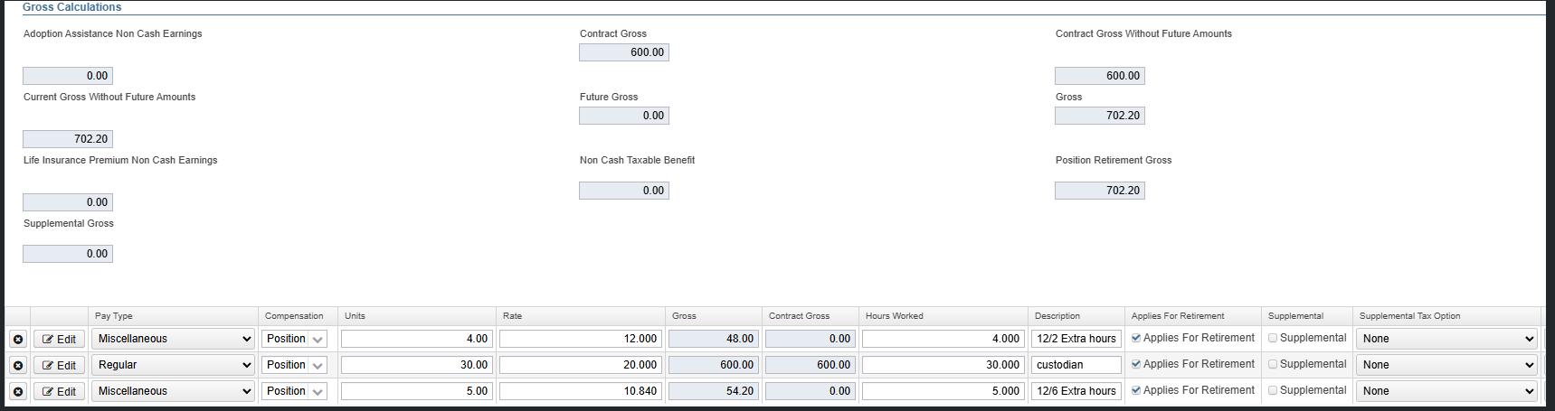

- Position 32 - Aide:
