DIGITAL W2’S DISTRICT INSTRUCTIONS 2026

Employees can receive Digital W2’s in ESS instead of a printed copy.
Not all employees have to agree to Digital W2’s. If the employee acknowledges that they will go digital then they will be excluded from the W2 Mailable Forms.

To Proceed:
- Notify MVECA - we will set the USPS configuration to
Enable W2 Digital Delivery. This will place the acknowledgement signature and date on each employee screen in USPS.
- Districts will go to ESS/System/Configuration/W2 Configuration. Set the flag to Allow Digital Only W2
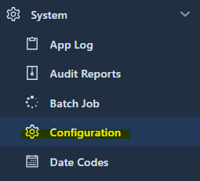
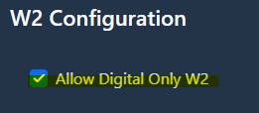
- When users log into ESS they will be prompted to complete the Digital W2 Acknowledgement. This is a one-time requirement. Once they have completed the acknowledgment, to either
“Consent to Receiving Digital Only W2” or
“Revoke Consent to Receive Digital Only W2” and click SUBMIT, they will no longer be prompted at login.

- Employees should enter their digital signature exactly as it appears in ESS
Acknowledgement.
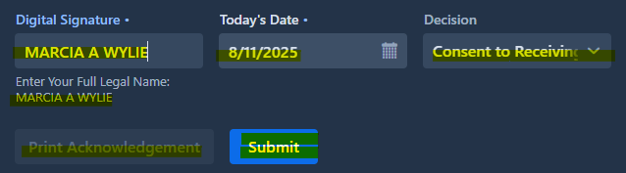
- Employee has the option to generate a PDF copy of their signed acknowledgement:
  - Go to Profile
  - Click W2 Acknowledgement
  - Click “Print Acknowledgement”
  - Click Submit


- The District Manager also has the option to generate a PDF copy of the
W2 Acknowledgement for an employee by going to:
  - District W2 Acknowledgement grid.
  - Find the employee
  - Click the download icon to print a single employee’s acknowledgement.
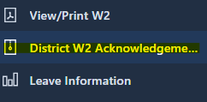

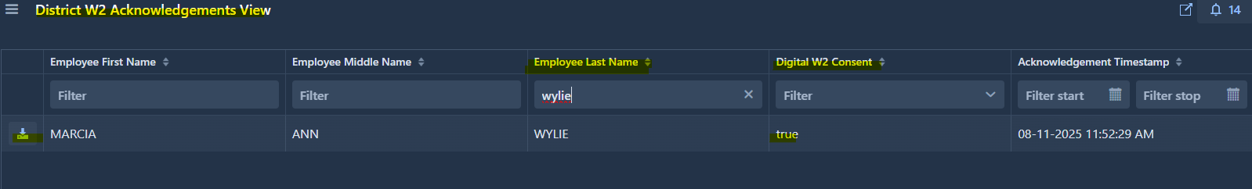
- In ESS View/Print W2 menu you will see in the top right corner the option to Download IRS Employee Notice, which is the information typically on the back of the W2.
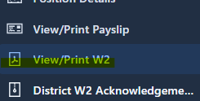

- In USPS every employee screen will house Digital W2 Acknowledgment date stamp.
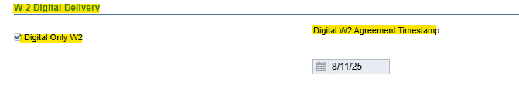

PROCESSING W2’S
Below are the links to instructions for processing W2’s

- W2 Archive Individual Forms - This process will place W2’s in Utilities/File Archive/W2 Archive and will also import W2’s into ESS. (Including Digital W2’s)

- W2 Form Output Files - The W2 Form Output Files will store the processed W2 Forms (Employee), W2 Forms City and W2 Mailable Forms

- W2 Mailable Forms - The W2 Mailable Forms option can generate a 8 1/2" x 14" paper form for all employees included on the parameters. (Excluding Digital W2’s)

- W2 Report and Submission - The W2 Report module creates a report used for reporting W2 wage information at calendar year end. (Digital W2’s will be included in these reports.)

