The purpose of this email is to highlight two important changes to the technology used for the PARCC Operational Assessments that were discussed in last week's hot topics call.

1. **New \**Optional\** TestNav Application Update (iOS and ChromeOS)**
2. **PearsonAccessnext 2.2 Release**

PARCC and Pearson have been working closely with schools, districts, and states to ensure readiness for operational window, so our intention is to limit the number of changes occurring to systems and processes at this late stage. However, the above mentioned updates are either optional and/or include enhancements that are intended to put forward the best possible systems for the upcoming administration. Additional detail about the impact of the changes is detailed below.

**1. New *Optional* TestNav Application Update (iOS and ChromeOS)**

* iOS app version 1.3.1*(Optional Update)*
  + In evaluating the different potential causes for application crashes, Pearson was able to identify that in less than 1% of scenarios on iOS, the issue could be isolated to examinees rapidly tapping/selecting on inline choice (drop-down) item interactions. This optional update resolves this issue.
  + *Recommendation*: If possible, complete the update to avoid this issue from occurring. If unable to update, this issue should be of very limited occurrence. If a student does encounter this, then either the application can be updated, or a student can be resumed and continue testing from where they left off.
  + Direct link to Instructions for [Setting Up Your Mobile Device](https://support.assessment.pearson.com/display/TN/Mobile+Devices" \t "_blank)
* ChromeOS app version 1.3.59 *(Optional Update)*
  + In some cases, when the application is not updated to the latest version, a

​ ​

3017 error occurs (You cannot take this test with your browser. To take this test, use the TestNav 8 App). The error can be resolved by updating to the latest version of the application by uninstalling and re-installing the application. This optional update allows the app to be updated through a device restart, rather than requiring a full uninstall.

* + *Recommendation*: If possible, complete the update to avoid this issue from occurring. If unable to update, this issue should be of very limited occurrence and when it does occur, uninstalling the application and reinstalling will resolve the issue.
  + Direct link to Instructions for [Setting Up Your Mobile Device](https://support.assessment.pearson.com/display/TN/Mobile+Devices" \t "_blank)

**2. PearsonAccessnext 2.2 Release**

* Reminder about the previously communicated PearsonAccessnext Release. As scheduled, the PearsonAccessnext 2.2 release is now available with the features that were requested, as well as some enhancements to some features and functionality based on the following.
  1. ***New Feature!***Print Student Test Tickets in different Views
  2. ***New Feature!***Support for out-of-order unit testing (Set Section Start)
  3. ***New Feature!***Pre-cache by Test - Ability to cache ALL content by test, rather than by session.
  4. ***Enhancement!*** Resume Student "Easy" button - The ability to resume students from the "Students in Sessions" screen, without initiating a task
  5. **Additional Order Email notification:** Ability to indicate an Additional Order Email Notification for each organization.
  6. **Permissions:** Unlock sections
  7. **Not Tested and Void Reason Codes:**Ability to indicate Not Tested and Void Reasons on Student Tests.

***1.) New Feature!***Print Student Test Tickets in different views – Grid View, List View, Detail View – 4 per page or Detail View – 1 per page:

* Go to *Testing > Sessions.*
* Select down arrow to the right of **Search.**
* Check **Show all results.**
* Select a session.
* Click on **Go to Students in Sessions** above the Tasks menu.
* Select the session under the Session List field on the left side of the screen.
* Click on **Download Resources**.
* Select any of the following: Grid View, List View, Detail View – 4 per page, or Detail View – 1 per page**.**

***2.) New Feature!***Support for out-of-order unit testing (Set Section Start):

* Go to *Testing > Sessions.*
* Select down arrow to the right of **Search.**
* Check **Show all results.**
* Select a session.
* Click on **Go to Students in Sessions** above the Tasks menu.
* Select the session under the Session List field on the left side of the screen.
* Select a student in the test session.
* Select **Set Section Start** under the **Tasks** drop down menu and select **Start**.
* Select student in session to Set Section Start.
* Select Unit/Section in the dropdown.
* Click **Save**.

***3.) New Feature!***Pre-cache by Test - Ability to cache ALL content by test, rather than by session:

* Go to *Setup > Precache By Test.*
* Select the test(s) and the Precache Server for each organization**.**
* Click **Precache.**

***4.) Enhancement!*** Resume Student "Easy" button - The ability to resume students from the "Students in Sessions" screen, without initiating a task:

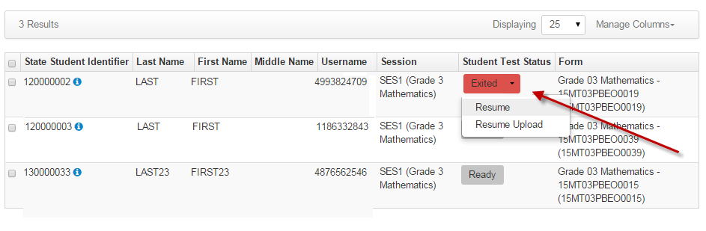

**5.) Additional Order Email notification:** Ability to indicate an Additional Order Email Notification for each organization:

* Go to *Setup > Organizations.*
* Select down arrow to the right of **Search.**
* Check **Show all results.**
* Select an organization.
* Select **Create/Edit Organizations** under the **Tasks** drop down menu and select **Start**.
* Select the organization under the Organizations field on the left side of the screen.
* Confirm the Email address for the state designated approver.
* Click **Save**.

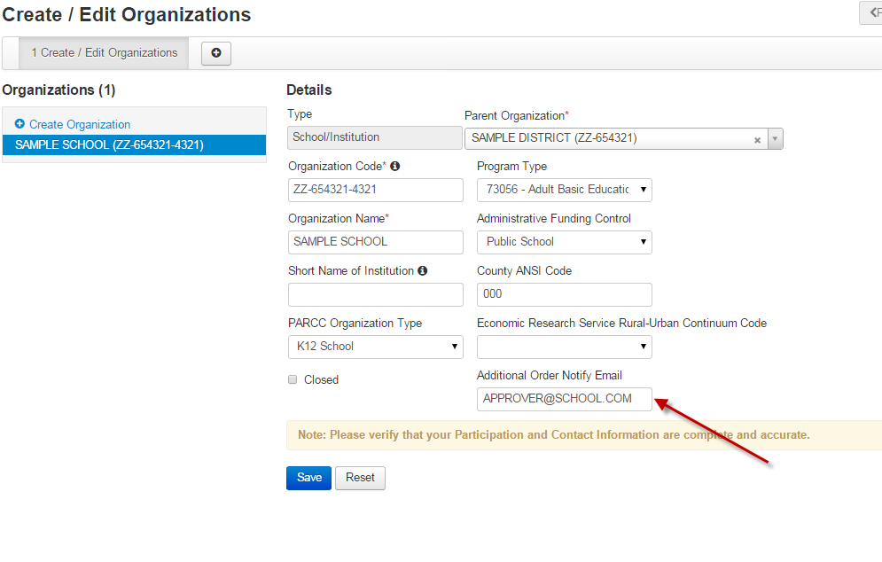

**6.) Permissions:** Unlock sections (State Users Only). Ability to Unlock Sections for a student to return to the beginning of the test. Limited access to this feature since it is typically only used for transcription or state approved situations.

* Go to *Testing > Sessions.*
* Select down arrow to the right of **Search.**
* Check **Show all results.**
* Select a session.
* Click on **Go to Students in Sessions** above the Tasks menu.
* Select the session under the Session List field on the left side of the screen.
* Select a student in the test session.
* Select **Unlock Sections** under the **Tasks** drop down menu and select **Start**.
* Select student in session and select **Unlock**.
* *Please note - Student must be in an Resumed or Exited status to complete this task*

***7.*Not Tested and Void Reason Codes**

* In PearsonAccessnext, click the **Setup**button and choose **Students**in the drop down.
* On the Students screen, search for the student in the Find Students search bar.
* Check the box for the student in the list at the bottom of the screen.
* At the top of the screen, click the Select Tasks drop down and check the box for **Manage Student Tests.**
* Click **Start**.
* Under Test Details, check the box next to **Not Tested Code or Void PBA/EOY Score Code**and then select a **Reason**from the drop down.
* Click **Create**.